Republic of Namibia

Ministry of Agriculture, Water and Forestry

Stampriet Artesian Aquifer –
Drilling and Test Pumping of
additional Monitoring Boreholes

Compiled by: H. Beukes, M. Katjimune, N. Kulobone & J. Wrabel

November 2005
Ref:


Department of Water Affairs
Table of contents

1 Introduction 4

2 Drilling Of Monitoring Boreholes 4

3 Test Pumping 4
3.1 Methodology 4
3.2 Results 5
3.3 Test Pumping WW40959 6
3.4 Test Pumping WW40960 10
3.5 Test Pumping WW40961 14
3.6 Test Pumping WW40962 18
3.7 Test Pumping WW40963 22
3.8 Test Pumping WW40964 26
3.9 Test Pumping WW40965 30

List of Appendices
Appendix 1: Overview map
Appendix 2: Site Maps of newly drilled boreholes
Appendix 2.1: Site Map of Spes Bona
Appendix 2.2: Site Map of Boomplaas
Appendix 2.3: Site Map of Muritz
Appendix 2.4: Site Map of Sandverhaar
Appendix 3: Lithological Logs and Borehole Design
Appendix 3.1: Log and Design WW40959 Spes Bona - Auob
Appendix 3.2: Log and Design WW40960 Boomplaas – Kalahari
Appendix 3.3: Log and Design WW40961 Boomplaas - Auob
Appendix 3.4: Log and Design WW40962 Muritz - Auob
Appendix 3.5: Log and Design WW40963 Muritz – Kalahari
Appendix 3.6: Log and Design WW40964 Sandverhaar - Auob
Appendix 3.7: Log and Design WW40965 Sandverhaar - Kalahari

Introduction
For the better understanding of the geological and hydrogeological situation of the Stampriet Artesian Basin (SAB) in 2004 additional monitoring boreholes were dilled (see Appendix 1 for an overview of the project area). Prinsloo Drilling carried out the drilling work and Annelise Wierenga was the responsible consultant.

Drilling Of Monitoring Boreholes
The table 1 below gives an overview of the drilled boreholes. Appendix 2 contains site maps of the location of the newly drilled boreholes. At Spes Bona and Boomplaas the boreholes replaced existing monitoring boreholes (WW?? and WW??), which has been identified as to be leaky. To avoid further leakage of water from the confined Auob into the Kalahari Aquifer these existing boreholes have been sealed off with cement. For details regarding the lithology and the borehole design of the newly drilled boreholes refer to appendix 3.
Table 1: SAB Monitoring Boreholes drilled in 2004.
Borehole | Place | Date | Latitude | Longitude | Depth (mbgl) | Aquifer
WW40959 | Spes Bona | 24/04 - 29/04/04 | -24.32928 | 18.39967 | 82.0 | Auob
WW40960 | Boomplaas | 01/05 - 02/05/04 | -24.54987 | 18.56329 | 47.0 | Kalahari
WW40961 | Boomplaas | 02/05 - 13/05/04 | -24.54980 | 18.56326 | 150.0 | Auob
WW40962 | Muritz | 16/05 - 20/05/04 | -24.09067 | 18.50338 | 118.0 | Auob
WW40963 | Muritz | 20/05 - 21/05/04 | -24.09057 | 18.50329 | 58.0 | Kalahari
WW40964 | Sandverhaar | 09/06 - 18/06/04 | -23.77160 | 19.22802 | 211.0 | Auob
WW40965 | Sandverhaar | 18/06 - 19/06/04 | -23.77163 | 19.22812 | 65.0 | Kalahari

Test Pumping

Methodology
Usually step test were conducted in order to evaluate the well characteristics, such as well losses and maximum recommended yields, whereas constant discharge tests were used to obtain the main hydraulic parameters of the aquifer, such as transmissivity, horizontal/vertical hydraulic conductivities, and leakage factor. The interpretation of constant discharge tests also allowed determining boundary conditions and leakage effects. The storage coefficients could not be determined because there were no observation wells nearby.
The duration of pumping tests varied largely, depending on how fast a steady-state condition was reached. During step testing the individual tests lasted mostly between 60 and 120 minutes.
In order to obtain the correct yield, flowmeter as well as manual volumetric measurements using sufficiently large volumes (either 20 l canisters or 100/200 l drums) were conducted. Yield measurements, as well as EC measurements were supposed to be carried out every 10 minutes, however, in practice this was not always achieved. If there were considerable differences between the two measurements, manual volumetric measurements were preferred.
Conducting step tests allows determining the combined effects of aquifer (linear) and well losses (linear and non-linear). Depending on the well design, non-linear head losses could be significant due to friction losses at the well screen and turbulent flow. These losses determine the efficiency (E) of a well and thus the energy consumption for pumping lifts:
Constant discharge tests were analyzed depending on the characteristics of the drawdown curve. Tests were analyzed using the Theis method (1935; in Krusemann & deRidder, 1994) for recovery data.
The software Aquifer Test Pro 3.5 (WHI) was used for evaluation of the pumping tests.

Results
Table 2: Results of Step Tests
WW | Aquifer | Yields of Steps Q_{n} | RWL | max. PWL | s_{max} | Q_{rec} | Well eff. at Q_{rec}
WW | Aquifer | [m³/h] | [m] | [m] | [m] | [m³/h] | %
40959 | Auob | 7.9 / 10.8 / 12.7 / 17.1 / 22.7 / 27.0 | -4.50 | 1.38 | -6.38 | 10.00 | 80
40960 | Kalahari | 0.95 / 2.89 / 5.21 | 36.05 | 46.37 | -10.32 | 0.20 | 60
40961 | Auob | 11.7 / 14.6 / 16.46 / 22.58 / 32.22 | 9.42 | 41.87 | -32.46 | 20.00 | 90
40962 | Auob | 26.1 / 28.2 / 33.7 / 39.8 / 49.39 | 23.73 | 26.32 | -2.59 | 10.00 | 90
40963 | Kalahari | 6.1 / 8.1 / 10.2 / 12.7 / 13.6 | 7.11 | 52.51 | -45.40 | 5.00 | 70
40964 | Auob | 33.0 / 48.0 / 62.0 / 71.0 / 73.0 | 63.66 | 78.60 | -14.94 | 180.00 | 90
Table 2: Results of CD Tests / Slug Tests
WW | Aquifer | Pumped yields | RWL | max. PWL | s_{max} | Aquifer thickness | T | Hydraulic conductivity
WW | Aquifer | [m³/h] | [m] | [m] | [m] | [m] | [m²/d] | [m/d]
40959 | Auob | 23.15 | -4.50 | 2.19 | -6.69 | 32 | 7.50 | 0.23
40960 | Kalahari | 0.55 | 35.98 | 40.62 | -4.64 | 12 | 2.08 | 0.17
40961 | Auob | 24.26 | 9.56 | 35.25 | -25.69 | 18 | 35.10 | 1.95
40962 | Auob | 51.53 | 23.87 | 26.72 | -2.86 | 54 | 1200.00 | 22.20
40963 | Kalahari | 10.89 | 7.20 | 37.96 | -30.75 | 32 | 16.00 | 0.50
40964 | Auob | 51.53 | 63.78 | 77.66 | -13.88 | 76 | 216.00 | 2.84
40965 | Kalahari | Slug test | 49.92 | 50.74 | -0.82 | 10 | 0.01 | 0.001

Test Pumping WW40959

Step Test WW40959
Table 2: Test characteristics of step test at WW40959.
Pumped Well | WW40959 Spes Bona - Auob |  | Step  n | Q_{n}  [m³/h] | s_{n}  [m]
Start of Test | 30-Nov-04 06:37:52 |  | 1 | 7.99 | 1.40
Start of Recovery | 30-Nov-04 12:44:17 |  | 2 | 10.77 | 2.19
Duration of Test [h] | 6.11 |  | 3 | 12.68 | 2.66
Duration of Recovery [h] | 2.1 |  | 4 | 17.10 | 3.73
RWL [m] | -5.00 |  | 5 | 22.73 | 5.22
Residual Drawdown [m] | 0.25 |  | 6 | 27.00 | 6.35
Figure 1: Time-Drawdown curve of step test of borehole WW40959.
Figure 2: Time-Yield curve of step test of borehole WW40959.
Figure 3: Well Loss graph of step test of borehole WW40959.
Figure 4: Well Efficiency graph of step test of borehole WW40959.

Interpretation of results
No steady-state condition was reached during the last two steps. Well efficiencies are rather low. At a well efficiency of 80 % the maximum recommended well yield would be 10 m3/h. This would result in a drawdown of approximately 2.0 m.

Constant Discharge Test WW40959
Table 3: Test characteristics of CD test at WW40959.
Pumped Well | WW40959 Spes Bona – Auob |  | Yield (m³/h)
Start of Test | 03-Dec-04 08:31:52 |  | 23.15
Start of Recovery | 04-Dec-04 09:37:52 |  | 23.15
Duration of Test [h] | 25.10 |  | 23.15
Duration of Recovery [h] | 27.2 |  | 23.15
RWL [m] | -4.50 |  | 23.15
Residual Drawdown [m] | -0.29 |  | 23.15
Figure 5: Time-Drawdown curve of CD test of borehole WW40959.
Figure 6: Time-Drawdown curve of CD test of borehole WW40959 (lin-log).

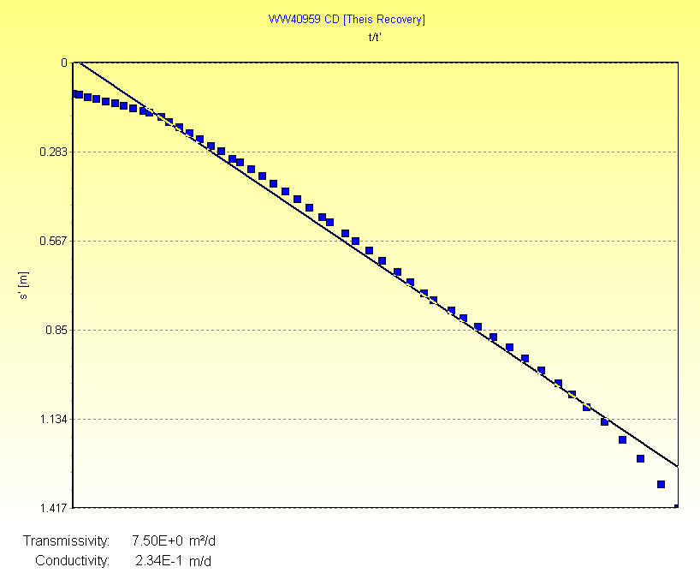
Figure 7: Evaluation of aquifer parameters for recovery phase of CD test of borehole WW40959 using the Theis Recovery Method.

Interpretation of Results
The time-drawdown curve clearly shows boundary effects, which set in at about 100 minutes after start of the test. However, evaluation of the boundary effect is difficult because no measurements at an observation borehole are available.
Transmissivity was therefore evaluated using the Theis recovery method as 7.5 m²/d. The combined saturated screened and open section of the well is 32 m long, so that the hydraulic conductivity of the aquifer is around 0.23 m/d. The saturated screened section can therefore be characterized as a moderate aquifer.

Test Pumping WW40960

Step Test WW40960
Table 4: Test characteristics of step test at WW40960.
Pumped Well | WW40960 Boomplaas - Kalahari |  | Step n | Q_{n} [m³/h] | s_{n} [m]
Start of Test | 25-Nov-04 12:12:49 |  | 1 | 0.25 | 0.95
Start of Recovery | 25-Nov-04 16:07:19 |  | 2 | 0.43 | 2.89
Duration of Test [h] | 3.91 |  | 3 | 0.59 | 5.21
Duration of Recovery [h] | 15.4 |  | 4
RWL [m] | 36.05 |  | 5
Residual Drawdown [m] | 2.83
Figure 8: Time-Drawdown curve of step test of borehole WW40960.
Figure 9: Time-Yield curve of step test of borehole WW40960.

Figure 10: Well Loss graph of step test of borehole WW40960.
Figure 11: Well Efficiency graph of step test of borehole WW40960.

Interpretation of results
No steady-state condition was reached during the last step. Well efficiencies are rather low. At a well efficiency of 60 % the maximum recommended well yield would be 0.2 m³/h. This would result in a drawdown of approximately 1.0 m.

Constant Discharge Test WW40960
Table 5: Test characteristics of step test at WW40960
Pumped Well | WW40960 Boomplaas - Kalahari |  | Yield (m³/h)
Start of Test | 26-Nov-04 07:33:33 |  | 0.55
Start of Recovery | 27-Nov-04 08:38:24
Duration of Test [h] | 25.08
Duration of Recovery [h] | 23.6
RWL [m] | 35.98
Residual Drawdown [m] | -0.01
Figure 12: Time-Drawdown curve of CD test of borehole WW40960.
Figure 13: Time-Drawdown curve of CD test of borehole WW40960 (lin-log).
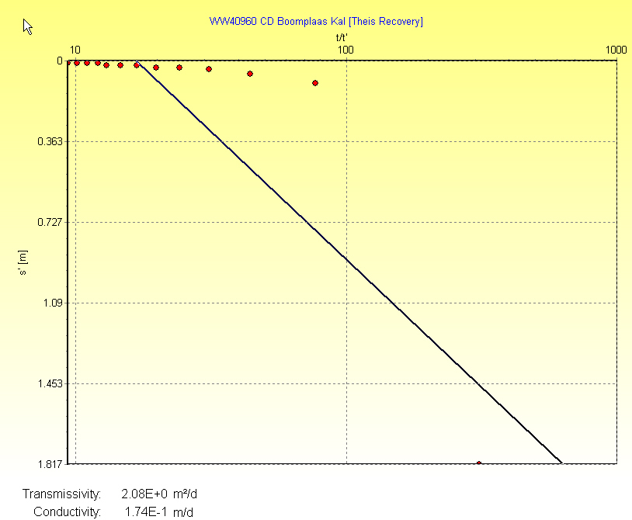
Figure 14: Evaluation of aquifer parameters for recovery phase of CD test of borehole WW40960 using the Theis Recovery Method.

Interpretation of Results
Transmissivity was evaluated using the Theis recovery method as 2.08 m²/d. The combined saturated screened and open section of the well is 12 m long, so that the hydraulic conductivity of the aquifer is around 0.17 m/d. The saturated screened section can therefore be characterized as a moderate aquifer.

Test Pumping WW40961

Step Test WW40961
Table 6: Test characteristics of step test at WW40961.
Pumped Well | WW40961 Boomplaas - Auob |  | Step n | Q_{n} [m³/h] | s_{n} [m]
Start of Test | 22-Nov-04 13:40:33 |  | 1 | 11.73 | 11.30
Start of Recovery | 22-Nov-04 18:42:48 |  | 2 | 14.56 | 13.77
Duration of Test [h] | 5.04 |  | 3 | 16.46 | 19.26
Duration of Recovery [h] | 12.8 |  | 4 | 22.58 | 22.44
RWL [m] | 9.42 |  | 5 | 32.76 | 32.22
Residual Drawdown [m] | 11.68
Figure 15: Time-Drawdown curve of step test of borehole WW40961.
Figure 16: Time-Yield curve of step test of borehole WW40961.
Figure 17: Well Loss graph of step test of borehole WW40961.
Figure 18: Well Efficiency graph of step test of borehole WW40961.

Interpretation of results
The five steps performed at well WW40961 show that well losses are mainly linear. Overall well efficiencies are rather high. Using an acceptable well efficiency of 90 %, the maximum yield would be 20 m³/h. This would result in a drawdown of approximately 20 m.

Constant Discharge Test WW40961
Table 7: Test characteristics of step test at WW40961
Pumped Well | WW40961 Boomplaas - Auob |  | Yield (m³/h)
Start of Test | 23-Nov-04 07:30:33 |  | 24.26
Start of Recovery | 24-Nov-04 08:28:28
Duration of Test [h] | 24.97
Duration of Recovery [h] | 96.0
RWL [m] | 9.56
Residual Drawdown [m] | -0.17
Figure 18: Time-Drawdown curve of CD test of borehole WW40961.
Figure 19: Time-Drawdown curve of CD test of borehole WW40961 (lin-log).
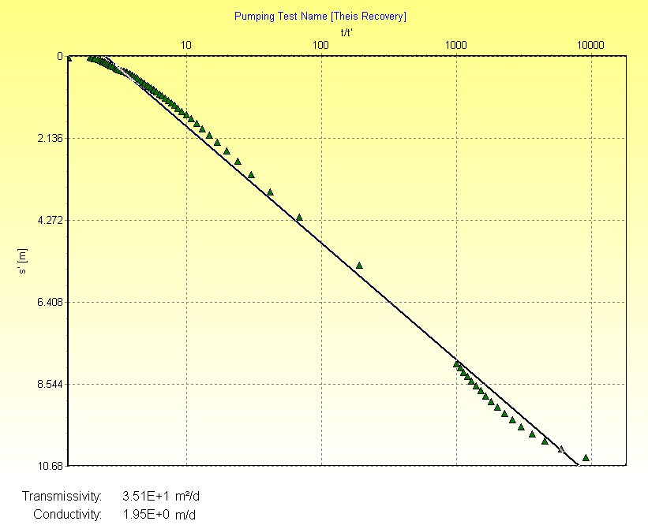
Figure 20: Evaluation of aquifer parameters for recovery phase of CD test of borehole WW40961 using the Theis Recovery Method.

Interpretation of Results
Transmissivity was evaluated using the Theis recovery method as 35.1 m²/d. The combined saturated screened and open section of the well is 18 m long, so that the hydraulic conductivity of the aquifer is around 1.95 m/d. The saturated screened section can therefore be characterized as a good aquifer.

Test Pumping WW40962

Step Test WW40962
Table 8: Test characteristics of step test at WW40962.
Pumped Well | WW40962 Muritz - Auob |  | Step n | Q_{n} [m³/h] | s_{n} [m]
Start of Test | 10-Dec-04 15:42:15 |  | 1 | 26.08 | 1.26
Start of Recovery | 10-Dec-04 20:24:00 |  | 2 | 28.16 | 1.54
Duration of Test [h] | 4.70 |  | 3 | 33.71 | 1.94
Duration of Recovery [h] | 9.8 |  | 4 | 39.82 | 2.43
RWL [m] | 23.73 |  | 5 | 49.39 | 1.72
Residual Drawdown [m] | 0.09
Figure 21: Time-Drawdown curve of step test of borehole WW40962.
Figure 22: Time-Yield curve of step test of borehole WW40962.

Figure 23: Well Loss graph of step test of borehole WW40962.
Figure 24: Well Efficiency graph of step test of borehole WW40962.

Interpretation of results
The five steps performed at well WW40962 show that well losses are mainly linear. Overall well efficiencies are rather high. Using an acceptable well efficiency of 90 %, the maximum yield would be 10 m³/h. This would result in a drawdown of approximately 0.50 m.

Constant Discharge Test WW40962
Table 9: Test characteristics of step test at WW40962
Pumped Well | WW40962 Muritz - Auob |  | Yield (m³/h)
Start of Test | 11-Dec-04 09:29:55 |  | 51.53
Start of Recovery | 12-Dec-04 10:05:55
Duration of Test [h] | 24.60
Duration of Recovery [h] | 23.1
RWL [m] | 23.87
Residual Drawdown [m] | 2.26
Figure 25: Time-Drawdown curve of CD test of borehole WW40962.
Figure 26: Time-Drawdown curve of CD test of borehole WW40962 (lin-log).

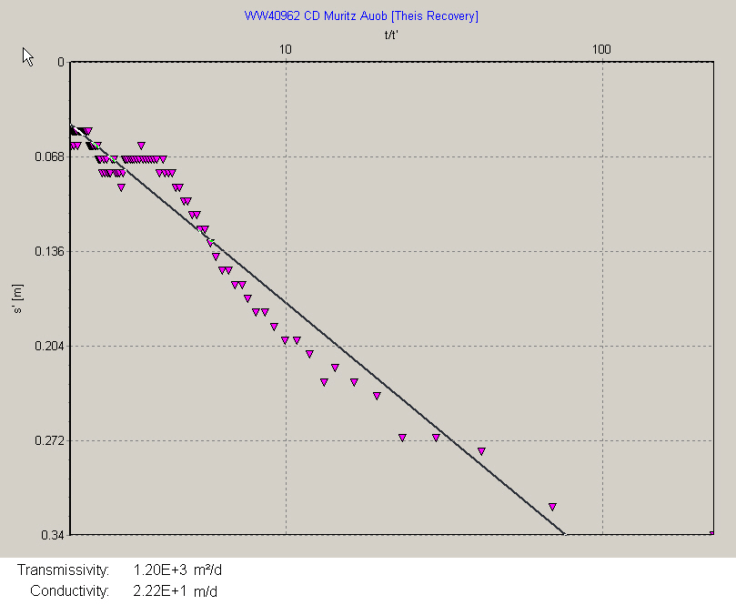
Figure 27: Evaluation of aquifer parameters for recovery phase of CD test of borehole WW40962 using the Theis Recovery Method.

Interpretation of Results
Transmissivity was evaluated using the Theis recovery method as 1200 m²/d. The combined saturated screened and open section of the well is 54 m long, so that the hydraulic conductivity of the aquifer is around 22.2 m/d. The saturated screened section can therefore be characterized as a very good aquifer.

Test Pumping WW40963

Step Test WW40963
Table 10: Test characteristics of step test at WW40960.
Pumped Well | WW40963 Muritz - Kalahari |  | Step n | Q_{n} [m³/h] | s_{n} [m]
Start of Test | 07-Dec-04 13:29:18 |  | 1 | 6.13 | 13.66
Start of Recovery | 07-Dec-04 18:35:08 |  | 2 | 8.11 | 18.86
Duration of Test [h] | 5.10 |  | 3 | 10.16 | 24.19
Duration of Recovery [h] | 13.2 |  | 4 | 12.70 | 34.80
RWL [m] | 7.11 |  | 5 | 13.60 | 45.13
Residual Drawdown [m] | 0.09
Figure 28: Time-Drawdown curve of step test of borehole WW40963.
Figure 29: Time-Yield curve of step test of borehole WW40963.
Figure 30: Well Loss graph of step test of borehole WW40963.
Figure 31: Well Efficiency graph of step test of borehole WW40963.

Interpretation of results
No steady-state condition was reached during the last two steps. Well efficiencies are rather low. At a well efficiency of 70 % the maximum recommended well yield would be 5 m³/h. This would result in a drawdown of approximately 10 m.

Constant Discharge Test WW40963
Table 11: Test characteristics of step test at WW40963
Start of Test | 08-Dec-04 07:49:18 |  | Yield (m³/h)
Start of Recovery | 09-Dec-04 08:58:43 |  | 10.89
Duration of Test [h] | 25.16
Duration of Recovery [h] | 19.6
RWL [m] | 7.20
Residual Drawdown [m] | 0.04
Start of Test | 08-Dec-04 07:49:18
Figure 32: Time-Drawdown curve of CD test of borehole WW40963.
Figure 33: Time-Drawdown curve of CD test of borehole WW40963 (lin-log).

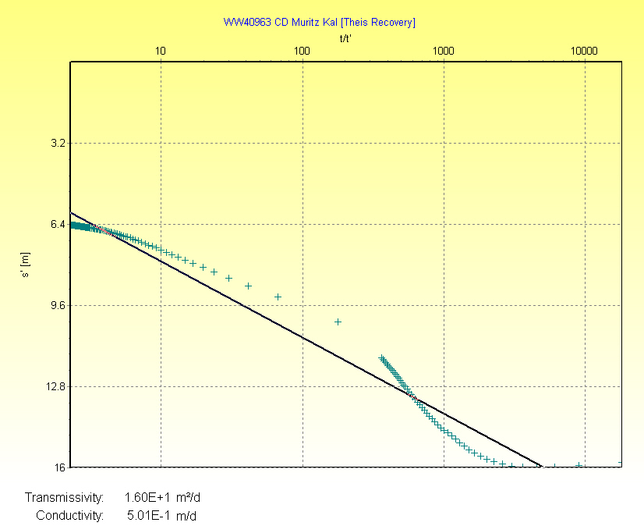
Figure 34: Evaluation of aquifer parameters for recovery phase of CD test of borehole WW40963 using the Theis Recovery Method.

Interpretation of Results
Transmissivity was evaluated using the Theis recovery method as 16 m²/d. The combined saturated screened and open section of the well is 32 m long, so that the hydraulic conductivity of the aquifer is around 0.50 m/d. The saturated screened section can therefore be characterized as a moderate aquifer.

Test Pumping WW40964

Step Test WW40964
Table 12: Test characteristics of step test at WW40964.
Pumped Well | WW40964 Sandverhaar Auob |  | Step n | Q_{n} [m³/h] | s_{n} [m]
Start of Test | 15-Jul-05 17:31:25 |  | 1 | 33.0 | 6.35
Start of Recovery | 15-Jul-05 22:32:15 |  | 2 | 48.0 | 10.44
Duration of Test [h] | 5.01 |  | 3 | 62.0 | 12.93
Duration of Recovery [h] | 13.2 |  | 4 | 71.0 | 14.25
RWL [m] | 63.66 |  | 5 | 73.0 | 14.89
Residual Drawdown [m] | 0.12
Figure 38: Time-Drawdown curve of step test of borehole WW40964.
Figure 39: Time-Yield curve of step test of borehole WW40964.
Figure 40: Well Loss graph of step test of borehole WW40964.
Figure 41: Well Efficiency graph of step test of borehole WW40964.

Interpretation of results
The five steps performed at well WW40964 show that well losses are mainly linear. Overall well efficiencies are rather high. Using an acceptable well efficiency of 90 %, the maximum yield would be 180 m³/h. This would result in a drawdown of approximately 40 m.

Constant Discharge Test WW40964
Table 13: Test characteristics of step test at WW40964
Pumped Well | WW40964 Sandverhaar - Auob |  | Yield (m³/h)
Start of Test | 16-Jul-05 11:46:15 |  | 51.53
Start of Recovery | 17-Jul-05 12:04:05
Duration of Test [h] | 24.30
Duration of Recovery [h] | 44.3
RWL [m] | 63.78
Residual Drawdown [m] | 0.03
Figure 42: Time-Drawdown curve of CD test of borehole WW40964.
Figure 43: Time-Drawdown curve of CD test of borehole WW40964 (lin-log).
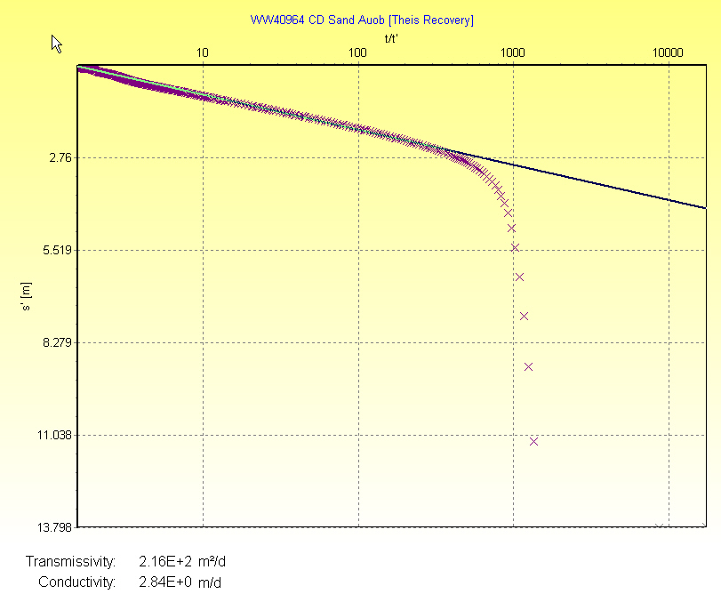
Figure 44: Evaluation of aquifer parameters for recovery phase of CD test of borehole WW40964 using the Theis Recovery Method.

Interpretation of Results
Transmissivity was evaluated using the Theis recovery method as 216 m²/d. The combined saturated screened and open section of the well is 76 m long, so that the hydraulic conductivity of the aquifer is around 2.84 m/d. The saturated screened section can therefore be characterized as a very good aquifer.

Test Pumping WW40965

Slug Test WW40965
Table 14: Test characteristics of step test at WW40965
Pumped Well | WW40963 Sandverhaar - Kalahari
Start of Test | 12-Apr-05 20:24:05
Start of Recovery | 20-Apr-05 23:04:05
Duration of Test [h] | 194.67
Duration of Recovery [h] | 81.2
RWL [m] | 49.92
Residual Drawdown [m] | 0.07
Figure 45: Time-Drawdown curve of CD test of borehole WW40965.
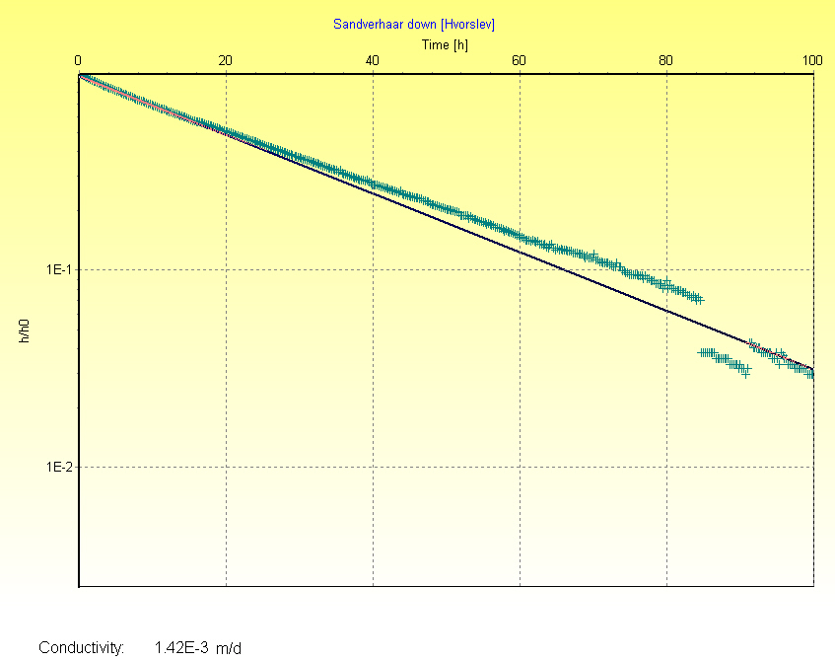
Figure 46: Time-Drawdown curve of CD test of borehole WW40965 (lin-log).
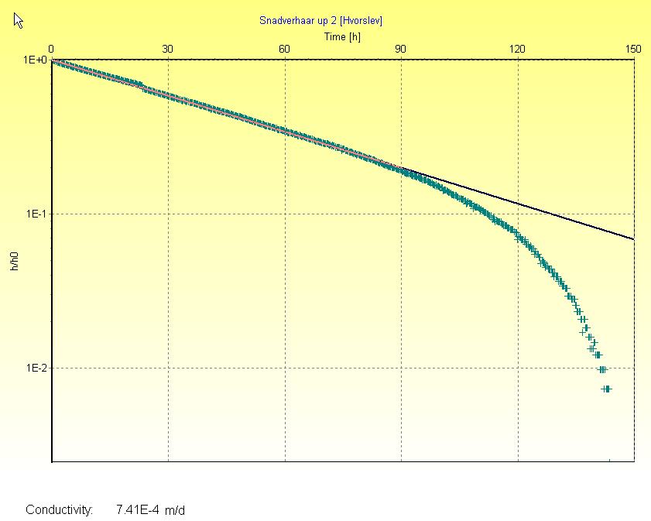
Figure 47: Evaluation of aquifer parameters for recovery phase of CD test of borehole WW40965 using the Theis Recovery Method.

Interpretation of Results
Transmissivity was evaluated using the Hvorslev recovery method as 0.01 m²/d. The combined saturated screened and open section of the well is 10 m long, so that the hydraulic conductivity of the aquifer is around 0.001 m/d. The saturated screened section can therefore be characterized as a very poor aquifer.

