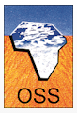
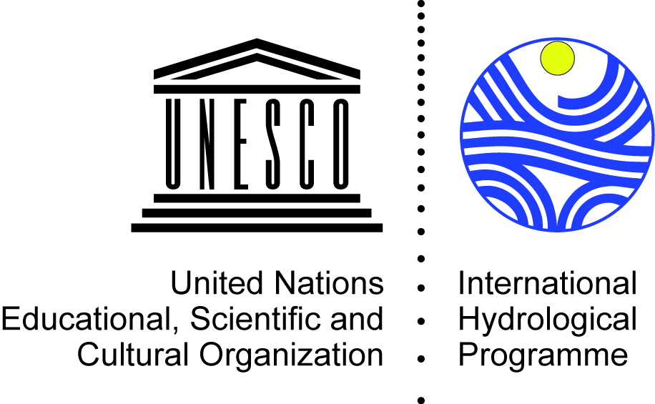
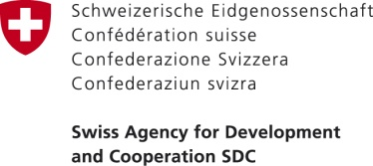

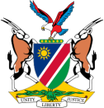
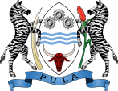
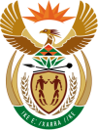

Assessment of potential collaboration between the STAS Countries, ORASECOM and OSS

5-8 September 2017
Observatory of the Sahara and the Sahel (OSS), Tunis, Tunisia

- INFORMATION NOTE –

- Background:

As a result of the Governance of Groundwater Resources in Transboundary Aquifers (GGRETA) Phase 2 project – Stampriet Transboundary Aquifer System (STAS) High Level Meeting (3-4 November 2016, Paris, France) and High Level Consultation Meetings (27 March 2017, Windhoek, Namibia; 30 March 2017, Gaborone, Botswana; 03 April 2017, Pretoria, South Africa), the Governments of Botswana, Namibia and South Africa have expressed their interest on learning from the experience of Tunisia, Algeria and Libya in institutionalizing cooperation over the North-Western Sahara Aquifer System (NWSAS).

On 17-18 May 2017, Members of the Botswana, Namibia and South Africa Delegation attending the 3rd Orange-Senqu River Commission (ORASECOM) Ground Water Hydrology Committee (GWHC) and the Technical Task Team (TTT), supported the proposal made by Namibia to nest the STAS Multi-Country Cooperation Mechanism (MCCM) in ORASECOM. This decision was then taken for discussion at the ORASECOM Council meeting held on 17-18 August 2017 that also supported this initiative.

Considering these new advancements, the Regional Meeting on Transboundary Aquifers Cooperation in Africa was organized by UNESCO International Hydrological Programme (IHP) and the Sahara and Sahel Observatory (OSS) on 5-8 September 2017 in Tunis, Tunisia with the main objective to share experiences in institutionalizing cooperation for the governance of transboundary aquifers and evaluating potential collaboration between the STAS Countries, ORASECOM and OSS.

- The NWSAS Consultation Mechanism (CM)

  - Background

The North Western Sahara Aquifer System (NWSAS), also referred as the Système Aquifère du Sahara Septentrional (SASS), is a large aquifer covering an area of more than one million square kilometers over Algeria (60%), Libya (25%), and Tunisia (15%). It is the one of the major North African transboundary groundwater basins and is the main source of water supply for domestic, agricultural and industrial activities of more than 4 million people.

The NWSAS has important water reserves (~40,000 km³) which are, however, mostly non-renewable and not fully exploitable. The use of the aquifer system dates back to many years, first through surface wells and “foggaras” (ancient type of water supply) and later through deeper “foggaras” that exceeded in certain cases one thousand meters. During the second half of the 20th century, the intensive use of the NWSAS water led to a significant increase of water demand (0.3 billion m³ per year in 1950s to 2 billion in 1990s) due to a lack of communication and consultation among the three riparian countries on the main risks of overuse and mismanagement of the NWSAS water resources.

Against this background, the NWSAS project (led by the Sahara and Sahel Observatory – OSS and funded by the Global Environment Facility – GEF) was launched in 1999 aimed at improving the knowledge of the dynamics of the aquifer system as a means to create favorable conditions for the joint-management of the NWSAS. The first phase of the project (1999 to 2002) saw technical teams from the three NWSAS countries working together on developing and applying common tools, establishing monitoring and observation networks, analyzing and validating data including the creation of common indicators. As a result, a joint borehole database and a mathematical model allowing simulations and estimations were elaborated. In 2002, the three countries reaffirmed their commitment to the principle of consultation over NWSAS by signing a declaration which calls for joint research, data sharing, effective modelling, common indicators, action plans for critical zones, as well as capacity building. This resulted in the establishment of a consultation mechanism that was consolidated and operationalized during the second phase of the project (2003-2006). During Phase 3 (2007-2013) socio-economic factors were embedded into its scope through the elaboration of operational recommendations for the utilization, management, and measurement of water extracted for agricultural purposes, notably in the zones where the water, the soil and/or the ecosystem are most vulnerable.

  - OSS

The Sahara and Sahel Observatory (OSS) is an international, intergovernmental organization operating in Africa’s Sahara-Sahel region. OSS was founded in 1992 in Paris and moved its headquarters to Tunis (Tunisia) in 2000. OSS members include 22 African countries, six non-regional countries, ten organizations (including sub-regional organizations representing West Africa, East Africa and North Africa), and a non-governmental organization.

OSS works with its member countries according to the principle of subsidiarity. It acts as both an initiator and a facilitator of partnerships to address common environmental challenges. The management of transboundary water resources and the implementation of Multilateral Environmental Agreements, notably those addressing desertification, biodiversity and climate change, constitute key areas in the organization’s work.
The OSS Water Program is structured around 4 main themes:
- improved knowledge on large transboundary aquifers (focusing on qualitative and quantitative aspects, on surface water-groundwater exchanges, and on the impacts of climate change),
- support for the implementation of Integrated Water Resources Management (IWRM) principles (e.g. databases, GIS, mathematical models, awareness raising, etc…),
- support for the establishment of consultation mechanisms,
- capacity-building.

OSS water activities have focused on the NWSAS, the Iullemeden Taoudeni/Tanezrouft Aquifer System (ITTAS), the IGAD and North African regions. The OSS currently hosts the NWSAS Consultation Mechanism (CM) Coordination Unit (CU).

  - Core tasks, structure, legal and funding arrangements of the NWSAS CM

    - Objectives and functions of the NWSAS CM

The overall goal of the NWSAS CM is to “enhance the means and the capacity in the countries to produce decision-making tools in view of ensuring jointly the sustainable management of the shared water resources of the NWSAS, in a spirit of equity” and to “consolidate the results of the NWSAS project, mainly in terms of cooperation”. The main objectives of the NWSAS CM are:
- Production of indicators on the resource and water demand,
- Elaboration of management scenarios,
- Enhancement and updating the database,
- Development and management of joint monitoring networks.

A non-exhaustive list of other missions of the NWSAS CM are to:
- Undertake joint studies and research,
- Define exchange of data protocols,
- Update the model and develop their utilization,
- Ensure the application of monitoring indicators,
- Identify risk and vulnerable zones,
- Organize trainings, information and raising awareness actions,
- Publish an annual report of the state of the NWSAS.

    - Structure of the NWSAS CM

The permanent structure at technical and political level was defined and approved in 2007 as indicated in Figure 1. The NWSAS CM is hosted by OSS and is composed by:
- Minister’s Council: in charge of taking the necessary political decisions for the joint and concerted management of the NWSAS,
- Permanent Technical Committee (PTC): composed by Water Director Generals and is in charge of approving the annual activities and budget of the CM, as well as of providing overall supervision of work activities.
- Coordination Unit (CU): hosted by OSS and composed by the NWSAS CM Coordinator. The CU currently runs with an annual budget of 90 000 EUR (30 000 EUR per country) and is in charge of preparing and executing the work program according to the planning and annual budget.
- National Committees: composed by water stakeholders (e.g. water managers, water suppliers, academia, etc…) and are in charge of assisting and feeding the PTC and CU with information for the development of scenarios and project activities.
- Ad hoc Working Groups (AWG): composed by experts nominated by the PTC and are formed when necessary for the evaluation of studies, or to support the PTC in design of projects.

OSS hosts the NWSAS CM CU and provides overall support to the implementation of the CM activities through its Water Program staff activities (e.g. database, GIS, modelling and training).

    - The NWSAS CM Coordination Unit

The Coordination Unit (CU) is the backbone of the NWSAS CM. The CU is hosted by OSS and has been operational since 2008. It is composed by one NWSAS CM Coordinator that is elected on a rotation basis every two years. The CU currently runs with an annual budget of 90 000 EUR (30 000 EUR per country) and is in charge of preparing and executing the work program according to the planning and annual budget. The CU reports on indicators of the status of water resources (e.g. quantity, quality and sustainability of the resource) and provides recommendations on:
- Strategy for sustainable use of the resource,
- Consideration of economic and environmental aspects in activities,
- Establish the national committees,
- Consolidate monitoring networks,
- Update the NWSAS numerical model to integrate hydro-chemistry.

The CU also acts as a decision-support tool by:
- Ensuring knowledge exchange and cooperation among stakeholders,
- Organizing periodic meeting for policy makers in order to identify major transboundary problems disturbing the NWSAS water cycle, formulating proposals and solutions to address these problems while highlighting the importance and advantages of a close cooperation between the three countries, and formalizing consensus and agreements between countries.
- Coordinating national and regional stakeholder groups involved in the NWSAS,
- Conduct campaigns to raise awareness of policy makers at different levels, “vulgarize” (disseminate) information, ensure communication, and promote the participatory approach.

Figure 1: Structure of the NWSAS Consultation Mechanism (CM)
Hierarchical relation Functional relation
NATIONAL COMMITTEES
Algeria
Libya
MINISTER’S COUNCIL
IN CHARGE OF NWSAS WATER
(Algeria, Libya, Tunisia)
COORDINATION UNIT (CU) OF THE CONSULTATION MECHANISM
AD HOC WORKING GROUPS
(AWG)
PERMANENT TECHNICAL COMMITTEE (PTC)
- ANRH (Algeria)
- DGRE (Tunisia)
-GWA (Libya)
Tunisia

- The STAS Multi-Country Cooperation Mechanism (MCCM)

  - Background

Within the framework of the “Governance of Groundwater Resources in Transboundary Aquifers” (GGRETA) project, funded by the Swiss Agency for Development and Cooperation (SDC), the Governments of Botswana, Namibia and South Africa, jointly with the UNESCO International Hydrological Programme (UNESCO-IHP) are undertaking an assessment of the Stampriet Transboundary Aquifer System (STAS). The importance of the STAS to the region draws from the fact that it is the only permanent and dependable water resource in the area, which covers 87,000 km² from Central Namibia into Western Botswana and South Africa’s Northern Cape Province.

The first phase of the project (2013-2015) focused on an in-depth assessment of the STAS which allowed establishing a shared science based understanding of the resource. The assessment has been carried out by a team familiar to the area and composed of professionals of Botswana, Namibia and South Africa. Apart from collecting and studying relevant literature for assessment and diagnostics, the team has spent much attention to compiling basic data and to GIS mapping. In total, a joint borehole database and more than 40 thematic maps (e.g. rainfall, temperature, conceptual model, groundwater quality, etc…) were elaborated. The activities of the second phase of the project (2016-2018) focus on consolidating the technical results achieved and the tools developed in the first phase, and on strengthening capacity on groundwater governance at the national and transboundary levels in order to support the process of establishment of a Multi-Country Cooperation Mechanism (MCCM). The over-arching objective of the STAS MCCM is to transition from GGRETA project-driven cooperation in the study and characterization of STAS to institutionalized cooperation among the STAS countries, beyond the life of the project.

On 17-18 August 2017, the Commissioners attending the ORASECOM Council Meeting supported the proposal made by Namibia to nest the STAS MCCM in ORASECOM structure. The establishment of the STAS MCCM will be the first example of a mechanism for the management and governance of a transboundary aquifer in Southern Africa.

  - ORASECOM

The Orange-Senqu River Commission (ORASECOM) was established in 2000 through the "Agreement for the Establishment of the Orange-Senqu Commission" by the Governments of Botswana, Lesotho, Namibia and South Africa to promote the equitable and sustainable development of the resources of the Orange-Senqu River, and to provide a forum for consultation and coordination between the riparian states to support integrated water resources management (IWRM) and development in the basin.

The goals of ORASECOM are to:
1. develop a comprehensive perspective of the basin
2. study the present and planned future uses of the river system
3. determine the requirements for flow monitoring and flood management.

The roles and functions of ORASECOM are changing from planning to implementation of actions as part of the on-going 10-year (2015-2024) IWRM Plan for the Basin. The Plan is an expression of optimal use of all water resources (including groundwater) through joint actions of all 4 Member States.

The importance of groundwater has been given due consideration in the Plan through primary Action Area 1.2 (Optimising efficient development and adaptive management of water resources) and secondary Action Area 1.1 (surface and groundwater assessments). The ORASECOM Agreement is also being reviewed in order to expand the Commission’s mandate to initiate, enhance, and maintain greater collaboration between the Parties on matters relating groundwater management and use.
The implementation of activities related to the STAS is part of the Action Area 1.1 (Surface and groundwater assessments), Strategic Action 1.1.2 (Improve assessments of aquifers: storage capacities, recharge rates, sustainable yields and other characteristics), Specific Action: detailed assessment of the STAS.

The ORASECOM structure is presented in Figure 2. Ministers meet once every year to direct the Commission and review overall programme of work. Senior Officials meet once every year to consider the Commission work programme, budget and prepare submission to Ministers. The Council (Director General level) meets twice a year to review and discuss progress on programme of work and budget; discuss bilateral cooperation projects; and exchange information on national development projects of transboundary significance. The Task Teams (including the Ground Water Hydrology Committee - GWHC) meet at least twice a year to discuss respective activities of the Commission and prepare technical updates for the Council. Committees report directly to Task Teams, not to Council. The Secretariat oversees implementation of the Commission’s work programme and is the corporate arm of the Commission. The Secretariat core staff currently comprises Executive Secretary, Water Resources Specialist, Finance and Administration, Administration Assistant. ORASECOM preojects are currently delivered through consultancies and medium/short term specialists at Secretariat.

ORASECOM’s annual budget is USD 160 000 USD (USD 40 000 per country), and also runs on funds from donors for projects implementation.

  - Core tasks, structure, legal and funding arrangements of the STAS MCCM

    - Objectives and functions of the STAS MCCM

The over-arching objective of a STAS MCCM is to transition from GGRETA project-driven cooperation to permanent institutionalized cooperation among the countries sharing the STAS.

In the short term, the STAS MCCM will continue the joint study and characterization of STAS, and generate flow of data feeding the STAS borehole database and numerical model (once operational), and report on activities at each meeting of the Ground Water Hydrology Committee (GWHC) – Technical Task Team (TTT) – Council – Forum of Parties. In the long term, the vision is to move from data collection & exchange to joint strategizing/advising STAS countries on management of the aquifer and its resources.

The future functions of the STAS MCCM will be to:
- Collect and exchange aquifer and aquifer-related data,
- Develop and maintain the STAS joint borehole database and numerical model,
- Manage the data flow feeding the STAS joint borehole database and numerical model,
- Set-up the framework and workplan for joint monitoring activities,
- Promote and incorporate the STAS on the agenda of ORASECOM,
- Attract donor interest and eventually funding for STAS-related activities,
- Liaise and coordinate joint activities with the SADC Groundwater Management Institute,
- Attend any other matters that may arise or decided upon by Country Representatives.
    - Structure of the STAS MCCM

The STAS MCCM aims at integrating the national GGRETA project support structure in the Ground Water Hydrology Committee (GWHC), which operates under the Technical Task Team established by the ORASECOM Council.

The GGRETA project hydrogeology/model, legal and institutional, and gender National Focal Points (NFP) in the three countries, will assist and feed the GWHC Members with data collected that will serve as a basis for the development of scenarios and project activities. In the short term, the GWHC Members will be in charge of updating the STAS joint borehole database during GWHC meetings, and to reporting to the Technical Task Team (TTT) on the work program according to the planning and annual budget. The TTT will then report to the Council. Ad hoc Working Groups (AWG) composed by experts nominated by the Council or GWHC will be formed when necessary for the evaluation of studies, or to support the design of projects and activities. Invited Members (e.g. SADC-GMI) would be regularly invited to GWHC meetings.

The structure of the STAS MCCM is presented in Figure 2.
Figure 2: Structure of the STAS Multi-Country Cooperation Mechanism (MCCM)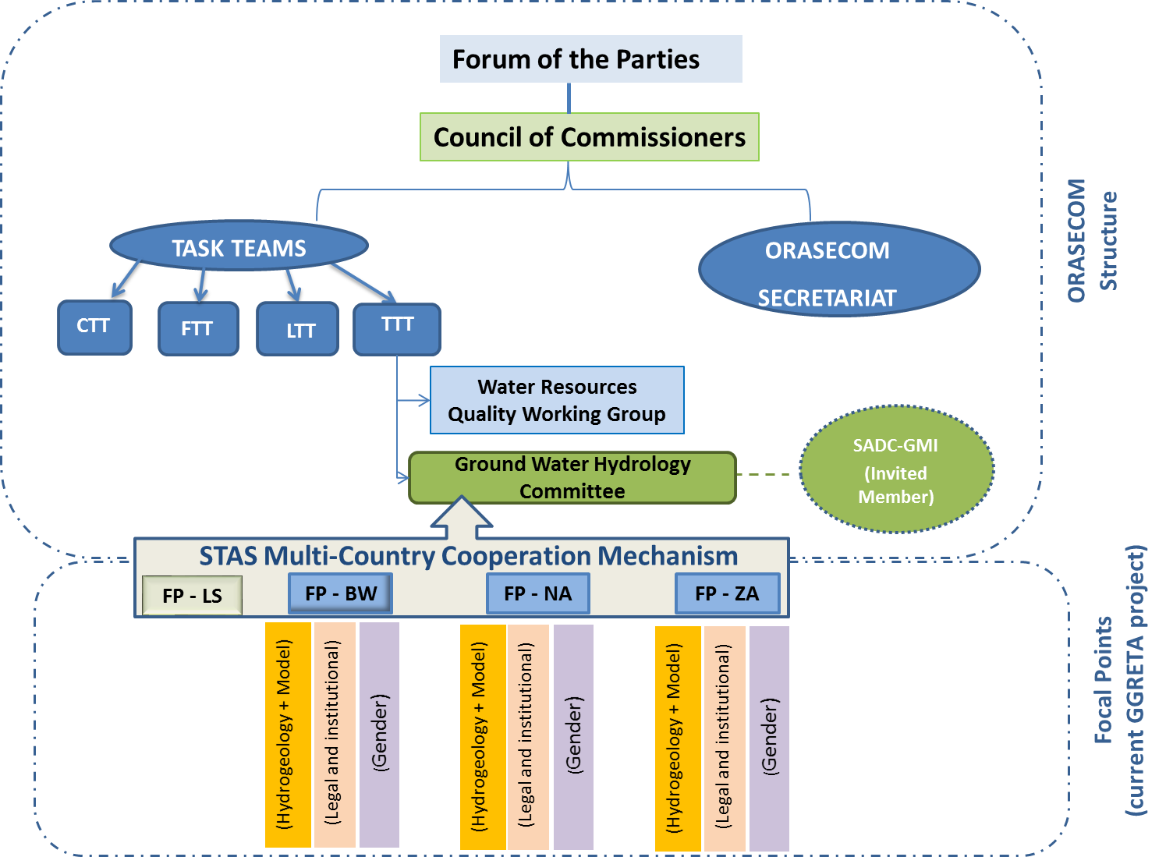

- Comparative analysis of the NWSAS CM and STAS MCCM

Based on the information provided in the previous sections, a comparative analysis of the role of the different bodies of the NWSAS CM and the STAS MCCM bodies is provided in Table 1.

Table 1: Comparative analysis of the NWSAS CM and STAS MCCM
Functions | NWSAS CM | STAS MCCM
Political decisions | Council of Water Ministers  (Ministers level) | Forum of the Parties  (Ministers level)
Approval of budget for CM | Permanent Technical Committee  (Director General level) | Council  (Director General level)
Preparation of work program planning and activities in accordance to budget allocated to CM | Coordination Unit | Ground Water Hydrology Committee (GWHC)
Approval of work program planning and activities | Permanent Technical Committee  (Director General level) | Technical Task Team  (Experts level) followed by Council (Director General level)
Database and model update | Coordination Unit with the assistance of OSS Water Program | Ground Water Hydrology Committee (GWHC) with the assistance of National committees
Data collection and execution of activities | National committees | National committees (currently GGRETA project focal points)
Ad hoc working groups | - Experts nominated by the PTC.  - Formed when necessary for the evaluation of studies, or to support the PTC. | - Experts nominated by the Council.  - Formed when necessary for the evaluation of studies, or to support the GWHC.
Role of host institution | - Hosting the CM Coordination Unit.  - Support for the implementation of the NWSAS CM activities. | - Support for the implementation of the STAS MCCM activities.
Annual budget | 90 000 EUR | Not defined

- Suggestions for potential collaboration between NWSAS CM and STAS MCCM

The comparative analysis of the role and functions of the different bodies of the NWSAS CM and the STAS MCCM presented in Table 1 highlights that there are several similarities between the two mechanisms which gives room for further potential collaboration.

It is suggested to establish a twinning programme between the NWSAS CM and the STAS MCCM. The twinning programme could be taken ahead through a Memorandum of Understading (MoU) between OSS and ORASECOM regarding cooperation, technical assistance, capacity building and information sharing on transboundary aquifers management. The areas of cooperation could include the exchange of knowledge and experience on the following:
- Institutional and organizational development for the operationalization of mechanisms for the governance of transboundary aquifers, including procedures and operations, and participation of key stakeholders such as NGOs and the business community in both operation activities and official meetings,
- Development of data collection and exchange protocols,
- (Technical assistance in the) update of databases and numerical models,
- (Technical assistance in the) development of basin wide management plans for improving stakeholder participation in basin management; infrastructural development; water allocation; pollution control, monitoring and prevention/mitigation; gender and conflict management.

Resources permitting, the scope of the proposed twinning programme could extend to the provision of direct technical assistance in the above matters by OSS/NWSAS CM to the STAS MCCM/ORASECOM GWHC.

In the long-term, the twinning programme could be further strengthened if ORASECOM becomes a Member of OSS.

It should however be noted that the sound implementation of such twinning programme between OSS and ORASECOM poses several challenges, especially in terms of funding. Both organizations have a limited budget and would depend on a first stage on donor funds. In order to attract donor funding, it is thus suggested that within the framework of the GGRETA project, UNESCO-IHP facilitate the organization of donor and partner (e.g. SADC-GMI) meetings that would allow the participation of OSS and ORASECOM Representatives to jointly publicize their activities and cooperation initiatives.

The current NWSAS Coordinator is Mr Rachid Taibi (Algeria)
The GWHC reports directly to the TTT and not to the Council.
ORASECOM’s annual budget is 160 000 USD (40 000 USD per country)

