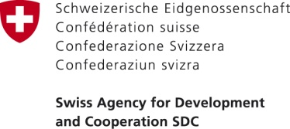
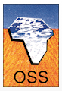
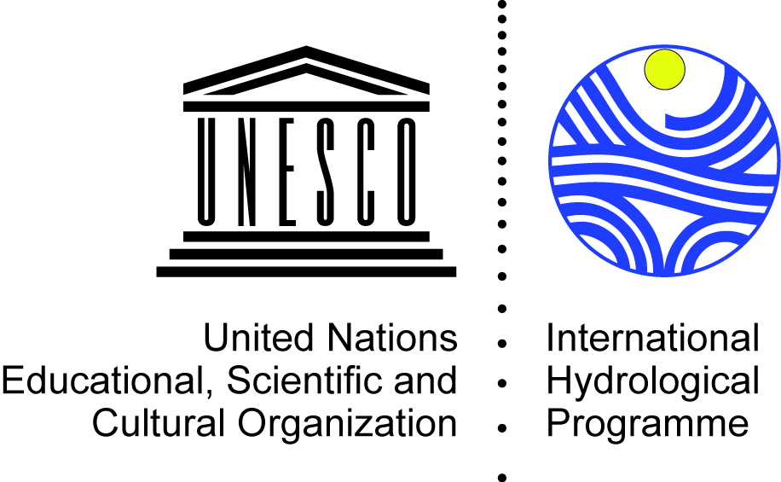

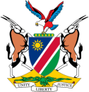
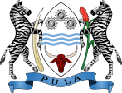
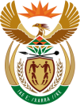

Regional Meeting on Transboundary Aquifers Cooperation in Africa

5-8 September 2017
Observatory of the Sahara and the Sahel (OSS), Tunis, Tunisia

LIST OF PARTICIPANTS

Name | Institution | Email
Mr Maria Amakali | Director: Integrated Water Resources Management, Ministry of Agriculture, Water and Forestry (Namibia) | maria.amakali@mawf.gov.na; gwamakali@gmail.com
Mr Bertram Swartz | Deputy Director: Geohydrology, Department of Water Affairs and Forestry (Namibia) | bertram.swartz@mawf.gov.na
Ms Mercy Mahoto | Hydrogeologist, Department of Water Affairs and Forestry (Namibia) | mercykahundumolefe@gmail.com
Mr Abed Shinana | Hydrogeologist, Namwater (Namibia) | abed.shinana@gmail.com
Mr Pelotshweu Phofuetsile | Deputy Director, Department of Water Affairs (Botswana) | pphofuetsile@gov.bw
Mr Piet Kenabatho | Botswana GGRETA Project National Coordinator, Senior Lecturer, Department of Environmental Science, University of Botswana (Botswana) | KENABATHO@mopipi.ub.bw; pietkenab@hotmail.com
Mr Tebogo Masaka | Senior Lecturer, Department of Environmental Science, University of Botswana (Botswana) | tmasaka@gmail.com
Mr Alfred Petros | Hydrogeologist, Department of Water (Botswana) | apetros@gov.bw
Mr Bochengebu Somolekae | Hydrogeologist, Department of Water (Botswana) | bsomolekae@gov.bw
Mr Dan Mashitisho (TBC) | Director General, Department of Water and Sanitation (South Africa)
Ms Deborah Mochotlhi (TBC) | Deputy Director General, Department of Water and Sanitation (South Africa) | MochotlhiD@dws.gov.za
Mr Kwazikwakhe Majola (TBC) | South Africa GGRETA Project National Coordinator, Senior Hydrogeologist, Department of Water and Sanitation (South Africa) | MajolaK@dws.gov.za
Ms Sivashni Naicker (TBC) | Hydrogeologist, Department of Water and Sanitation (South Africa) | NaickerS@dws.gov.za
Ms Joyce Leshomo | Hydrogeologist, Council for Geoscience (South Africa) | jleshomo@geoscience.org.za
Mr Rapule Pule | Orange-Senqu River Basin Commission (ORASECOM) | Rapule.pule@orasecom.org
Ms Nouha Mimouni | Ministry of Agriculture, Water Resources and Fisheries (Tunisia)
(TBC) | National Agency of Water Resources (Algeria)
(TBC) | Ministry of Water Resources (Libya)
Mr Christian Leduc | IRD, Tunisia | christian.leduc@ird.fr
Mr Stefano Burchi | International Water Law Association (AIDA) | stefano.burchi@gmail.com
Mr Shaminder Puri (TBC) | International Association of Hydrogeologists (IAH) | ShammyPuri@aol.com
Mr Olivier Magnin | Swiss Agency for Development and Cooperation (SDC) | olivier.magnin@eda.admin.ch
Mr Khatim Kerraz | Executive Secretary, Observatory of the Sahara and the Sahel (OSS) | Khatim.kerraz@oss.org.tn
Mr Abdel Kader Dodo | Water Program Coordinator, Observatory of the Sahara and the Sahel (OSS) | abdelkader.dodo@oss.org.tn
Mr Djamel Latrech | Water Expert, Observatory of the Sahara and the Sahel (OSS) | djamel.latrech@oss.org.tn
Mr Rachid Taibi | Coordinator of the North-Western Sahara Aquifer System Consultation Mechanism, Observatory of the Sahara and the Sahel (OSS) | Rachid.taibi@oss.org.tn
Mr Mouhamadou Ould Babasy | Database, GIS and Modelling Manager, Observatory of the Sahara and the Sahel (OSS) | lamine.babasy@oss.org.tn
Ms Sonia Njah | Observatory of the Sahara and the Sahel (OSS) | sonia.njah@oss.org.tn
Ms Wafa Jouini | Observatory of the Sahara and the Sahel (OSS) | wafa.jouini@oss.org.tn
Ms Alice Aureli | UNESCO-IHP | a.aureli@unesco.org
Mr Tales Carvalho Resende | UNESCO-IHP | t.carvalho-resende@unesco.org

