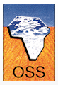
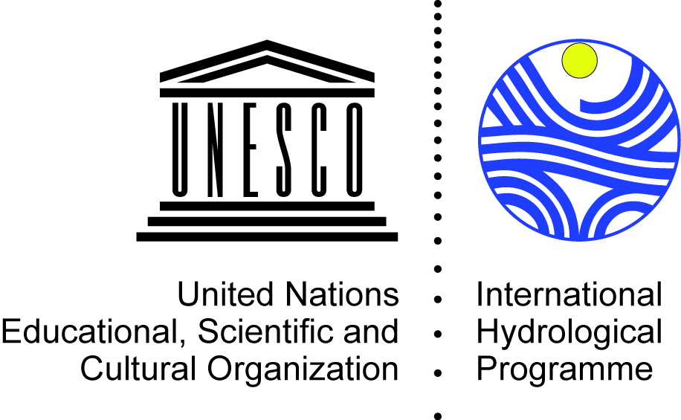
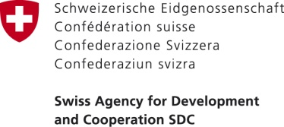

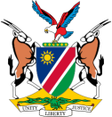
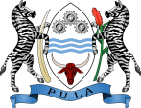
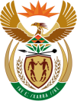

Regional Meeting on Transboundary Aquifers Cooperation in Africa

5-8 September 2017
Observatory of the Sahara and the Sahel (OSS), Tunis, Tunisia

- DRAFT AGENDA –

DAY 1 • Tuesday, 5 September 2017

8:30-9:30 | Registration
9:30 | Opening of the meeting
9:30-10:45 | Statements from National Authorities
- Welcome remarks
  - Mr Khatim Kerraz, Executive Secretary, Sahara and Sahel Observatory (OSS)

  - Ms Alice Aureli, Chief of Section Groundwater Systems, UNESCO-IHP

- Opening Statements
  - Ms Nouha Mimouni, Ministry of Agriculture, Water Resources and Fisheries, Tunisia
  - Representative from Algeria, Ministry of Water Resources, Algeria (TBC)
  - Representative from Libya, General Water Authority, Libya (TBC)
  - Mr Rachid Taibi, Coordinator of the North-Western Sahara Aquifer System Consultation Mechanism (NWSAS MCCM)

- Statements by High-Level Officials from the Ministries in charge of Water Resources Department in the Stampriet Transboundary Aquifer System (STAS)

  - Mr Pelotshweu Phofuetsile, Deputy Director, Department of Water Affairs (Botswana)
  - Ms Maria Amakali, Director, Directorate of Water Resources Management, Ministry of Agriculture, Water and Forestry (Namibia)
  - Mr Dan Mashitisho, Director General, Department of Water and Sanitation (South Africa) (TBC)

- Statements by Donors and Regional Organizations

  - Mr Olivier Magnin, Swiss Agency for Development and Cooperation
  - Mr Rapule Pule, Orange-Senqu River Basin Commission (ORASECOM)

- Introduction of the participants and adoption of the agenda

10:45-11:00 | Coffee break
11:00 – 13:00 | Transboundary Aquifers Cooperation in Africa
- Presentation of the OSS – Experience on transboundary aquifers cooperation
  - Mr Khatim Kerraz, OSS

- UNESCO experience on transboundary aquifers cooperation
  - Mr Tales Carvalho Resende, UNESCO-IHP

- The role of science in decision making in the context of transboundary aquifer cooperation
  - Mr Shaminder Puri, International Association of Hydrogeologists (IAH), Secretary General (TBC)

- Legal norms, agreements, and joint cooperation mechanisms for transboundary aquifers
  - Mr Stefano Burchi, International Water Law Association (AIDA)

- Discussion

13:00-14:30 | Lunch
14:30-15:30 | Presentation of the North-Western Sahara Aquifer System (NWSAS) Consultation Mechanism
- From the knowledge to a joined management of the NWSAS water resources
  - Mr Djamel Latrech, in charge of NWSAS project, OSS

- NWSAS Consultation Mechanism : Institutional Framework
  - Mr Rachid Taibi, Coordinator of the North-Western Sahara Aquifer System Consultation Mechanism

- Discussion

15:30-16:00 | Coffee break
16:30-17:30 | Duplication and adaptation from NWSAS to other aquifers
- Presentation of the Iullemeden-Taoudeni-Tanezrouft Aquifer System (ITTAS): Duplication and Adaptation from NWSAS to others aquifers
  - Mr Abdel Kader Dodo, Water Program Coordinator, OSS

- Discussion

17:30-19:00 | Visit to OSS Secretariat

DAY 2 • Wednesday, 6 September 2017

9:30-11:00 | Towards the establishment of the Stampriet Transboundary Aquifer System (STAS) Multi-Country Consultation Mechanism (MCCM)
- Presentation of the Governance of Groundwater Resources in Transboundary Aquifers (GGRETA) project: main findings and achievements
  - Mr Piet Kenabatho, University of Botswana, STAS Assessment Report Coordinator

- Presentation of the Orange-Senqu River Basin Commission (ORASECOM)
  - Mr Rapule Pule, ORASECOM

- Presentation of the Namibia proposal for the establishment of the STAS MCCM
  - Ms Maria Amakali, Ministry of Water, Agriculture and Forestry, Namibia

11:00-11:30 | Coffee break
11:30-13:00 | Sharing experiences on transboundary aquifers cooperation
 | - Group work exercise on sharing experiences for the future STAS MCCM based on the NWSAS MCCM.
13:00-14:30 | Lunch
14:30-15:30 | Sharing experiences on transboundary aquifers cooperation (ctd.)
- Reactions from Member States
- General discussion and feedback
- Main decisions and way forward
 | Final remarks
  - Mr Khatim Kerraz, Executive Secretary, OSS

  - Ms Alice Aureli, Chief of Section Groundwater Systems, UNESCO-IHP
  - Ms Nouha Mimouni, Ministry of Agriculture, Water Resources and Fisheries, Tunisia
  - Representative from Algeria, Ministry of Water Resources, Algeria (TBC)
  - Representative from Libya, General Water Authority, Libya (TBC)
  - Mr Rachid Taibi, Coordinator of the North-Western Sahara Aquifer System Consultation Mechanism (NWSAS MCCM), OSS
  - Mr Pelotshweu Phofuetsile, Deputy Director, Department of Water Affairs (Botswana)
  - Ms Maria Amakali, Director, Directorate of Water Resources Management, Ministry of Agriculture, Water and Forestry (Namibia)
  - Mr Dan Mashitisho, Director General, Department of Water and Sanitation (South Africa) (TBC)

DAY 3 • Thursday, 7 September 2017

9:30-10:00 | Sharing experiences on groundwater modelling
- Overview of groundwater modelling in a transboundary context
- Mr Tales Carvalho Resende, UNESCO-IHP

- Discussion
10:00-11:00 | Presentation of the baseline for the development of the NWSAS numerical model
- Presentation of the baseline for the development of the NWSAS numerical model:
- Background
- Challenges
- Lessons learnt
- Mr Mouhamadou Ould Babasy, Database, GIS and Modeling Manager, OSS

- Discussion
11:00-11:30 | Coffee break
11:30-12:30 | Presentation of the baseline for the development of groundwater modeling in Northern Africa
- Presentation of the baseline for the development of groundwater modeling in Northern Africa:
- Background
- Challenges
- Lessons learnt
- Mr Christian Leduc, IRD, Tunis

- Discussion
12:30-14:30 | Lunch
14:30-15:30 | Climate change and groundwater modelling
- Impact of climate variability on groundwater resources across Africa
- Mr Tales Carvalho Resende, UNESCO-IHP

15:30-16:00 | Coffee break
16:00-17:00 | Climate change and groundwater modelling (ctd.)
- Consideration of climate variability in groundwater modelling
- Mr Tales Carvalho Resende, UNESCO-IHP

DAY 4 • Friday, 8 September 2017

9:30-11:00 | Groundwater modelling for the STAS: data preparation (ctd.)
- Working group for data preparation

- Discussion

11:00-11:30 | Coffee break
11:30-12:30 | Groundwater modelling for the STAS: data preparation (ctd.)
- Working group for data preparation

- Discussion

12:30-13:00 | Groundwater modelling for the STAS: way forward
- General discussion and feedback

- Main decisions and way forward
13:00-14:00 | Lunch

