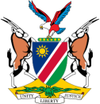
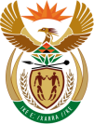
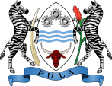
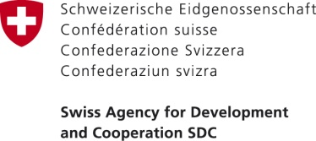
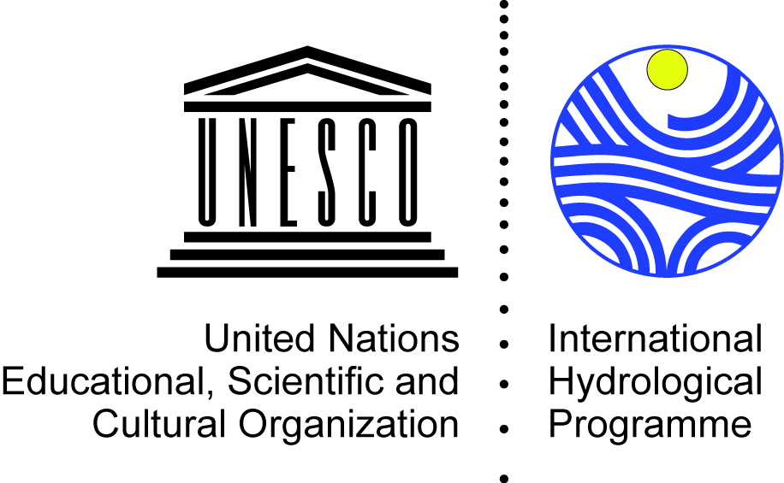

Governance of Groundwater Resources in Transboundary Aquifers (GGRETA Project)
Stampriet Transboundary Aquifer System (STAS)
- Phase 2 -

STAS HIGH LEVEL MEETING (3-4 NOVEMBER 2016)
16 November 2016
UNESCO HQs, Paris, France

MAIN OUTCOMES
Within the framework of the “Governance of Groundwater Resources in Transboundary Aquifers” (GGRETA) project, funded by the Swiss Agency for Development and Cooperation (SDC), the Governments of Botswana, Namibia and South Africa, jointly with the UNESCO International Hydrological Programme (UNESCO-IHP) are undertaking an assessment of the Stampriet Transboundary Aquifer System (STAS). The importance of the STAS to the region draws from the fact that it is the only permanent and dependable water resource in the area, which covers 87,000 sq. km from Central Namibia into Western Botswana and South Africa’s Northern Cape Province.
The first phase of the project (2013-2015) focused on an in-depth assessment of the STAS which allowed establishing a shared science based understanding of the resource. The activities of the second phase of the project (2016-2018) will consolidate the technical results achieved and the tools developed in the first phase, and will strengthen capacity on groundwater governance at the national and transboundary levels in order to support the process of establishment of a multi-country cooperation mechanism (MCCM). The establishment of the STAS MCCM would be the first example of a mechanism for the management and governance of a transboundary aquifer in Southern Africa.
In this regard, the Governments of Botswana, Namibia and South Africa decided at the STAS High Level Meeting (3-4 November 2016, Paris, France) to establish a Working Group for the establishment of the STAS MCCM. It has been agreed that the Working Group will be composed by Representatives from the Ministries in charge of Water Resources and Ministries of Foreign Affairs. The Working Group will have the mandate to formulate the structure, composition, mandate, funding, and functioning of the STAS MCCM. It is expected that this process will be supported by several trainings on groundwater governance at the national and transboundary levels. Countries have agreed that a first training to the Working Group will be held on 28-30 November 2016 in Johannesburg, South Africa.

