ANNEXURE C : MASS PLOTS OF PATCHED RAINFALL DATA

C.1. Mass plot of patched monthly rainfall for 0297436 2
C.2. Mass plot of patched monthly rainfall for 0297612 2
C.3. Mass plot of patched monthly rainfall for 0297825 3
C.4. Mass plot of patched monthly rainfall for 0298194 3
C.5. Mass plot of patched monthly rainfall for 0298244 4
C.6. Mass plot of patched monthly rainfall for 0265875 4
C.7. Mass plot of patched monthly rainfall for 0266001 5
C.8. Mass plot of patched monthly rainfall for 0297082 5
C.9. Mass plot of patched monthly rainfall for 0297388 6
C.10. Mass plot of patched monthly rainfall for 0233775 6
C.11. Mass plot of patched monthly rainfall for 0234150 7
C.12. Mass plot of patched monthly rainfall for 0234170 7
C.13. Mass plot of patched monthly rainfall for 0264417 8
C.14. Mass plot of patched monthly rainfall for 0264715 8
C.15. Mass plot of patched monthly rainfall for 0264836 9

Mass plot of patched monthly rainfall for 0297436
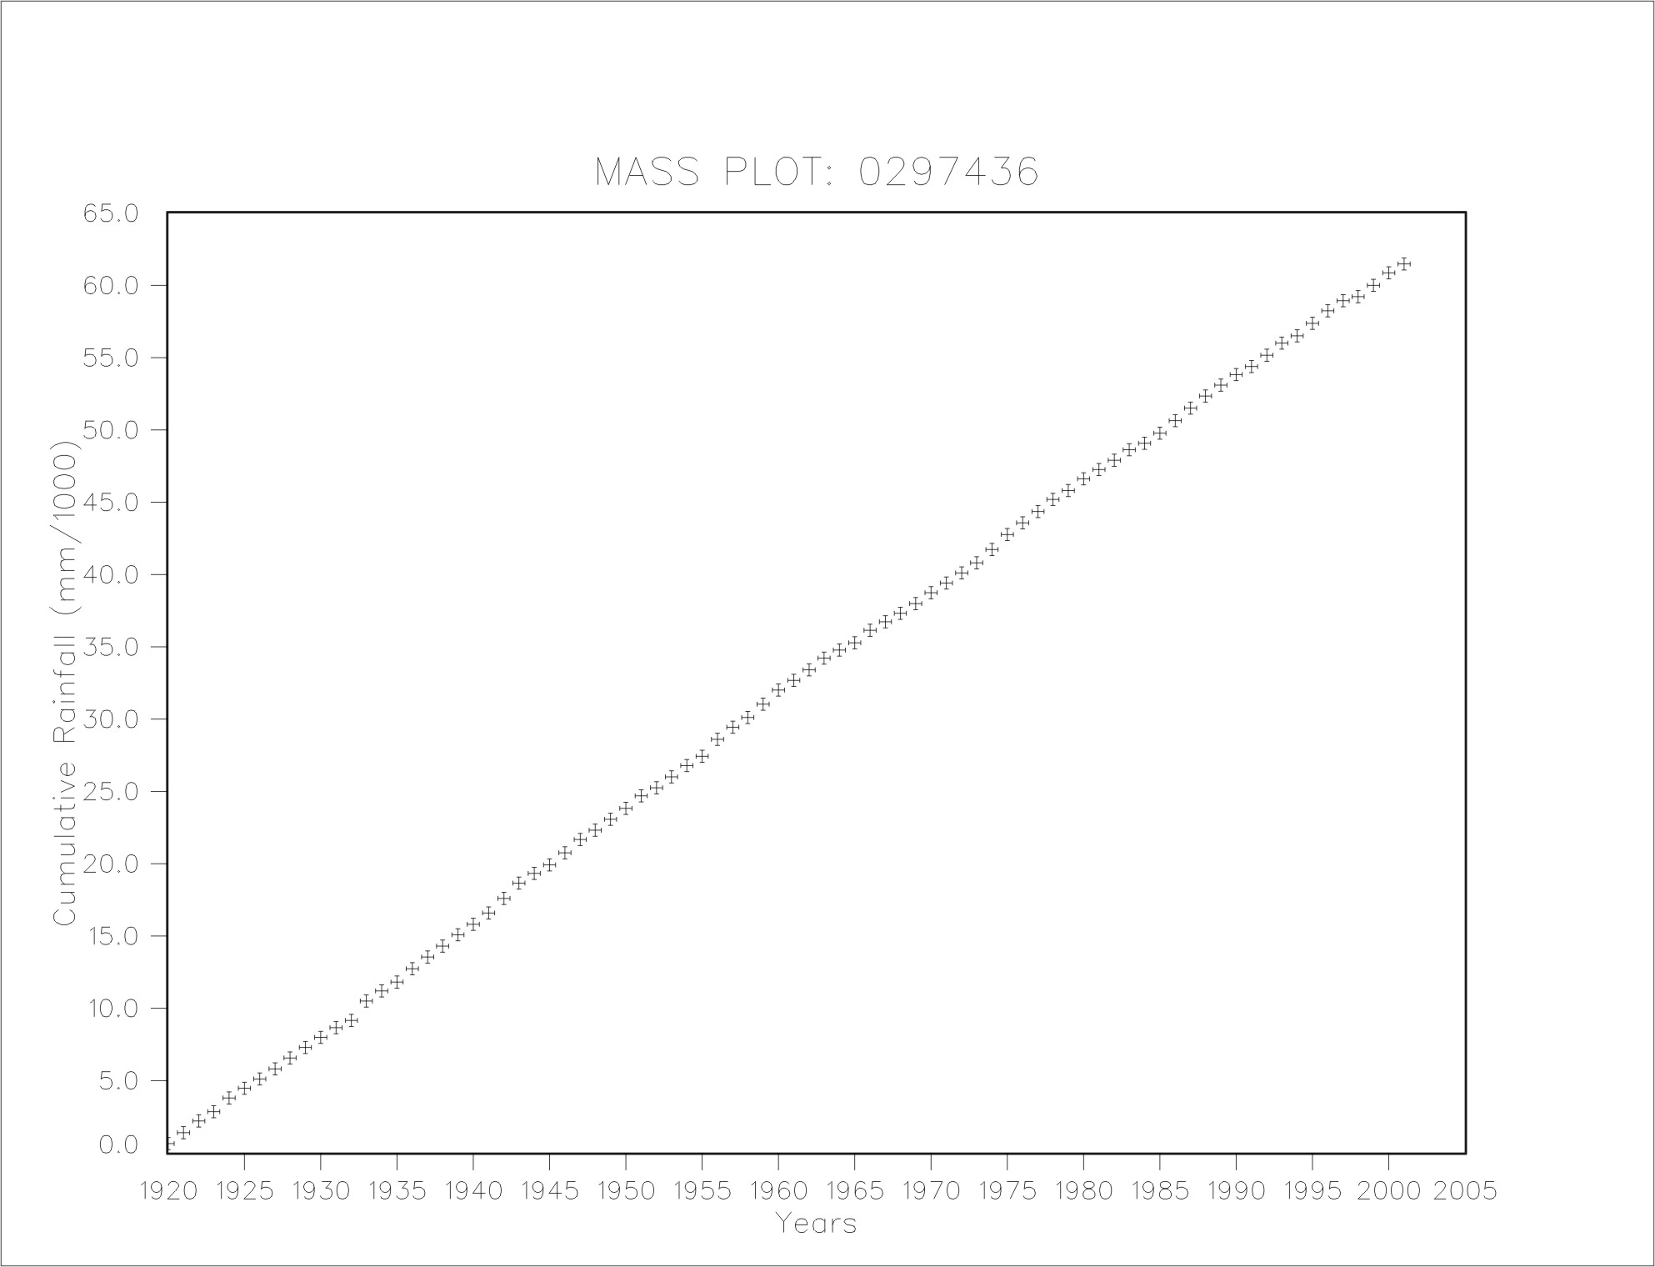

Mass plot of patched monthly rainfall for 0297612
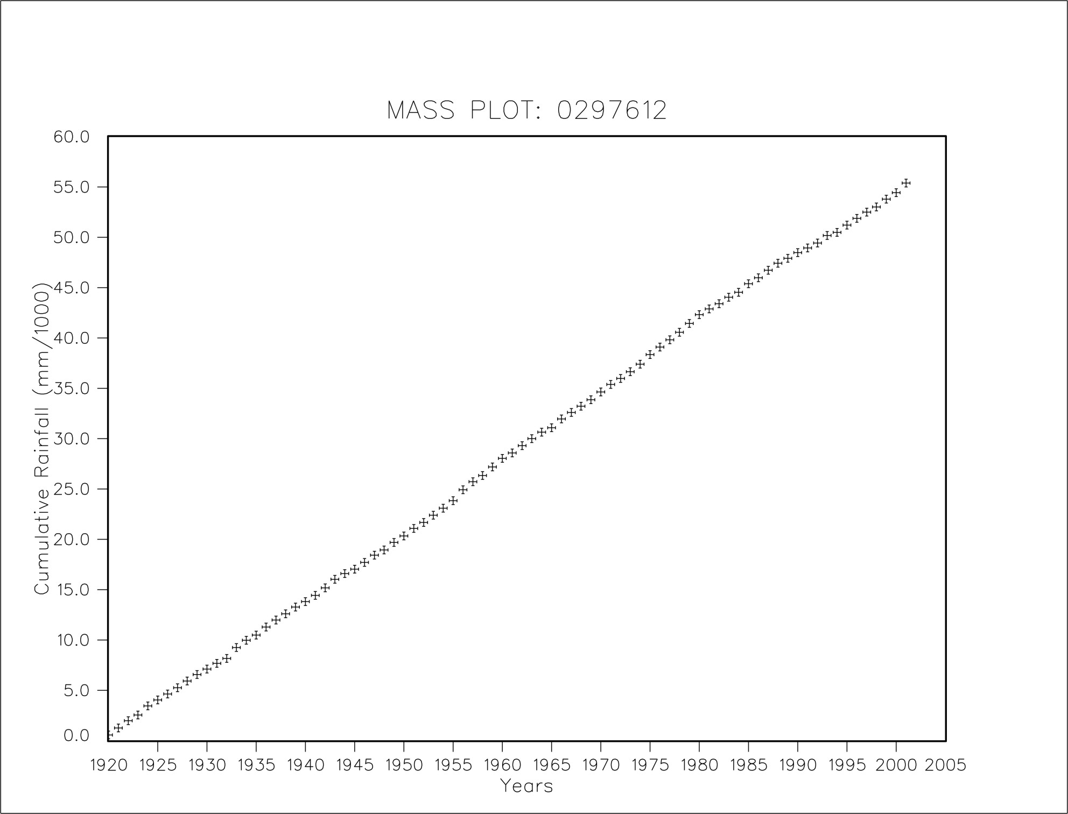

Mass plot of patched monthly rainfall for 0297825
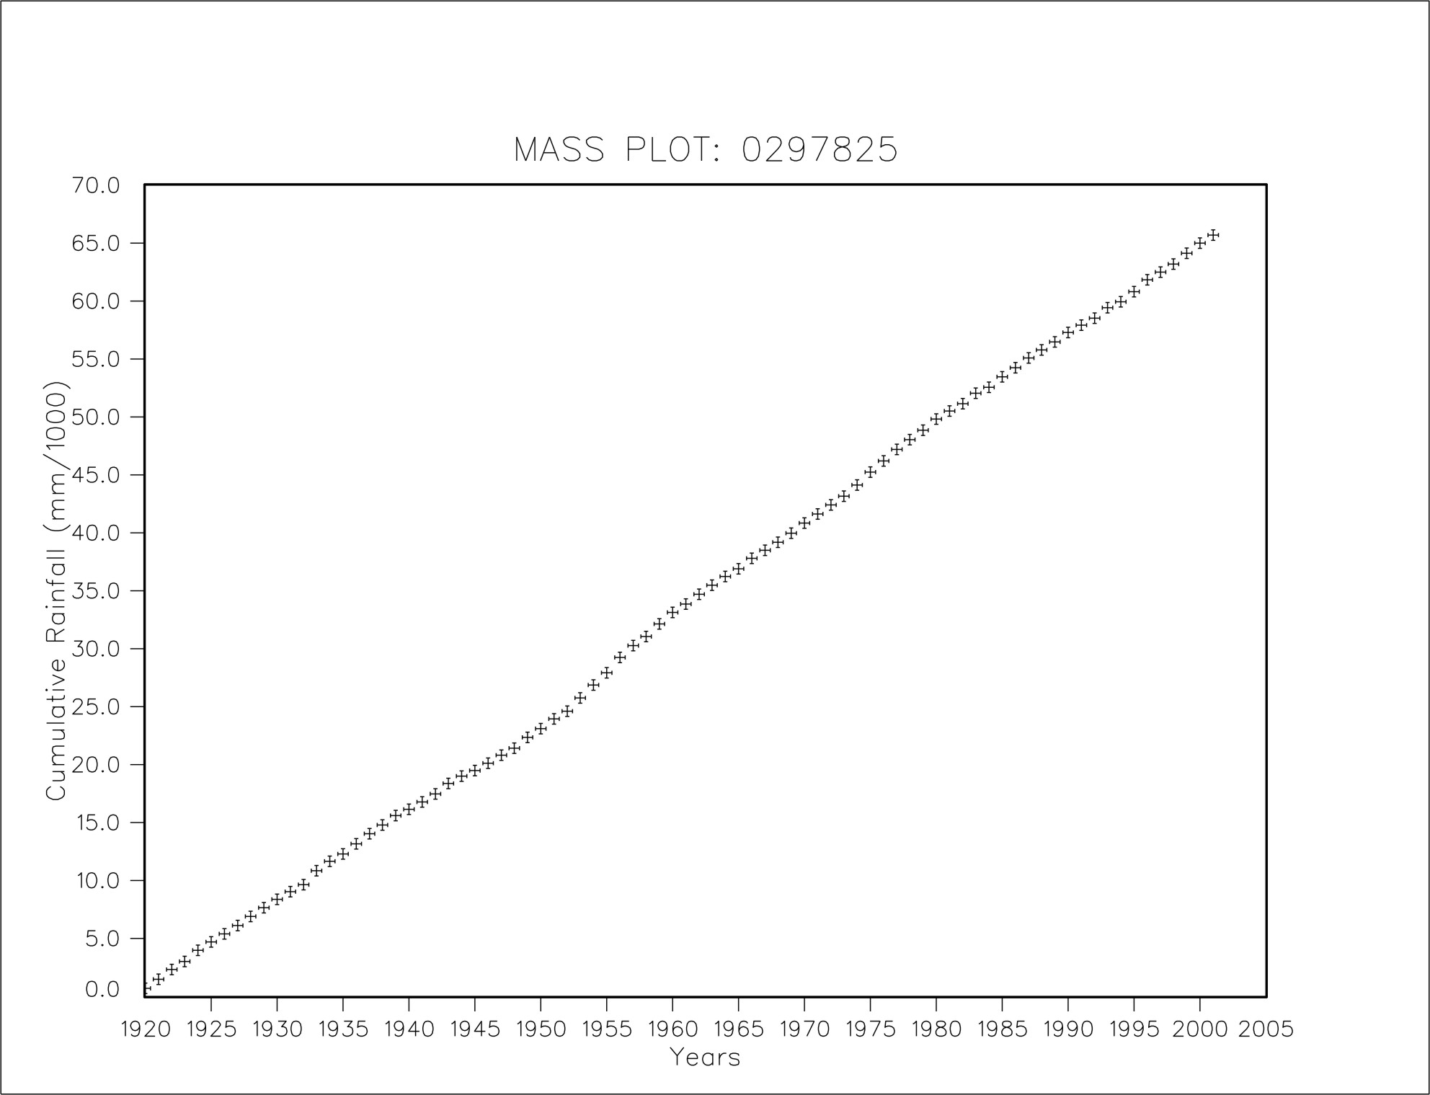

Mass plot of patched monthly rainfall for 0298194
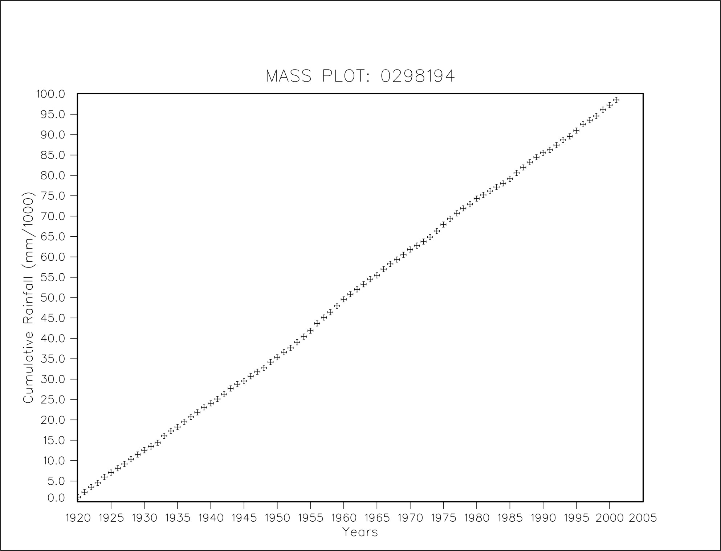

Mass plot of patched monthly rainfall for 0298244
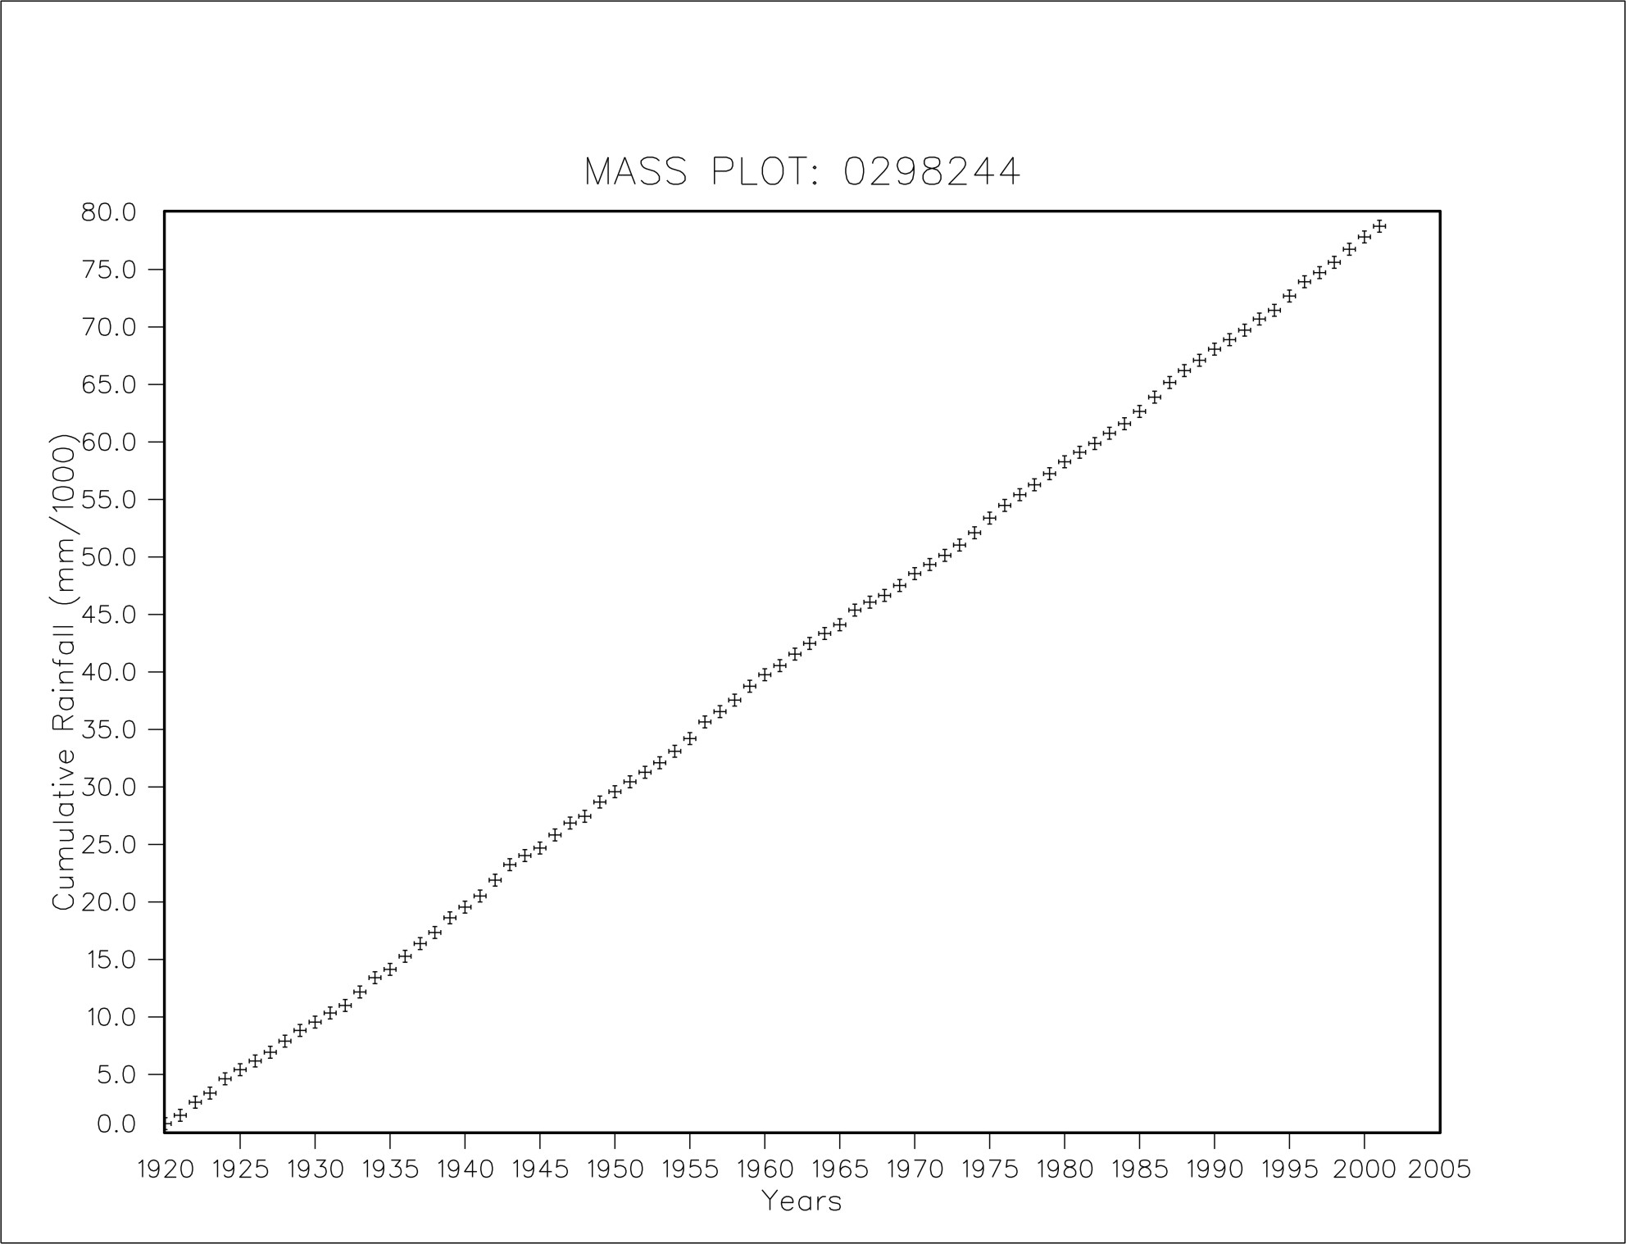

Mass plot of patched monthly rainfall for 0265875
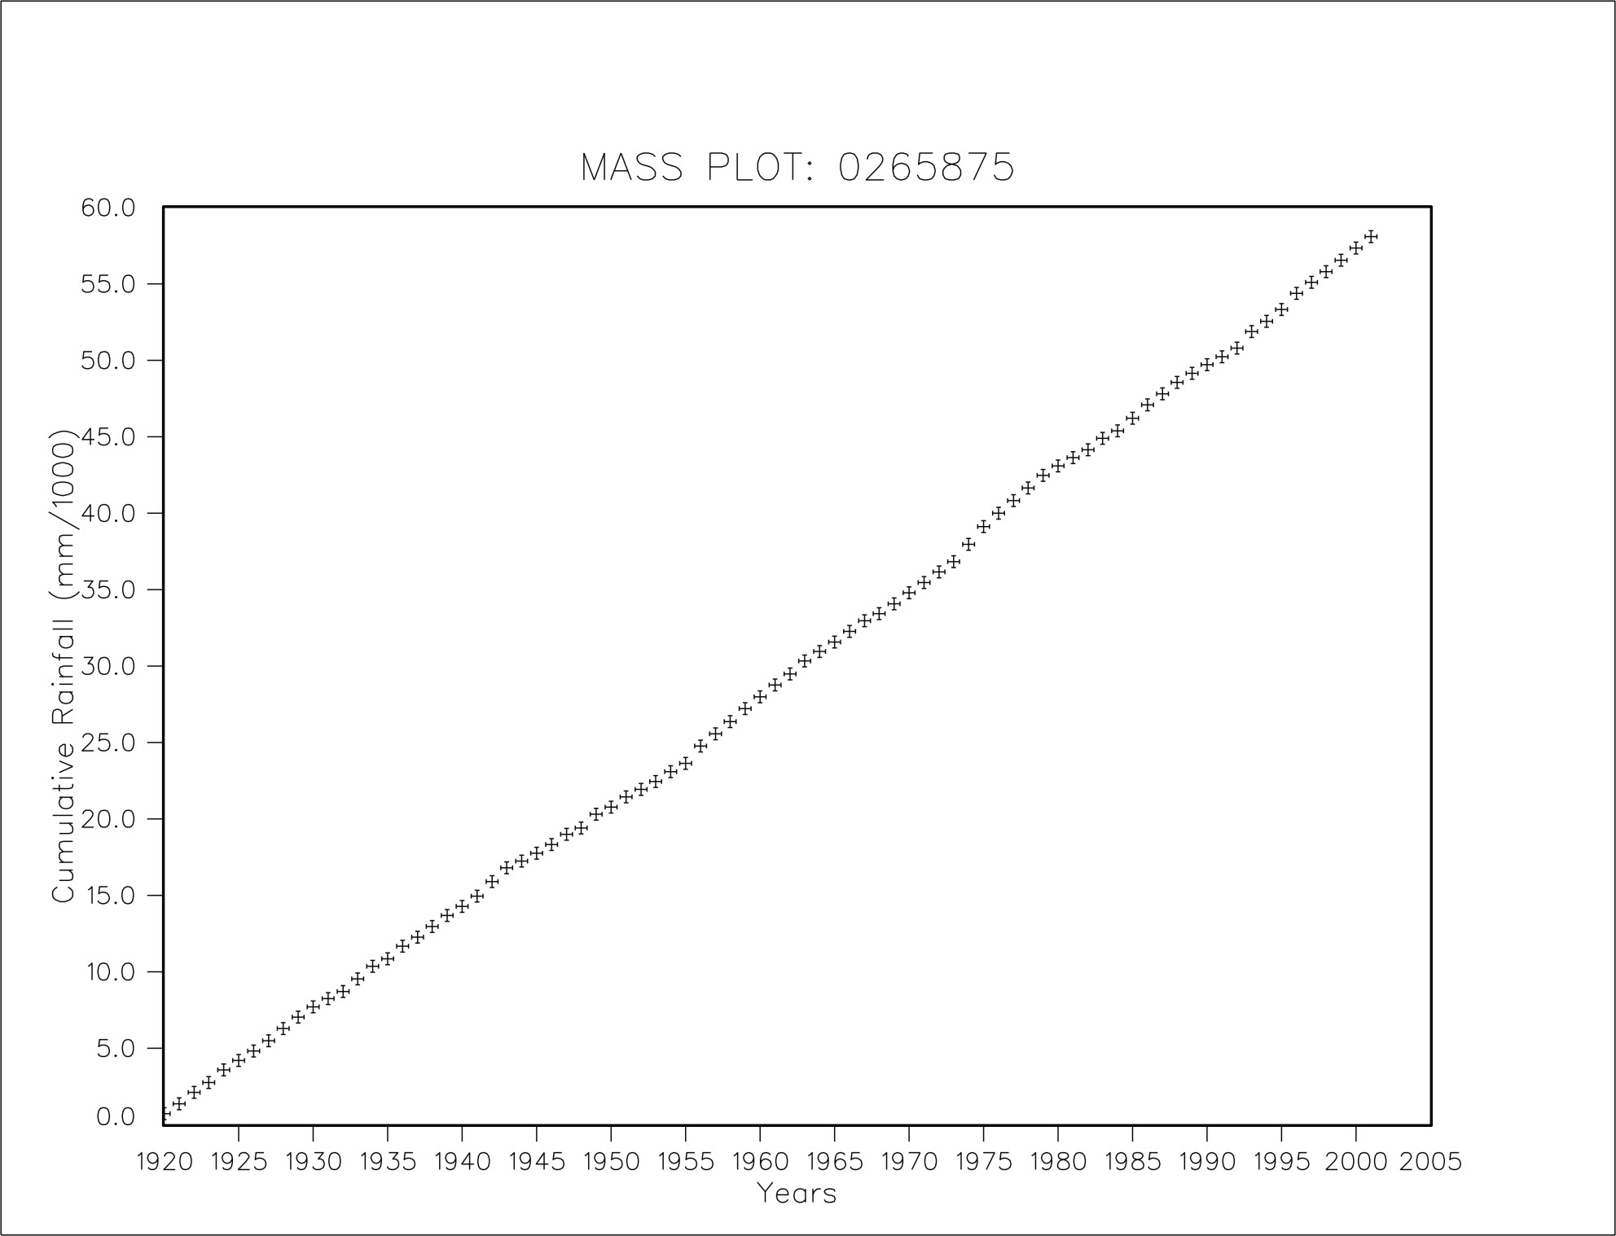

Mass plot of patched monthly rainfall for 0266001
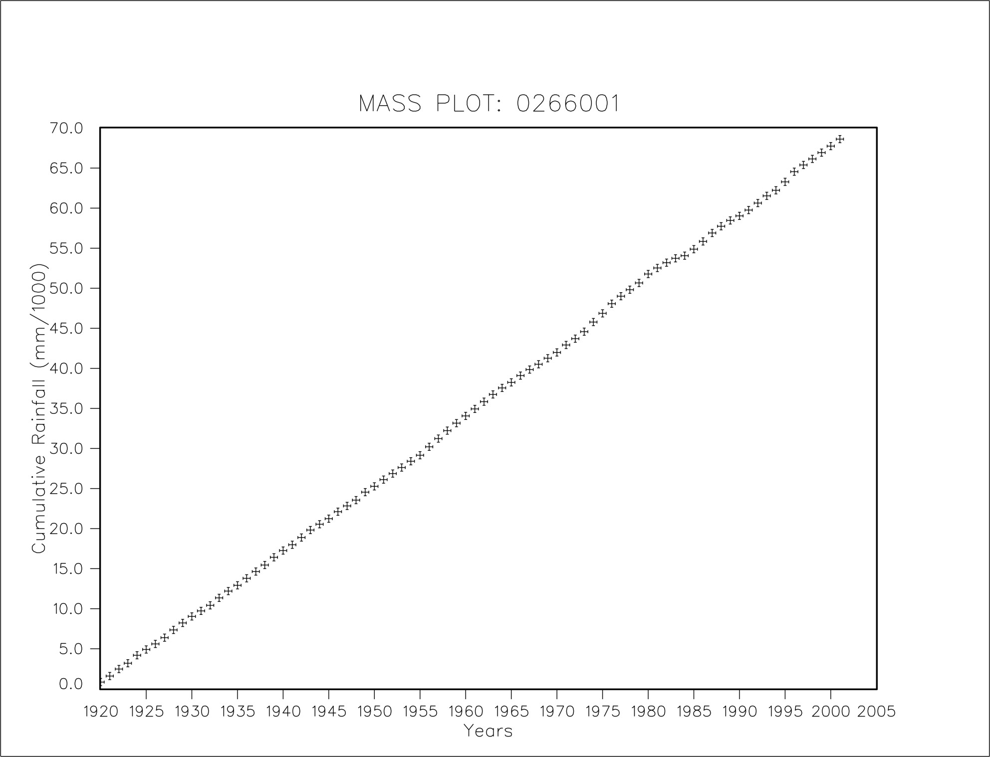

Mass plot of patched monthly rainfall for 0297082
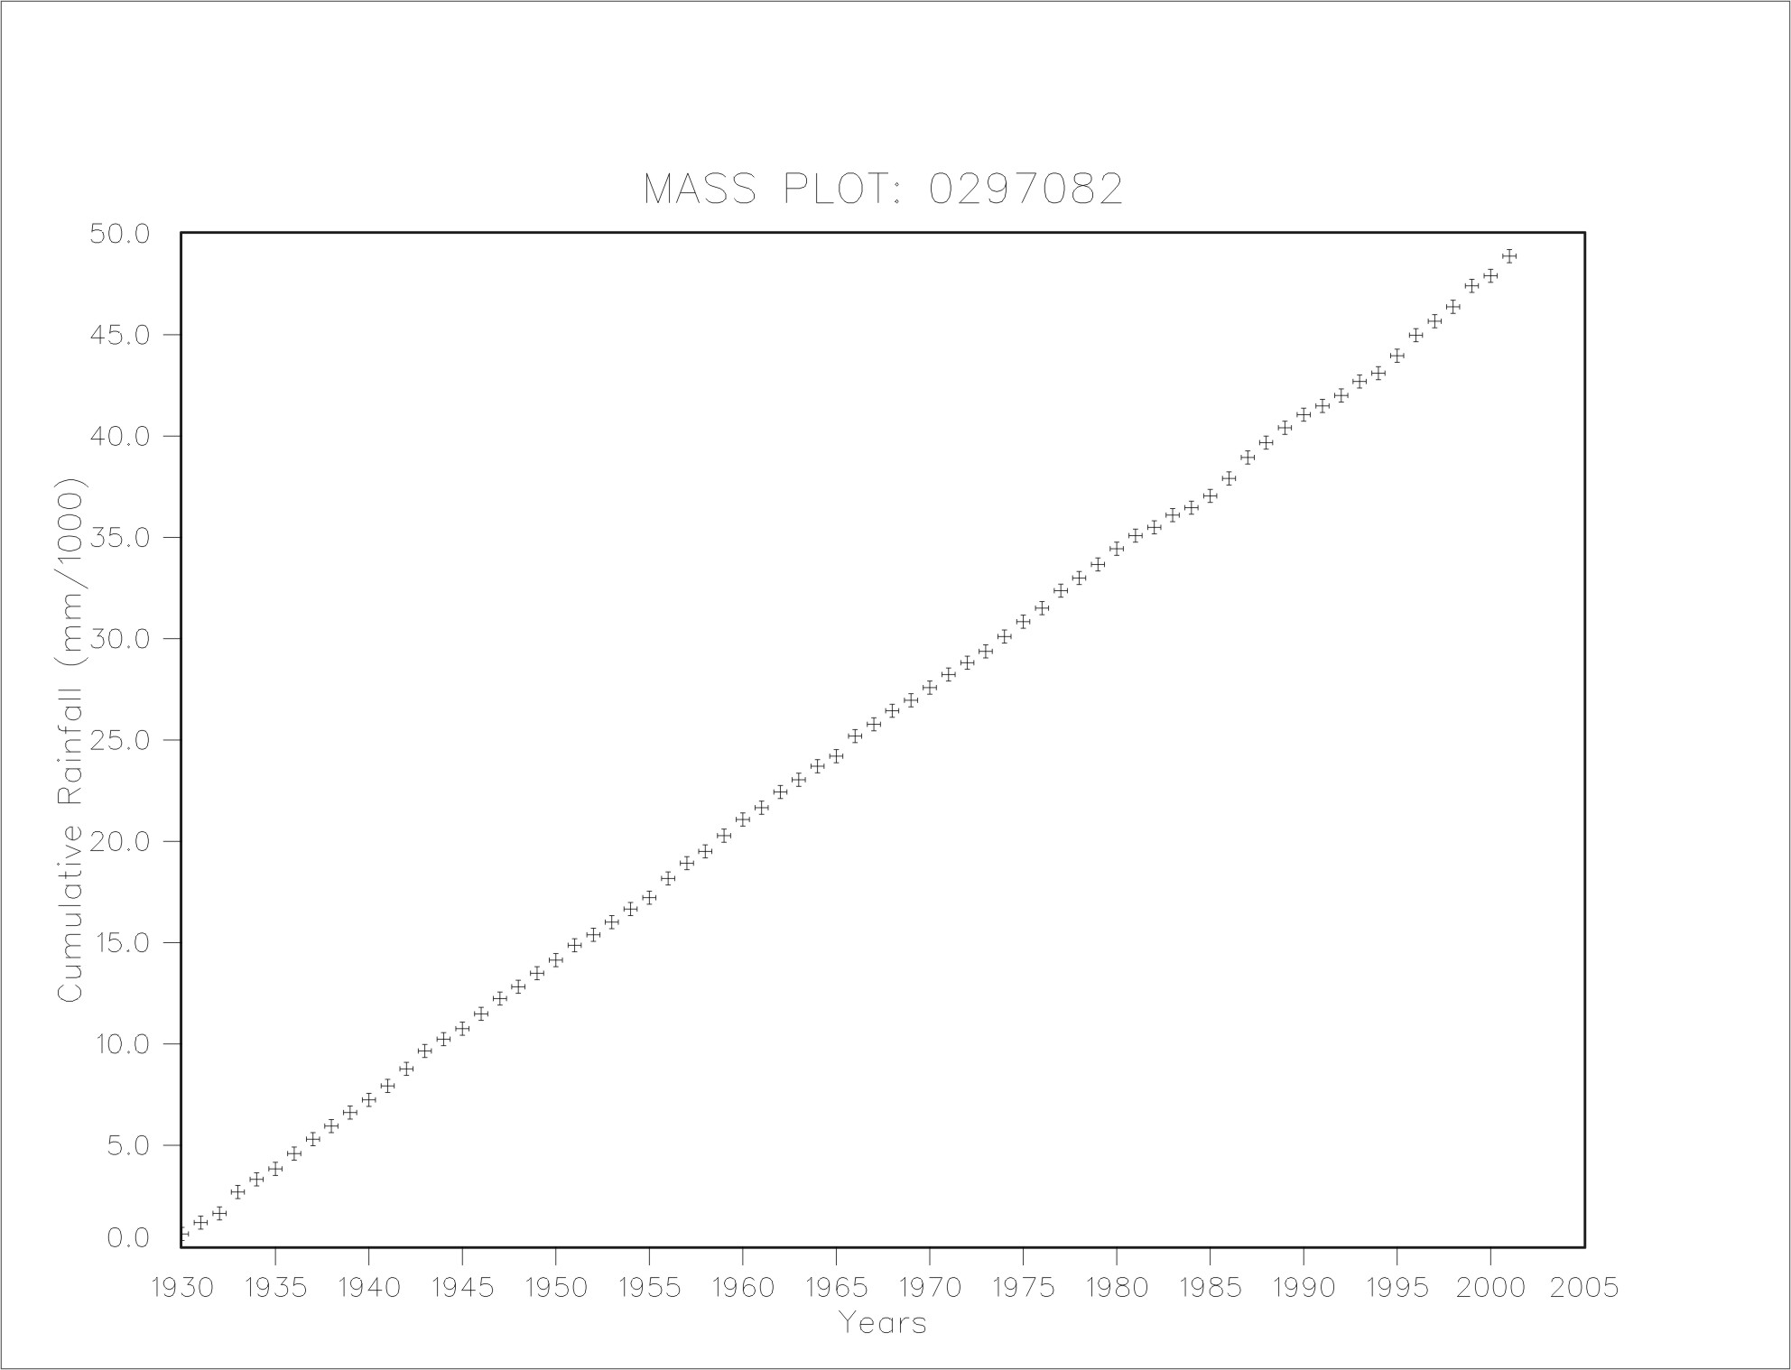

Mass plot of patched monthly rainfall for 0297388
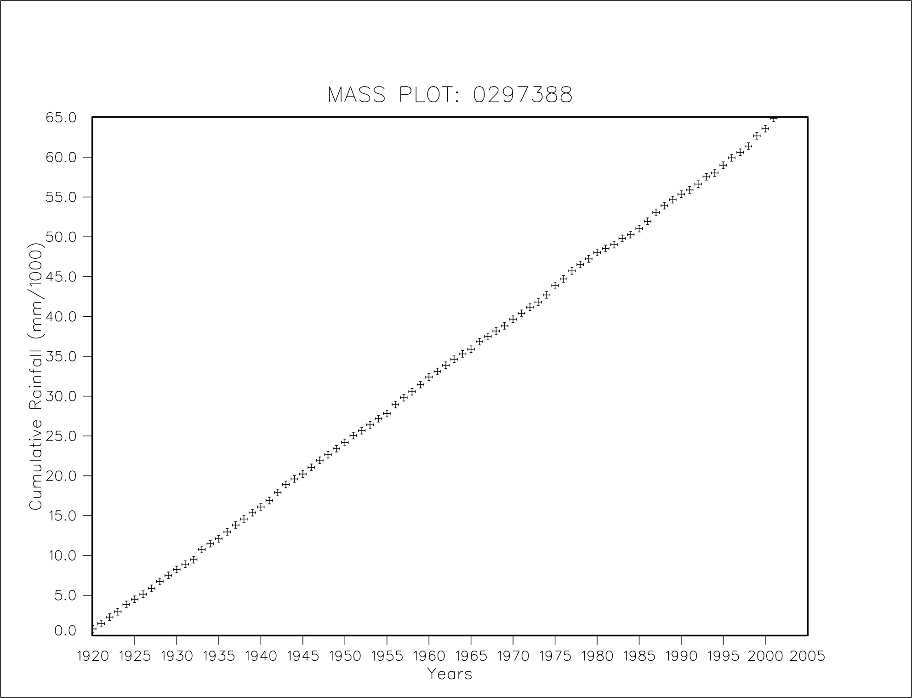

Mass plot of patched monthly rainfall for 0233775
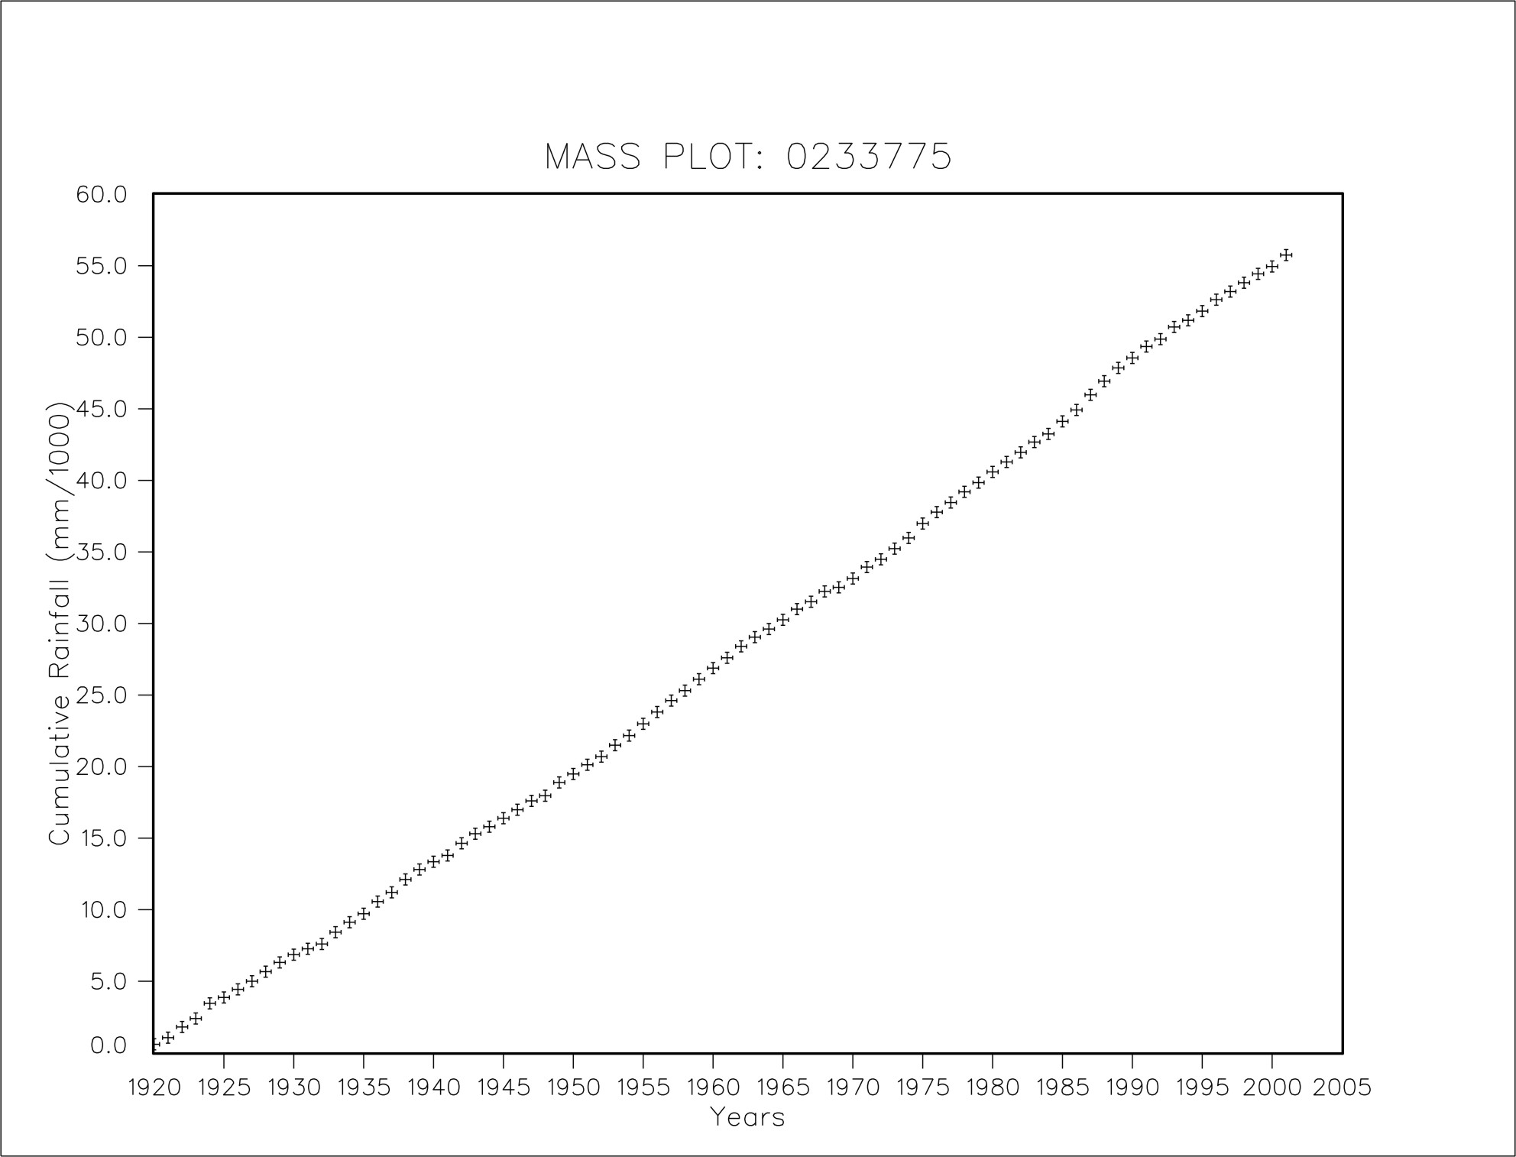

Mass plot of patched monthly rainfall for 0234150
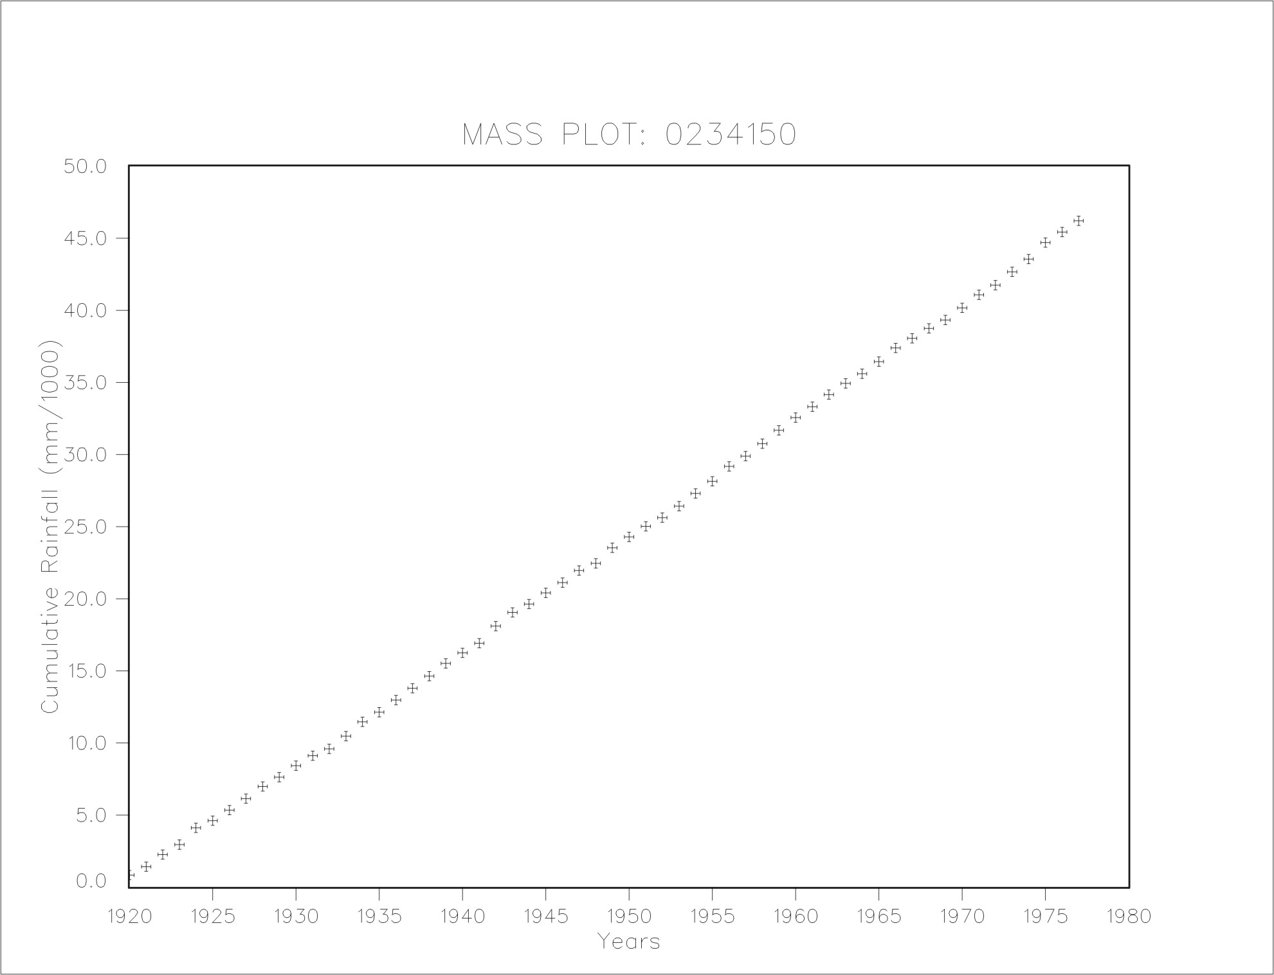

Mass plot of patched monthly rainfall for 0234170
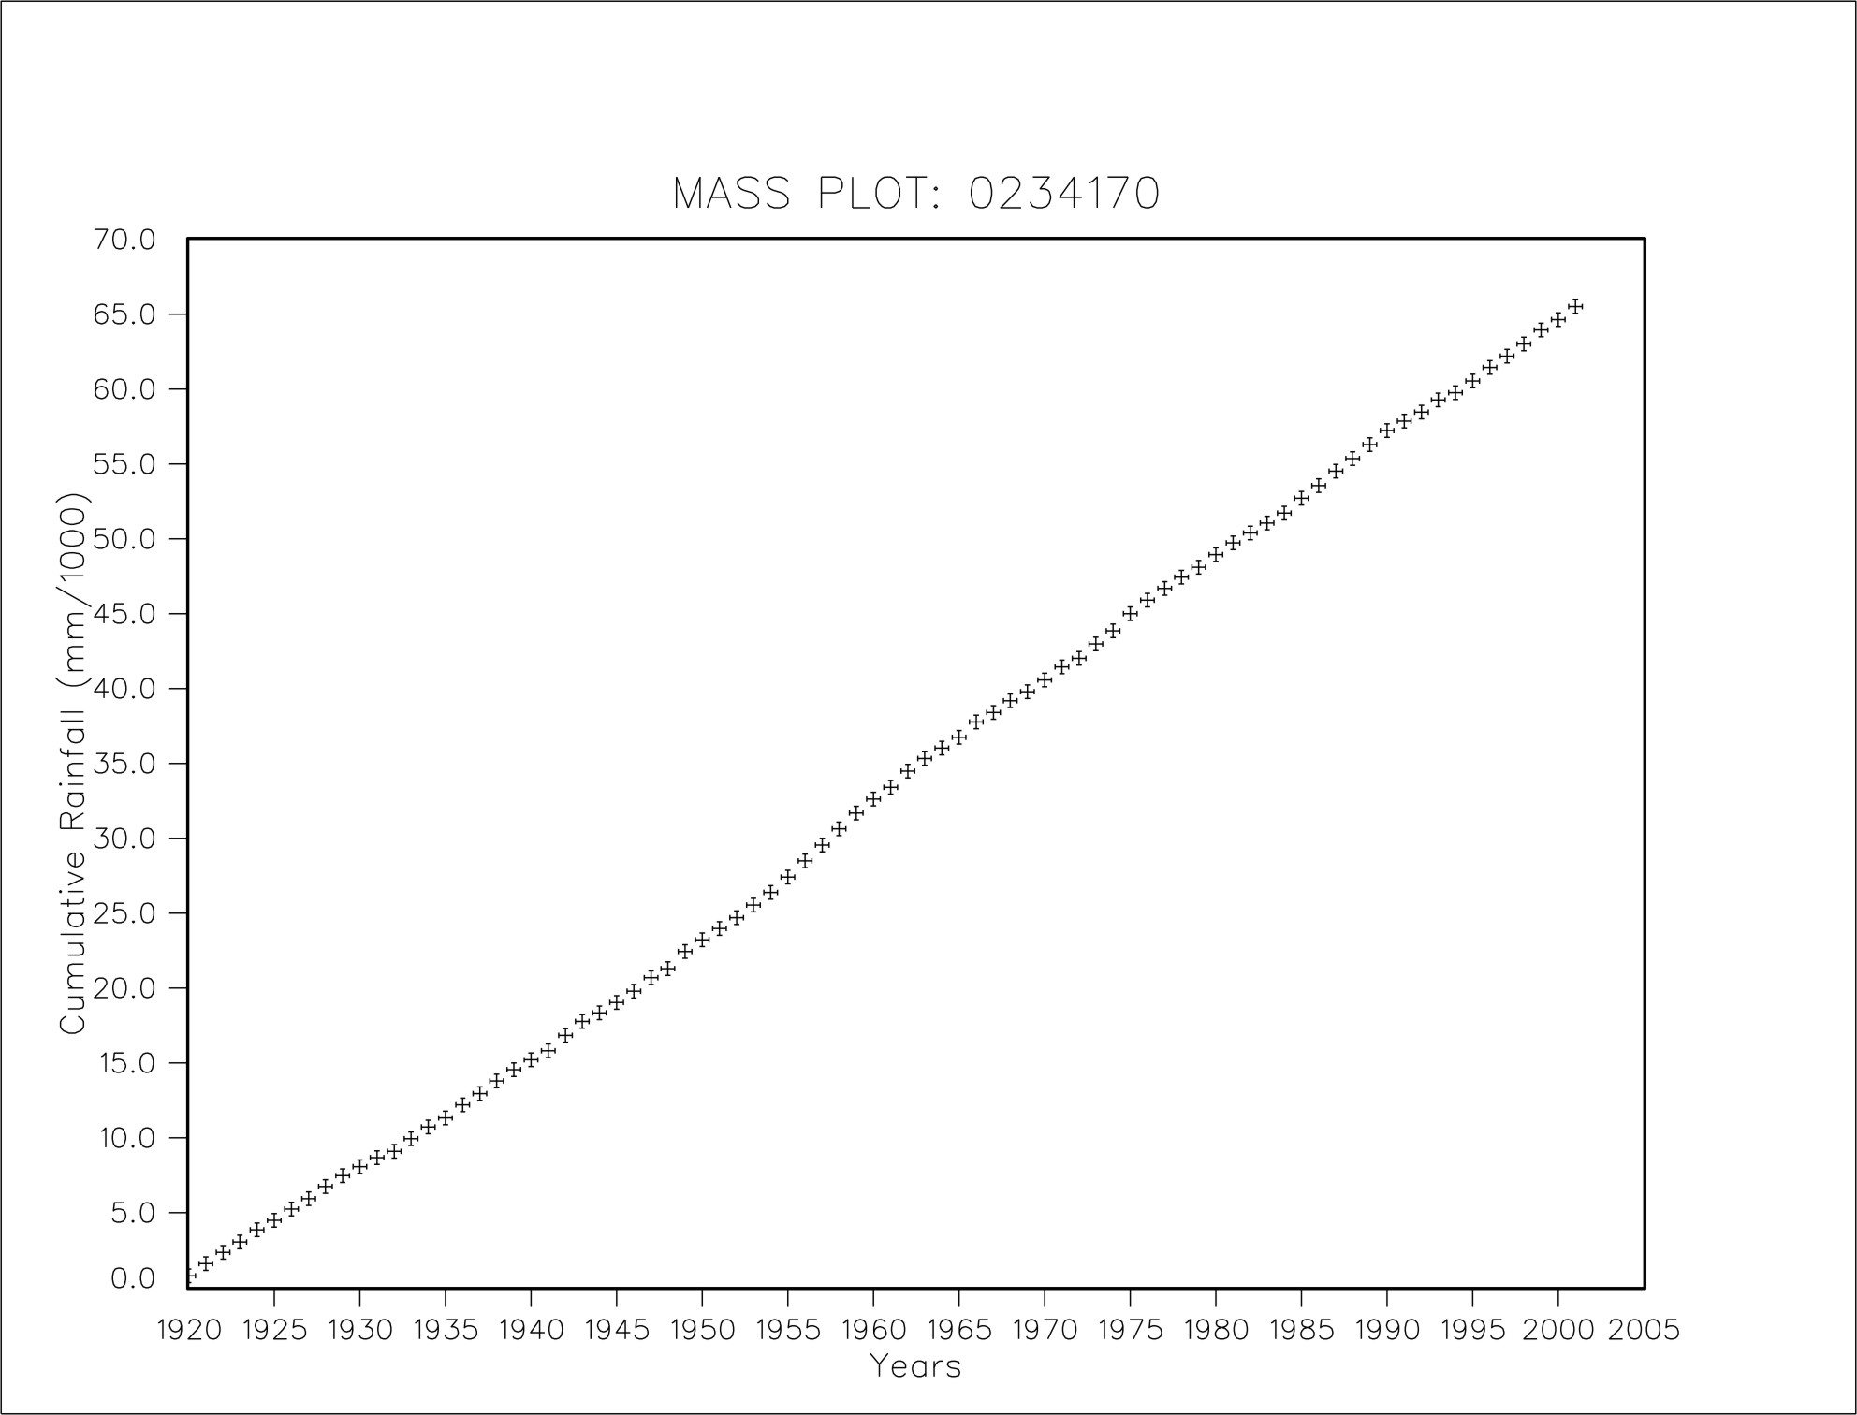

Mass plot of patched monthly rainfall for 0264417
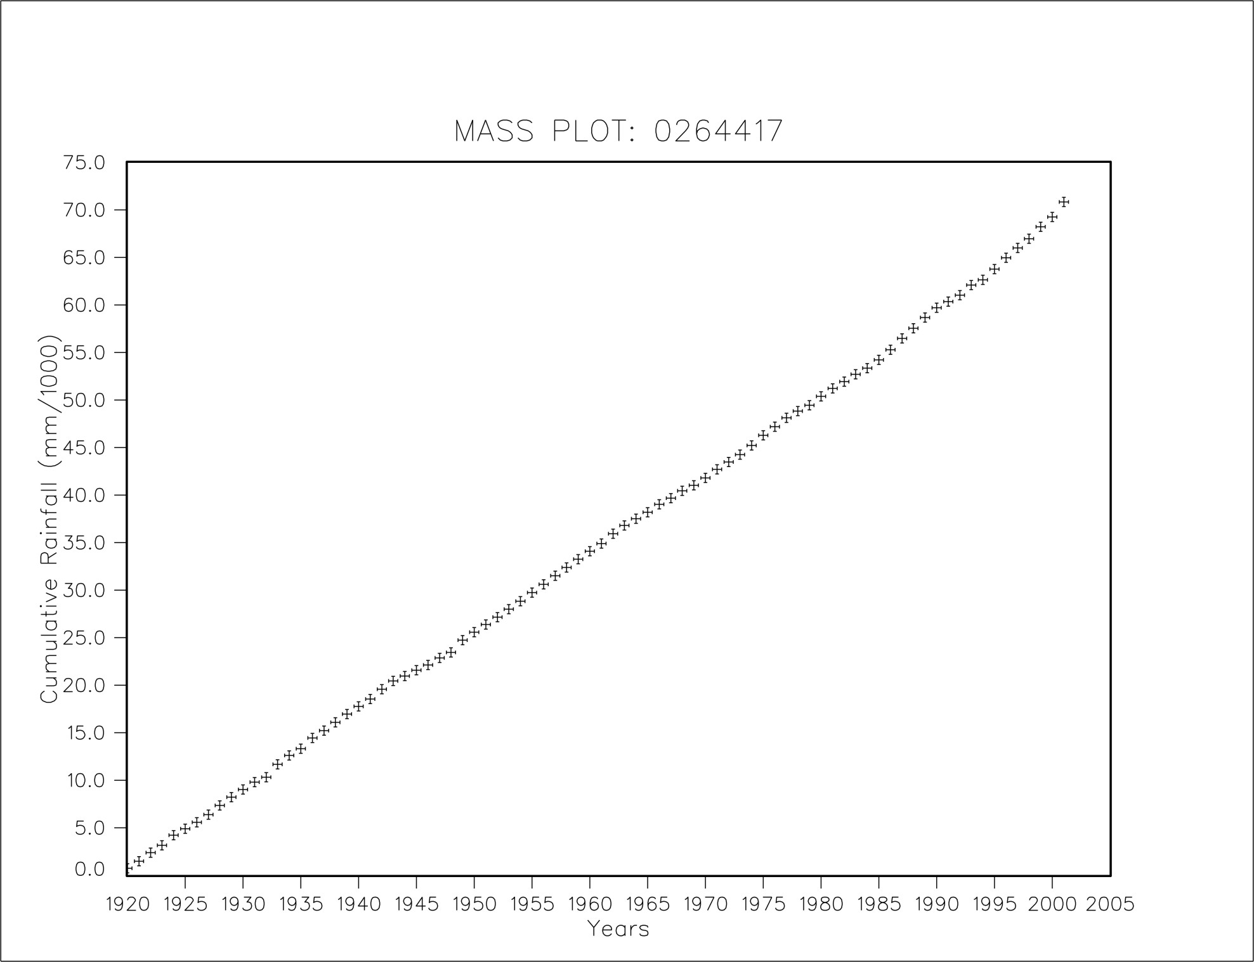

Mass plot of patched monthly rainfall for 0264715
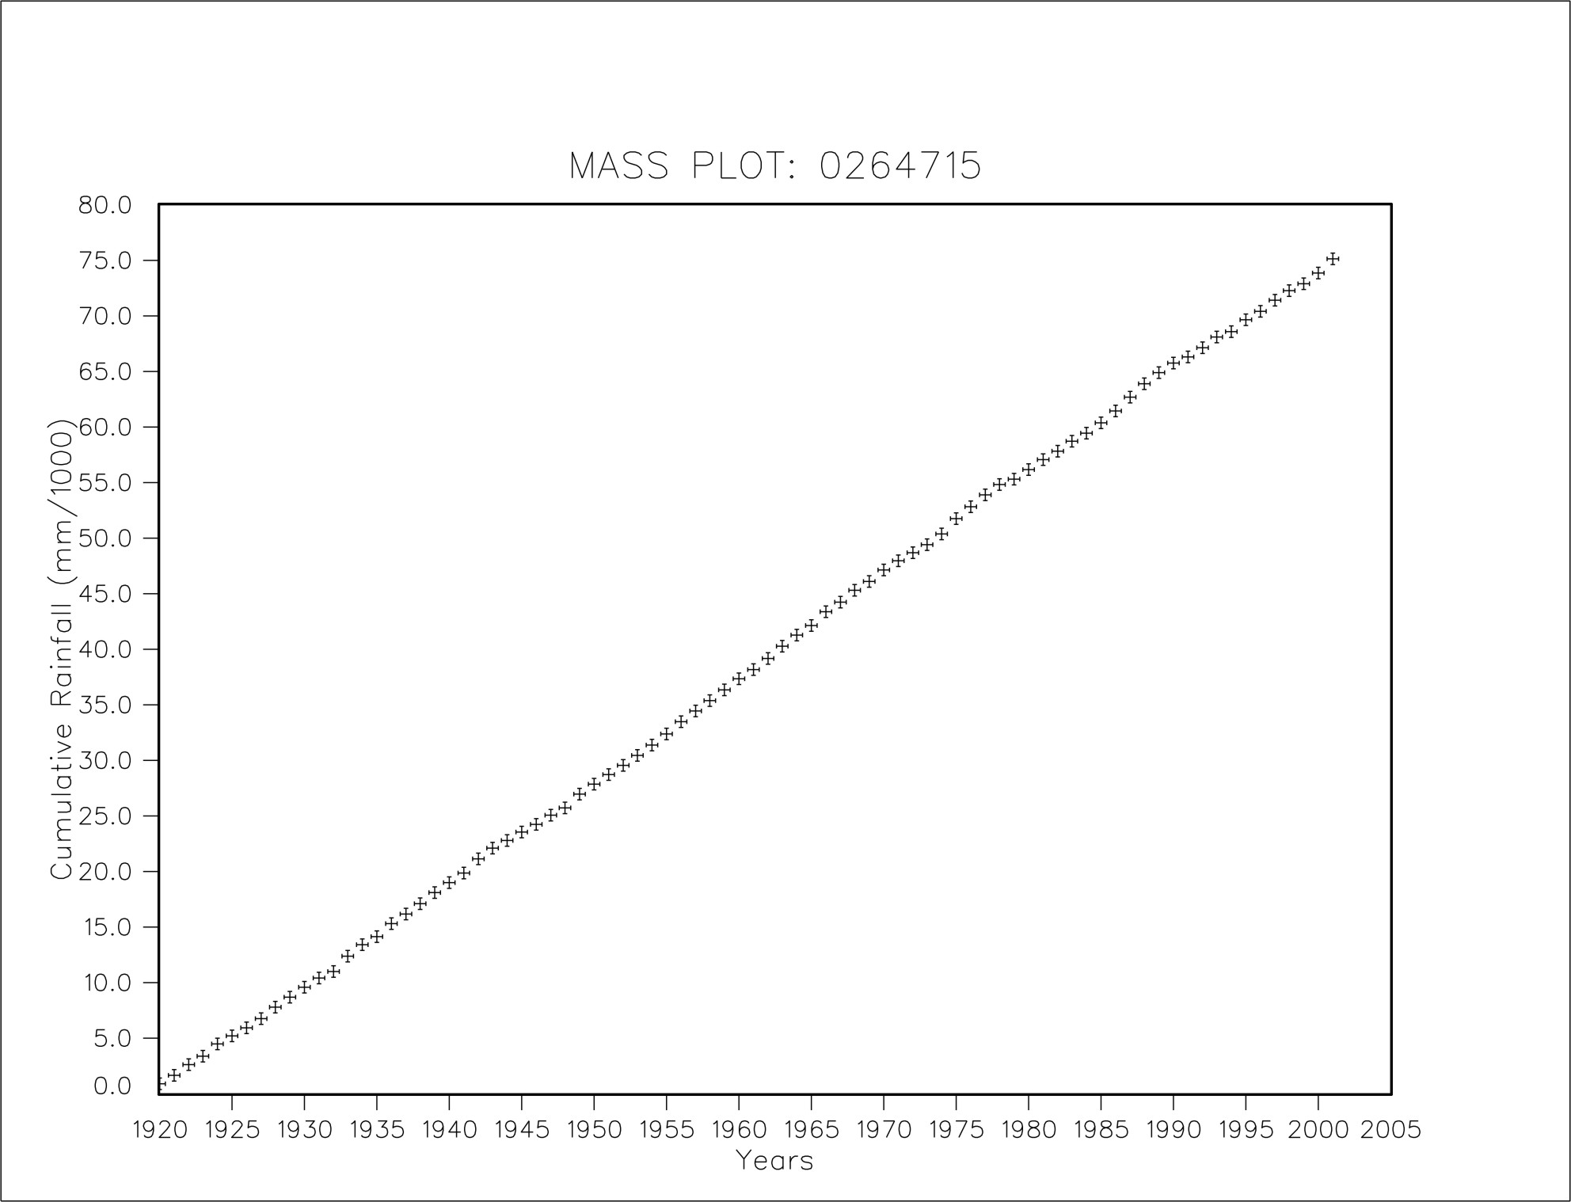

Mass plot of patched monthly rainfall for 0264836


