GUIDELINES FOR PROJECT MANAGERS TO COMPLETE MAP REQUIRED FOR MANAGEMENT UNIT CLEARING PLAN

- Minimum scale map of 1:50 000 should be used. Should orthophoto’s be available for the area, even if 10 years old, this is a better option.

- If possible, the regional GIS co-ordinator should plot the project boundary on a 1:50 000 backdrop for the project manager. If not possible, the project manager must draw the project boundary onto the original 1:50 000. Should the regional GIS co-ordinator be able to plot a map, followup areas and areas currently being cleared should be indicated on the map as well.

- Project Managers will take these maps and draw alien vegetation units onto it. They can do this over any length of time. They can leave the maps in the vehicle and add information as they visit various areas in the project. They should keep binoculars with them.

- If a vegetation unit is drawn on a map, it must be given a unique number (i.e. no two vegetation units should have the same number). This number must be listed in a table where all the information about the vegetation unit is given – i.e. species, density, area and treatment required. An example of this table is given below. The project manager should have numberous blank copies in their vehicle along with the maps.

- The regional GIS co-ordinator should provide the Project managers with a 1ha grid on a transparency which can be overlaid on the map to assist the project manager calculate area when in the field.

- When drawing on the maps, a thin as possible pen is required. Do not use thick permanent markers. Architect pens work the best.

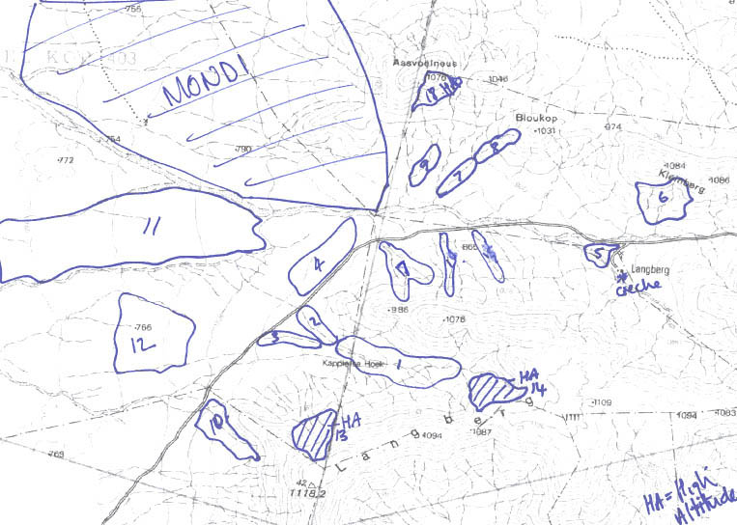
SCALE: 1:50 000
EXAMPLE OF A MAP INDICATING VEGETATION UNITS DRAWN BY A PROJECT MANAGER
Vegetation Units. Numbers must correspond with table overleaf.
Use permanent pen to draw on map. Thin architect fine liner is best option. Do not use thick permanent markers
Indicate other aspects of interests – e.g. crèche locations
Indicate landownership if known E.g. Plantations.
This will assist when deciding on clearing strategy for the project
Vegetation Units indicating where High altitude teams are required

