Groundwater sampling

Determinand | Units | Drinking | Livestock | Irrigation
 |  | South African National Standard for drinking water SANS: 241 (2011) | South African Water Quality Guidelines for Aquatic Ecosystems DWAF (1996a) | South African Water Quality Guidelines for Aquatic Ecosystems DWAF (1996b)
Alkalinity | mg CaCO3/L | n/a
Arsenic | µg As/L
Calcium | mg Ca/L
Chloride (Soluble) | mg Cl/L
Conductivity | mS/m
Fluoride | µg F/L
Iron | mg Fe/L
Total hardness | mg CaCO3/L
Magnesium | mg Mg/L
Manganese | mg Mn/L
Sodium | mg Na/L
Ammonia (Soluble)* | mg N/L
Nitrate (Soluble) | mg N/L
pH | pH units
Selenium | µg Se/L
Sulphate (Soluble) | mg SO4/L
Turbidity | NTU

Legend
Limit exceedance
Exceeds drinking water limit (SANS, 2011)
Exceeds livestock watering limit (DWAF, 1996a)
Exceeds irrigation limit (DWAF, 1996b)
No limit/ no exceedance

Site WW39840, Blumfelde, Namibia

Site Description
The site is situated directly adjacent to the Olifants River near Blumfelde, approximately 115 km north-east of Mariental, Namibia. The Olifants River is a tributary of the Auob River, with the confluence located approximately 230 km downstream. The primary land-use is livestock agriculture, with irrigated crops also present. The borehole is a Namibia Ministry of Agriculture, Water & Forestry (MWAF) monitoring borehole, which is used for monitoring purposes only. No water is drawn at this site, but with neighbouring farms drawing water for livestock watering, crop irrigation and domestic use. This borehole is 130m deep, and draws on the Auob aquifer for the purposes of monitoring the aquifer. A second monitoring borehole is located within 50m, but which draws on the deeper Nossob aquifer for monitoring purposes. The sites are routinely sampled at quarterly intervals by the Namibian Ministry of Agriculture, Water & Forestry.

Longitude | 18.388726° | Latitude | -23.647475°
Altitude (m.a.s.l.) | 1 277 | Country | Namibia
Date sampled | 21 July 2015
River catchment | Olifants/Auob | Aquifer | Auob
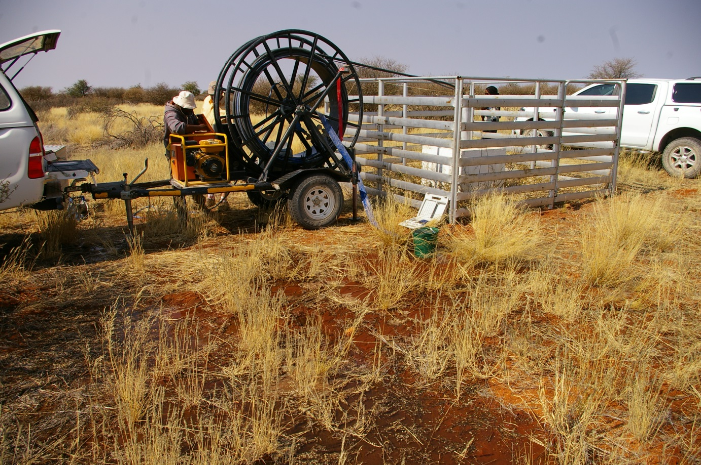

Water quality
In-situ water quality sampling
Determinand | Units | WW 39840
pH | pH units | 8.11
Temperature | (°c) | 27.5
Conductivity | (µS/cm) | 914
e.coli¹ | (CFU/ml) | 0
¹sampled in-situ using an e.coli hygiene and monitoring swab

Laboratory water quality sampling
Determinand | Units | WW 39840
Alkalinity | mg CaCO3/L | 298
Arsenic | µg As/L | <2.00
Calcium | mg Ca/L | 22.8
Chloride (Soluble) | mg Cl/L | 59.9
Conductivity | mS/m | 98.1
Fluoride | µg F/L | 725
Iron | mg Fe/L | <0.02
Total hardness | mg CaCO3/L | 154
Magnesium | mg Mg/L | 23.4
Manganese | mg Mn/L | 0.03
Sodium | mg Na/L | 137
Ammonia (Soluble)* | mg N/L | <0.10
Nitrate (Soluble) | mg N/L | 11.6
pH | pH units | 8.10
Selenium | µg Se/L | 6.15
Sulphate (Soluble) | mg SO4/L | 30.9
Turbidity | NTU | 0.4

Legend
Limit exceedance
Exceeds drinking water limit (SANS, 2011)
Exceeds livestock watering limit (DWAF, 1996a)
Exceeds irrigation limit (DWAF, 1996b)
No limit/ no exceedance

Main Impacts at the Site
Causes¹ | Sources²
n/a | High volumes of water extracted for irrigated crops
1 CAUSE: A stressor that occurs at an intensity, duration and frequency of exposure that results in a change in the ecological conditions.
2 SOURCE: A source is the origin of a stressor. It is an entity or action that releases or imposes a stressor into the waterbody (EPA, 2000).

Site WW40960, Stampriet, Namibia

Site Description
The site is situated in the Auob River catchment (900m from the Auob River) on the farm Boomplaas near Stampriet, approximately 65 km east of Mariental, Namibia. The primary land use is livestock agriculture, with irrigated crops also present. The borehole is a Namibia Ministry of Agriculture, Water & Forestry (MWAF) monitoring borehole. The site is routinely sampled at quarterly intervals by the Namibian Ministry of Agriculture, Water & Forestry.

Please note: we are still awaiting laboratory results and other details of this site

Longitude | 18.562200° | Latitude | -24.550110°
Altitude (m.a.s.l.) | 1 163 | Country | Namibia
Date sampled | 23 July 2015
River catchment | Auob | Aquifer
Awaiting photo

Water quality
In-situ water quality sampling
Determinand | Units | WW 40960
pH | pH units | 7.3
Temperature | (°c) | 26.2
Conductivity | (µS/cm) | 1 050
e.coli ¹ | (CFU/ml) | 0
¹sampled in-situ using an e.coli hygiene and monitoring swab

Laboratory water quality sampling
Determinand | Units | WW 40960
Alkalinity | mg CaCO3/L | Awaiting results
Arsenic | µg As/L | Awaiting results
Calcium | mg Ca/L | Awaiting results
Chloride (Soluble) | mg Cl/L | Awaiting results
Conductivity | mS/m | Awaiting results
Fluoride | µg F/L | Awaiting results
Iron | mg Fe/L | Awaiting results
Total hardness | mg CaCO3/L | Awaiting results
Magnesium | mg Mg/L | Awaiting results
Manganese | mg Mn/L | Awaiting results
Sodium | mg Na/L | Awaiting results
Ammonia (Soluble)* | mg N/L | Awaiting results
Nitrate (Soluble) | mg N/L | Awaiting results
pH | pH units | Awaiting results
Selenium | µg Se/L | Awaiting results
Sulphate (Soluble) | mg SO4/L | Awaiting results
Turbidity | NTU | Awaiting results

Legend
Limit exceedance
Exceeds drinking water limit (SANS, 2011)
Exceeds livestock watering limit (DWAF, 1996a)
Exceeds irrigation limit (DWAF, 1996b)
No limit/ no exceedance

Main Impacts at the Site
Causes¹ | Sources²
n/a | High volumes of water extracted for irrigated crops
1 CAUSE: A stressor that occurs at an intensity, duration and frequency of exposure that results in a change in the ecological conditions.
2 SOURCE: A source is the origin of a stressor. It is an entity or action that releases or imposes a stressor into the waterbody (EPA, 2000).

Site BH5229, Two Rivers, Botswana

Site Description
The site is situated in the Nossob River catchment at Two Rivers within the Botswana side of the Kgalagadi Transfrontier Park. The borehole is sited 150m from the Nossob River, 4km downstream of the confluence with the Auob River. The primary land use is the Kgalagadi Transfrontier Park, with Two Rivers forming a small settlement in the park containing a border post, staff housing, tourist accommodation, a petrol station, shop and workshops. The borehole supplies water for domestic purposes to the Botswana staff housing in the park at Two Rivers. This borehole draws on the Nossob aquifer.

Longitude | 20.617194° | Latitude | -26.469361°
Altitude (m.a.s.l.) | 876 | Country | Botswana
Date sampled | 23 July 2015 | River catchment | Nossob
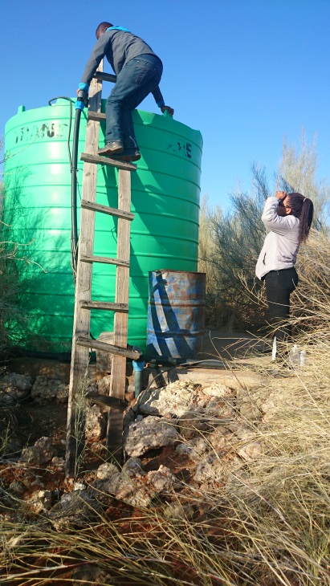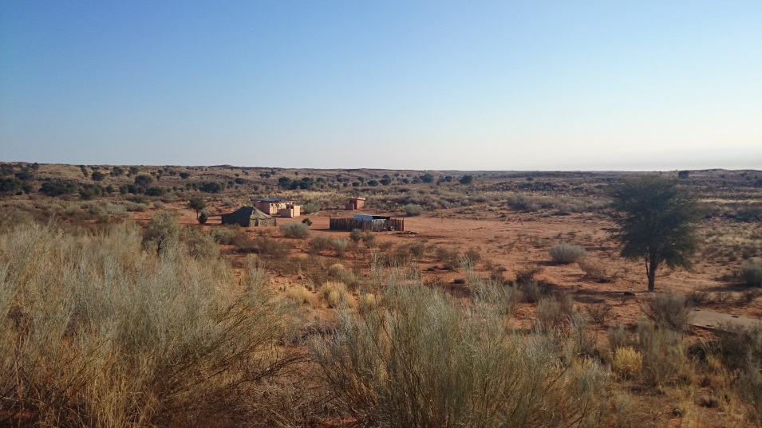

Water quality
In-situ water quality sampling
Determinand | Units | BH5229
pH | pH units | n/a²
Temperature | (°c) | n/a²
Conductivity | (µS/cm) | n/a²
e.coli¹ | (CFU/ml) | 0
¹sampled in-situ using an e.coli hygiene and monitoring swab
²Member state personnel did not sample in-situ determinants

Laboratory water quality sampling
Determinand | Units | BH5229
Alkalinity | mg CaCO3/L | 859
Arsenic | µg As/L | 109
Calcium | mg Ca/L | <1.00
Chloride (Soluble) | mg Cl/L | 568
Conductivity | mS/m | 430
Fluoride | µg F/L | 6980
Iron | mg Fe/L | <0.02
Total hardness | mg CaCO3/L | <6.67
Magnesium | mg Mg/L | <1.00
Manganese | mg Mn/L | <0.01
Sodium | mg Na/L | 964
Ammonia (Soluble)* | mg N/L | <0.10
Nitrate (Soluble) | mg N/L | 24.0
pH | pH units | 9.38
Selenium | µg Se/L | 12.2
Sulphate (Soluble) | mg SO4/L | 350
Turbidity | NTU | 1.2

Legend
Limit exceedance
Exceeds drinking water limit (SANS, 2011)
Exceeds livestock watering limit (DWAF, 1996a)
Exceeds irrigation limit (DWAF, 1996b)
No limit/ no exceedance

Main Impacts at the Site
Causes¹ | Sources²
1 CAUSE: A stressor that occurs at an intensity, duration and frequency of exposure that results in a change in the ecological conditions.
2 SOURCE: A source is the origin of a stressor. It is an entity or action that releases or imposes a stressor into the waterbody (EPA, 2000).

Site BH9087, Tsabong, Botswana

Site Description
The site is situated 6km south-west of the town of Tsabong in Botswana within a sparsely populated housing area on the outskirts of the town. The primary land use of the surrounding area is the town of Tsabong, with associated housing, retail and light industrial activities. The immediate area of the borehole is comprised of sparsely distributed housing, with many residents having a small number of livestock. No irrigated crops were evident. The borehole supplies water for domestic purposes to neighbouring communities. The borehole is located within the Molopo River catchment, 17 km from the river itself.

Longitude | 22.374588° | Latitude | -26.072368°
Altitude (m.a.s.l.) | 969 | Country | Botswana
Date sampled | 23 July 2015 | River catchment | Molopo
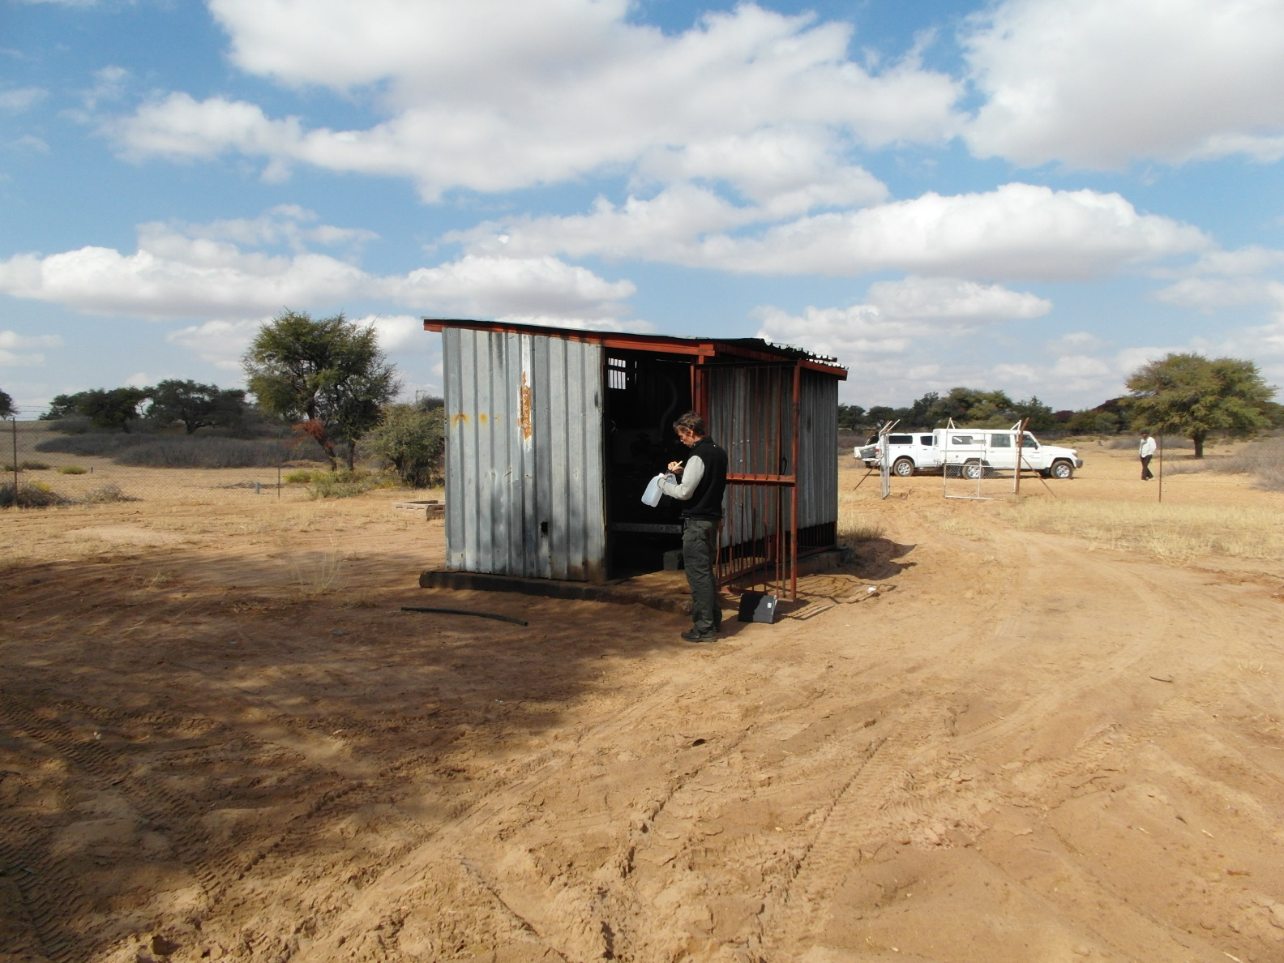

Water quality
In-situ water quality sampling
Determinand | Units | BH9087
pH | pH units | n/a²
Temperature | (°c) | n/a²
Conductivity | (µS/cm) | n/a²
e.coli¹ | (CFU/ml) | 0
¹sampled in-situ using an e.coli hygiene and monitoring swab
²Member state personnel did not sample in-situ determinants

Laboratory water quality sampling
Determinand | Units | BH9087
Alkalinity | mg CaCO3/L | 29.1
Arsenic | µg As/L | <2.00
Calcium | mg Ca/L | <1.00
Chloride (Soluble) | mg Cl/L | 123
Conductivity | mS/m | 64.0
Fluoride | µg F/L | 174
Iron | mg Fe/L | 0.03
Total hardness | mg CaCO3/L | <6.67
Magnesium | mg Mg/L | <1.00
Manganese | mg Mn/L | <0.01
Sodium | mg Na/L | 114
Ammonia (Soluble)* | mg N/L | <0.10
Nitrate (Soluble) | mg N/L | 5.00
pH | pH units | 6.49
Selenium | µg Se/L | <2.00
Sulphate (Soluble) | mg SO4/L | 49.9
Turbidity | NTU | 0.4

Legend
Limit exceedance
Exceeds drinking water limit (SANS, 2011)
Exceeds livestock watering limit (DWAF, 1996a)
Exceeds irrigation limit (DWAF, 1996b)
No limit/ no exceedance

Main Impacts at the Site
Causes¹ | Sources²
 | Rural housing/small holdings, retail and light industrial activities
1 CAUSE: A stressor that occurs at an intensity, duration and frequency of exposure that results in a change in the ecological conditions.
2 SOURCE: A source is the origin of a stressor. It is an entity or action that releases or imposes a stressor into the waterbody (EPA, 2000).

Site BH1255, Mokatako, Botswana

Site Description
The site is located on the outskirts of the village of Mokatako in Botswana. The borehole is sited directly adjacent (700m) to the Ramatlabama River, less than 1km upstream of the confluence with the Molopo River. The primary land use is a sparsely populated, small, rural village with a school and limited other amenities. Livestock were present in the village, with subsistence agriculture present on a limited scale. Large scale agriculture was present within the surrounding region, but all croplands observed were dryland agriculture. Commercial livestock farming was also observed in the region.

Longitude | 25.226076° | Latitude | -25.763613°
Altitude (m.a.s.l.) | 1168 | Country | Botswana
Date sampled | 24 July 2015 | River catchment | Ramatlabama/Molopo
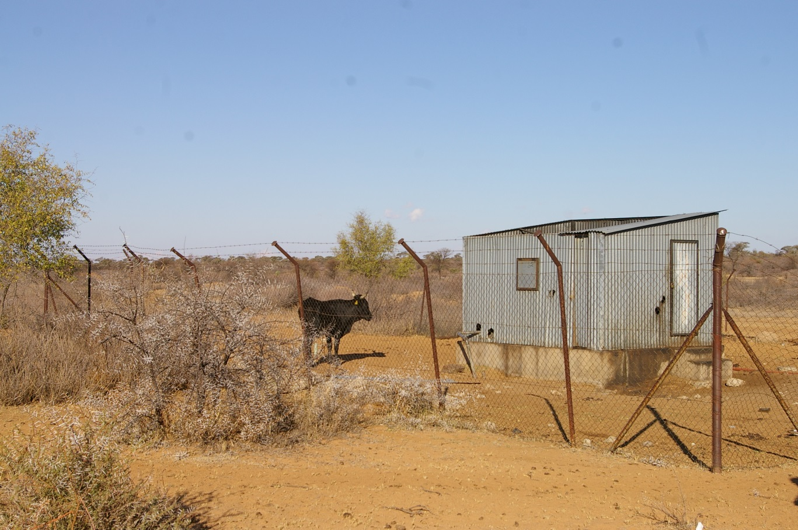

Water quality
In-situ water quality sampling
Determinand | Units | BH1255
pH | pH units | n/a²
Temperature | (°c) | n/a²
Conductivity | (µS/cm) | n/a²
e.coli¹ | (CFU/ml) | 0
¹sampled in-situ using an e.coli hygiene and monitoring swab
²Member state personnel did not sample in-situ determinants

Laboratory water quality sampling
Determinand | Units | BH1255
Alkalinity | mg CaCO3/L | 377
Arsenic | µg As/L | <2.00
Calcium | mg Ca/L | 59.2
Chloride (Soluble) | mg Cl/L | 34.6
Conductivity | mS/m | 86.3
Fluoride | µg F/L | 816
Iron | mg Fe/L | 0.02
Total hardness | mg CaCO3/L | 258
Magnesium | mg Mg/L | 26.3
Manganese | mg Mn/L | 0.02
Sodium | mg Na/L | 89.2
Ammonia (Soluble)* | mg N/L | <0.10
Nitrate (Soluble) | mg N/L | <0.10
pH | pH units | 7.35
Selenium | µg Se/L | 3.69
Sulphate (Soluble) | mg SO4/L | 29.1
Turbidity | NTU | 0.3

Legend
Limit exceedance
Exceeds drinking water limit (SANS, 2011)
Exceeds livestock watering limit (DWAF, 1996a)
Exceeds irrigation limit (DWAF, 1996b)
No limit/ no exceedance

Main Impacts at the Site
Causes¹ | Sources²
1 CAUSE: A stressor that occurs at an intensity, duration and frequency of exposure that results in a change in the ecological conditions.
2 SOURCE: A source is the origin of a stressor. It is an entity or action that releases or imposes a stressor into the waterbody (EPA, 2000).

Site 42477, Tswalu, South Africa

Site Description
The site is situated within the Kuruman River catchment in the Tswalu Private Game Reserve, 100km north-west of the town of Kuruman. The Kuruman River is a tributary of the Molopo River. The primary land use is the game reserve, with the borehole supplying water to the staff accommodation of the reserve for domestic use.

Longitude | 22.488683° | Latitude | -27.285922°
Altitude (m.a.s.l.) | 1210 | Country | South Africa
Date sampled | 25 July 2015 | River catchment | Kuruman
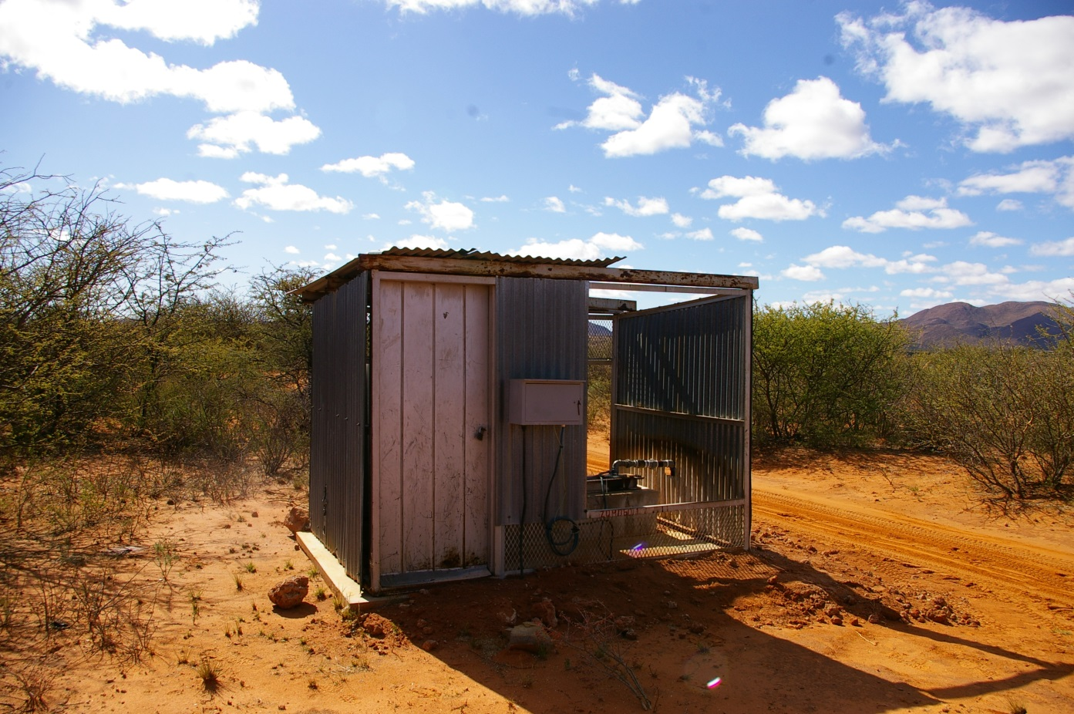

Water quality
In-situ water quality sampling
Determinand | Units | 42477
pH | pH units | n/a²
Temperature | (°c) | n/a²
Conductivity | (µS/cm) | n/a²
e.coli¹ | (CFU/ml) | 0
¹sampled in-situ using an e.coli hygiene and monitoring swab
²Member state personnel did not sample in-situ determinants

Laboratory water quality sampling
Determinand | Units | 42477
Alkalinity | mg CaCO3/L | 135
Arsenic | µg As/L | 2.48
Calcium | mg Ca/L | 39.2
Chloride (Soluble) | mg Cl/L | 41.9
Conductivity | mS/m | 58.0
Fluoride | µg F/L | 335
Iron | mg Fe/L | 0.02
Total hardness | mg CaCO3/L | 206
Magnesium | mg Mg/L | 25.9
Manganese | mg Mn/L | <0.01
Sodium | mg Na/L | 29.2
Ammonia (Soluble)* | mg N/L | <0.10
Nitrate (Soluble) | mg N/L | 15.4
pH | pH units | 6.67
Selenium | µg Se/L | <2.00
Sulphate (Soluble) | mg SO4/L | 15.4
Turbidity | NTU | 0.6

Legend
Limit exceedance
Exceeds drinking water limit (SANS, 2011)
Exceeds livestock watering limit (DWAF, 1996a)
Exceeds irrigation limit (DWAF, 1996b)
No limit/ no exceedance

Main Impacts at the Site
Causes¹ | Sources²
1 CAUSE: A stressor that occurs at an intensity, duration and frequency of exposure that results in a change in the ecological conditions.
2 SOURCE: A source is the origin of a stressor. It is an entity or action that releases or imposes a stressor into the waterbody (EPA, 2000).

References
DWAF. 1996a. South African Water Quality Guidelines (Volume 5): Agricultural Water Use: Livestock Watering. Department of Water Affairs and Forestry (DWAF), Pretoria.

DWAF. 1996b. South African Water Quality Guidelines (Volume 4): Agricultural Water Use: Irrigation. Department of Water Affairs and Forestry (DWAF), Pretoria.

SANS 241. 2011. South African National Standard: Drinking water: Part 1: Microbiological, physical, aesthetic and chemical determinands. June 2011.

