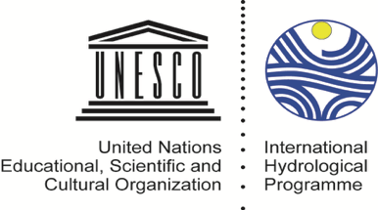
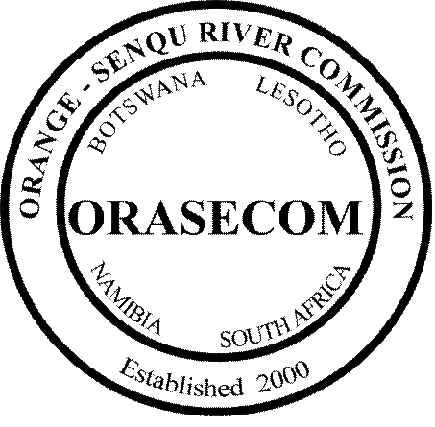

OPERATIONALIZATION OF THE STAMPRIET TRANSBOUNDARY AQUIFER SYSTEM (STAS) MULTI-COUNTRY COOPERATION MECHANISM (MCCM)

TERMS OF REFERENCE

MAY 2018

Acronyms

AWG | Ad hoc Working Groups
BCC | Borehole Completion Certificates
BWIS | Basin Water Information System
CM | Consultation Mechanism
DG | Division Geohydrology (Namibia)
DGS | Department of Geology Survey (Botswana)
DWA | Department of Water Affairs (Botswana)
DWAF | Department of Water Affairs and Forestry (Namibia)
DWS | Department of Water and Sanitation (South Africa)
GEF | Global Environment Facility
GGRETA | Governance of Groundwater Resources in Transboundary Aquifers
GIZ | Deutsche Gesellschaft für Internationale Zusammenarbeit (German Development Agency)
GROWAS | Groundwater Database (Namibia)
GWHC | Ground Water Hydrology Committee
IHP | International Hydrological Programme
IWRM | Integrated Water Resources Management
MAWF | Ministry of Agriculture, Water and Forestry (Namibia)
MCCM | Multi-Country Cooperation Mechanism
NBA | National Borehole Archive
NFP | National Focal Point
NGIS | National Groundwater Information System
NIWIS | National Integrated Water Information System
NWSAS | North Western Sahara Aquifer System
OKACOM | Okavango River Commission
ORASECOM | Orange-Senqu River Commission
OSS | Observatory of the Sahara and Sahel
UNDP | United Nations Development Programme
SDC | Swiss Agency for Development and Cooperation
SDG | Sustainable Development Goals
STAS | Stampriet Transboundary Aquifer System
TDA | Transboundary Diagnostic Analysis
TTT | Technical Task Team
WIS | ORASECOM Water Information System
WINS | Water Information Network System

1. Background and Rationale

The Stampriet Transboundary Aquifer System (STAS) stretches from Central Namibia into Western Botswana and South Africa’s Northern Cape Province, and lies entirely within the Orange-Senqu River Basin (Figure 1.1). The STAS covers a total area of around 87 000 km², of which 73% is in Namibia, 19% in Botswana, and 8% in South Africa. With financial assistance from the Swiss Agency for Development Corporation (SDC), and with the technical assistance of UNESCO-IHP, the STAS countries have been actively cooperating in the in-depth assessment of the aquifer and its characteristics since 2013, through the Governance of Groundwater Resources in Transboundary Aquifers (GGRETA) project.

The first phase of the project (2013-2015) focused on an in-depth assessment of the STAS using existing data and information, which allowed for the establishing of a shared science based understanding of the resource. The activities of the second phase of the project (2016-2018) focused primarily on consolidating the technical results achieved and the tools developed in the first phase, and on strengthening capacity on groundwater governance at the national and transboundary levels in order to support the process of the establishment of a Multi Country Cooperation Mechanism (MCCM) for the governance and management of the STAS.

Figure 1.1: Location of the Stampriet Transboundary Aquifer System (in orange) and the Orange-Senqu River Basin (in green)
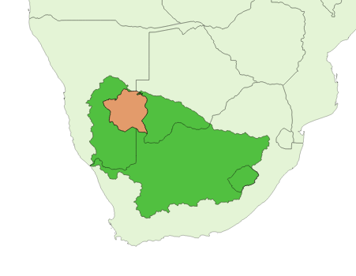

2. The establishment of the Stampriet Transboundary Aquifer System (STAS) Multi-Country Cooperation Mechanism (MCCM)

2.1 Overview of the STAS
The STAS is a very large transboundary aquifer system, receiving relatively insignificant recharge, in a semi-arid to arid region without permanent surface water. The STAS is made up of two deep confined artesian transboundary aquifers in the Karoo sediments (Auob and Nossob aquifers), overlain by an unconfined aquifer system in the Kalahari sediments (Kalahari aquifer). Average rainfall in the STAS area range from 150 to 310 mm/yr with very limited recharge (estimated at 0.5% of rainfall) to the Kalahari aquifer during years with average rainfall. Recharge to the deeper Auob and Nossob aquifers in normal rainfall years is negligible, but considerable recharge occurs during extreme rainfall events. The area is sparsely populated with slightly over 45,000 persons concentrated in settlements ranging from small rural settlements to villages and towns. Groundwater is the major source of water in the area, and provides potable water to the population, livestock and for irrigation. There is currently no industrial or mining activities taking place in the STAS area. Over 20 million m³/year is abstracted from the STAS , a considerable majority of which occurs in Namibia (over 95%). The largest consumer of water is agriculture in form of irrigation (~46%) followed by stock watering (~38%) and domestic use (~16%). There is a considerable amount of water that is difficult to estimate that is lost through the evaporative losses of invasive plant species.

2.2 STAS in-depth assessment and joint borehole database

The on-going cooperation over the STAS between the Department of Water Affairs of Botswana, the Department of Water Affairs and Forestry of Namibia, and the Department of Water and Sanitation of South Africa arising from the GGRETA project, has yielded an in-depth assessment of the aquifer characteristics; including current and projected uses of groundwater, and likely future stress conditions under relevant factors.

The assessment initiated in 2013 was carried out by a team familiar with the area and composed of professionals from Botswana, Namibia and South Africa who met regularly in the form of regional meetings (six meetings in total) that were held on rotational basis among the three countries sharing the STAS. Such meetings also included two stakeholder consultation meetings that counted with the participation of a broader audience (e.g. governments, regional organizations, farmers, NGOs,). Based on the data collected, analyzed and harmonized by national experts, a joint borehole database with information on more than 10 attributes on approximately 6000 boreholes was set up. This database is considered the cornerstone for the assessment as it allowed the preparation of more than 40 thematic maps providing information on groundwater levels, borehole yield, geochemistry and groundwater quality of the aquifer system.

As a result of the assessment, the hydrogeological typology of the STAS can be stated as a weakly recharging three layer aquifer system (Kalahari, Auob and Nossob aquifers), characterised by low transmissivity, and low storage, primarily being utilised in Namibia for socio economic growth, where withdrawal from storage has caused local groundwater level to decline. In the extension of the aquifers into South Africa, water quality constraints have restricted its utilisation, while in Botswana the potential for available resources is likely to be exploited, but insufficient data is available for making firm conclusions.

In particular, the challenges that have emerged from the assessment can be summarized as follow:
- Lack of monitoring data (climate, groundwater abstraction, water levels, water quality) seriously hampers a systematic diagnostic analysis of groundwater quantity stress;
- pollution by humans and animals, and that caused by poor well construction and lack of protection, appears to be localized at present to the shallow Kalahari aquifers;
- although there is no mining or industrial activity in the STAS area at present, unregulated mining activities in the future might lead to pollution of the aquifer system due to its fragility and vulnerability;
- acceleration of vertical leakage between superposed aquifers from uncemented borehole casings and metallic corrosion.

In view of the importance of the aquifer resources to the future of the local population, the three countries sharing the aquifer concurred in 2016 on the willingness of establishing a Multi-Country Cooperation Mechanism (MCCM) for the governance and management of the STAS.

2.3 Nesting of the STAS MCCM in ORASECOM

On 17-18 May 2017, Members of the Botswana, Namibia and South Africa Delegation attending the 3rd Orange-Senqu River Commission (ORASECOM) Ground Water Hydrology Committee (GWHC) and the Technical Task Team (TTT), supported the proposal to establish the STAS MCCM within the ORASECOM structure. This proposal was discussed at the 34th Ordinary meeting of the ORASECOM Council meeting (17-18 August 2017, Windhoek, Namibia) which resolved that the STAS MCCM be nested/housed within the ORASECOM GWHC. The Ordinary meeting of the ORASECOM Forum of the Parties (Ministers responsible for water), held on 16 November 2017 in Kasane, Botswana, endorsed the resolution of the Council and approved milestones and schedule for the nesting (see Section 3).
The process that led to the establishment of the STAS joint governance mechanism is a breakthrough in many aspects. First, it is the first arrangement for the governance of a transboundary aquifers since the adoption of the Sustainable Development Goals (SDGs) in 2016. Prior to the ORASECOM’s decision of establishing this mechanism, only six formal and two informal agreements were documented worldwide. Second, it is the first operational governance mechanism to be nested in a river basin organization, thus fully capturing the IWRM approach (in particular the conjunctive management of grounsdwater and surface water) and directly contributing to the implementation of Target 6.5 both at national and transboundary level. Third, the mechanism will enable sustainable actions on the ground, as activities related to the STAS are part of ORASECOM’s 10-year IWRM Plan (2015-2024). As such, the implementation and reporting of activities related to the STAS will preside under ORASECOM’s mandate and will be fully integrated therein with no additional costs to the STAS countries. Last but not least, what is striking in this process that led to institutionalizing cooperation over the STAS was its expeditiousness. This was possible mainly because of the institutional architecture of ORASECOM, structured into a Council, a Secretariat, Task Teams and committees (e.g. GWHC), that has allowed the proposal made by the GWHC to be brought for the Council’s consideration and decision in less than one year.

2.3.1 The structure of ORASECOM and its GWHC

Structure of ORASECOM
The structure of ORASECOM is presented in the upperpart of Figure 2.1. Ministers meet once every year to direct the Commission and review overall programme of work. Senior Officials (Director General/Permanent Secretary level) meet once every year to consider the Commission work programme, budget and prepare submission to Ministers. The Council meets twice a year to review and discuss progress on programme of work and budget; discuss bilateral cooperation projects; and exchange information on national development projects of transboundary significance. The Task Teams (including the GWHC) meet at least twice a year to discuss respective activities of the Commission and prepare technical updates for the Council. Committees report directly to Task Teams, who then report to the Council. The Secretariat oversees implementation of the Commission’s work programme and is the corporate arm of the Commission. The Secretariat core staff currently comprises Executive Secretary, Water Resources Specialist, Finance and Administration, Administration Assistant. ORASECOM projects are currently delivered through consultancies and medium/short term specialists to the Secretariat and Member States.

Countries to contribute 76,000 Euros per country per year towards operations of the Commission (2018/19 Financial Year). From 2004 to 2014, it has been 34 000 Euros, and 55 000 Euros for 2015 to 2017.

Objective of the GWHC
The objective of the GWHC is to oversee and advise the TTT and the Secretariat on the development and management of groundwater resources of the Orange-Senqu River Basin.

Constitutions of the GWHC
Each Party provides one official and one alternate official, both with ground water resources development and management background.

Meetings of the GWHC
The meetings of the GWHC are conducted as follows:-
- The GWHC and its meetings are chaired on a rotating basis, following the Commission chairpersonship;
- The GWHC meets at least twice a year prior to the TTT’s meetings, but may conduct extraordinary meetings on a needs-basis;
- Ordinary meetings of the GWHC are convened ahead of those of the TTT to enable preparation of related submissions to the TTT;
- Quorum for meetings of the GWHC is formed when at least three State Parties are represented;
- The venue for ordinary meetings of the GWHC are the same as those of the TTT; and
- The Chairperson of the GWHC reports to the TTT.

Financial arrangements
The Parties cover the costs of travel and participation for their respective GWHC officials to the ordinary meetings. The Secretariat may mobilise funds for extra ordinary meetings of the GWHC. In cases where the Secretariat is not successful in raising funds for extra-ordinary meetings of the GWHC, Parties shall cover costs of travel and participation of their respective GWHC officials to the extra-ordinary meetings of the GWHC.

Functions of the GWHC
- Oversee and advise the TTT and the Commission on:
  - the development and management of the groundwater resources of the Basin;
  - the implementation of the relevant provisions of the ORASECOM Agreement and its revised versions, including the standardised form of collecting, processing and disseminating groundwater data or information;
  - the implementation of the groundwater activities and projects in the Integrated Water Resources Management (IWRM) Plan for the Orange-Senqu River Basin;
  - the implementation of the activities, projects, and programmes aimed at the development and management of the trans-boundary aquifers of the Basin; and
  - Undertake any other activities that may be assigned to it by the TTT and/or the Commission.

2.3.2 Objective of the STAS MCCM

The over-arching objective of a STAS MCCM is to transition from GGRETA project-driven cooperation to permanent institutionalized cooperation among the countries sharing the STAS within the ORASECOM structure.

In the short term, the STAS MCCM will:
- continue the joint study and characterization of STAS,
- generate flow of data feeding the STAS borehole database and numerical model (once operational), and
- report on activities at each meeting of the GWHC.

In the long term, the vision is to move from data collection & exchange to joint strategizing/advising STAS countries on management of the aquifer and its resources.

2.3.3 Structure of the STAS MCCM

The STAS MCCM aims at integrating the GGRETA project support structure in the GWHC, which operates under the TTT established by the ORASECOM Council.

Under the overall guidance of GGRETA Project National Coordinators, the GGRETA hydrogeology/model, legal and institutional, and gender National Focal Points (NFP) in the three countries, will assist and report to the GWHC Officials on data collected that will serve as a basis for the development of scenarios and project activities. In the short term, the GWHC Officials will be in charge of updating the STAS joint borehole database during GWHC meetings, and reporting to the TTT on the work program according to the planning and annual budget. The TTT will in return report to the Council. Ad hoc Working Groups (AWG) composed by experts nominated by the Council or GWHC will be formed as and when necessary for the evaluation of studies, or to support the design of projects and activities. Invited Members (e.g. SADC-GMI) would on a regular basis be invited to GWHC meetings.

The STAS MCCM does not have a dedicated budget but would not add any additional costs to ORASECOM as GWHC meetings are already covered in the budget.

Figure 2.1: Structure of the STAS Multi-Country Cooperation Mechanism (MCCM)
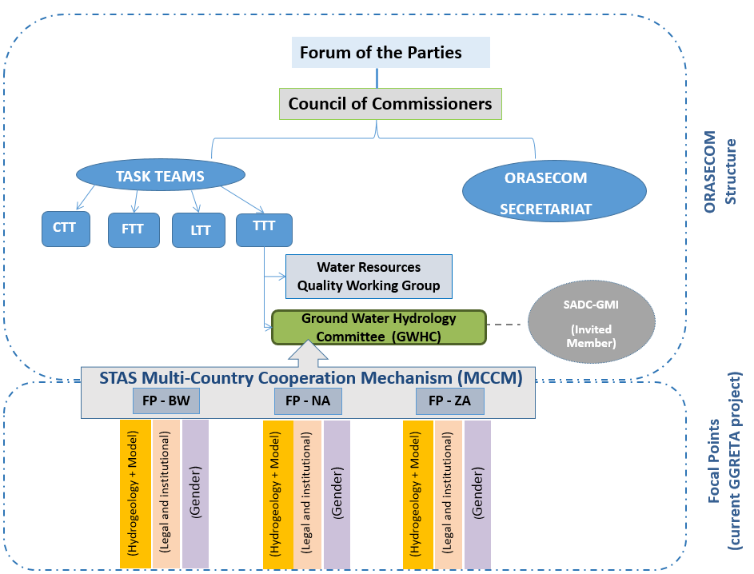

3. Operationalization of the STAS MCCM

As part of the resolution in August 2017, the Council also directed that the STAS databases, websites, information generated and requisite rights be migrated to the ORASECOM Secretariat, and be integrated into the ORASECOM Water Information System (WIS), with copies established in the offices of the STAS riparian Countries, before the end of the second phase of the GGRETA project.

The Ordinary meeting of the ORASECOM Forum of the Parties (Ministers responsible for water), held on 16 November 2017 in Kasane, Botswana, endorsed the resolution of the Council. The Forum of the Parties also approved the following proposed milestones and schedule for the nesting as well as migration of the database and information:

- Joint drafting of the Terms of Reference between UNESCO and ORASECOM for the implementation of tasks to be undertaken,
- Engagement of a short-term consultancy to assist with the required tasks,
- Implementation of the decisions, i.e.:
  - assessment of the current capabilities of ORASECOM WIS and national information systems,
  - development of protocols for data collection, update and maintenance of databases,
  - consultations with key stakeholders,
  - migration of the database,
  - training on operation and maintenance of the database.

3.1 GGRETA project STAS databases

All information generated by the GGRETA project and STAS databases are currently available in the following Dropbox link:
https://www.dropbox.com/sh/nkfp07me0u7pynd/AACVFKTR9-mY5RkMDz_ShUPfa?dl=0
The information in the STAS Dropbox is structured in 4 main components as depicted in Figure 3.1: Meetings, Publications, STAS Databases, and STAS Model.

Figure 3.1: Main components of the STAS Dropbox
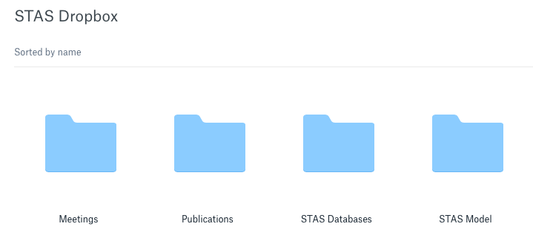
The Meetings component consists of presentations and reports of the meetings that were organized within the framework of the GGRETA project (both Phase 1 and Phase 2). The Publications component consists of publications that were produced within the framework of the GGRETA project (not limited to the STAS). The STAS Databases component consists of two databases, i.e. the hydrogeology and gender. The STAS Model component will contain source files and tutorials for the numerical model that is currently being developed in ModelMuse in collaboration with the University of Avignon.

3.1.1. Hydrogeology database
The hydrogeology database contains key information that was collected and harmonized during the in-depth assessment of the STAS. The information is structured in 10 sub-components as depicted in Figure 3.2. Among these sub-components are the STAS joint borehole database providing information on groundwater levels, borehole yield, geochemistry and groundwater quality of the aquifer system (0 – Borehole database) which was the cornerstone of the assessment of the STAS as it allowed the preparation of more than 40 thematic maps (1 – Maps (GGRETA report 1)). The STAS joint borehole database is a .CSV format file with information (i.e. attributes in bold in Figure 3.3) for approximately 6000 boreholes. The database is being updated on regular basis during GGRETA Phase 2 and new data on geochemistry (carbon-14 and deuterium) has been added. Updated cross sections and shapefiles are available in sub-components 2 – Cross sections and 3 – Shapefiles, respectively. Key reports (e.g. JICA and Matsheng) are available in 4 – Bibliography. Additional data for a specific topic (i.e. piezometry, groundwater quality, geochemistry, geology, precipitation, evapotranspiration and abstraction) are available from sub-components 5 – Piezometric data to 10 – Abstraction data.

Figure 3.2: Sub-components of the hydrogeology database

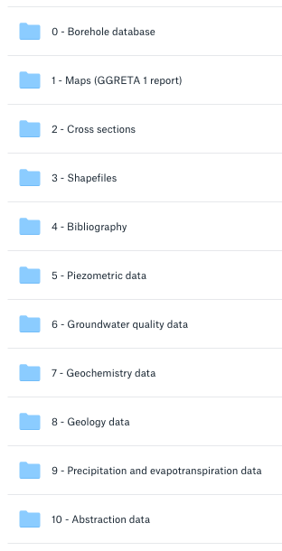

Figure 3.3: Attributes of the STAS joint borehole database

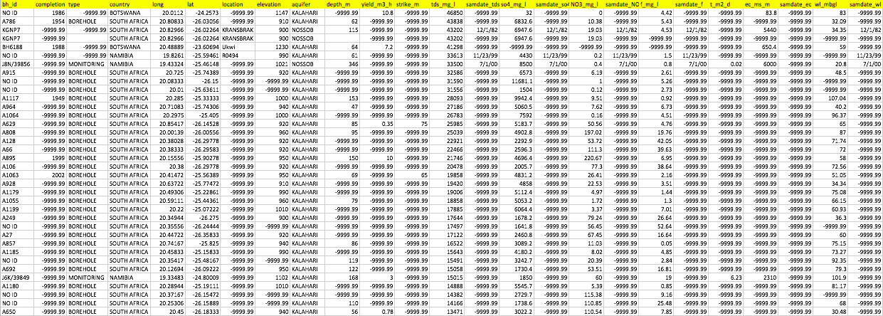

3.1.2. Priority monitoring boreholes in the STAS
The in-depth assessment of the STAS has permitted to identify priority monitoring boreholes that have long-term chronicles of groundwater level (monthly basis) (Table 3.1). It should be noted that areas where there has not been monitoring of the deep transboundary aquifers (Auob or Nossob), consideration and priority should be given, for future activities. These chronicles will be critical to calibrate the STAS model and to better understand the impact of pumping and climate variability on groundwater resources in the STAS.

Table 3.1: Priority monitoring boreholes in the STAS
Site ID | Name | Country | Long | Lat | Altitude | Aquifer | Time frame
26164 | Aminuis | Namibia | 19.36556 | -23.6495 | 1209 | Kalahari | 1986-2017
35157 | Aranos | Namibia | 19.12911 | -24.1376 | 1184 | Kalahari | 1986-2017
7407 | Aranos | Namibia | 19.13256 | -24.1344 | 1185 | Auob | 1986-2017
7638 | Aranos | Namibia | 19.12933 | -24.1346 | 1185 | Auob | 1986-2017
32783 | Aranos | Namibia | 19.13525 | -24.1323 | 1189 | Auob | 1986-2017
8935 | Aranos | Namibia | 19.1327 | -24.1326 | 1185 | Nossob | 1986-2017
7491 | Gochas | Namibia | 18.81138 | -24.86125 | 1122 | Kalahari | 1986-2017
16343 | Gochas | Namibia | 18.7434 | -24.61379 | 1190 | Auob | 1986-2017
21258 | Kries | Namibia | 18.19439 | -25.04131 | 1189 | Auob | 1986-2017
7309 | Leonardville | Namibia | 18.79191 | -23.49953 | 1280 | Auob | 1986-2017
23334 | Onderompaba | Namibia | 19.55556 | -23.14528 | 1277 | Kalahari | 1986-2017
39845 | Okonyama | Namibia | 19.62489 | -23.40098 | 1258.05 | Kalahari | 2000-2007
39846 | Okonyama | Namibia | 19.62577 | -23.40049 | 1256.39 | Auob | 2000-2004
39847 | Okonyama | Namibia | 19.62621 | -23.40105 | 1256.38 | Nossob | 2000-2004
39854 | Tweerivier | Namibia | 19.43266 | -25.46122 | 1021.25 | Kalahari | 2004-2018
39856 | Tweerivier | Namibia | 19.43324 | -25.46148 | 1021.26 | Nossob | 2007-2018
22546 | Olifantswater West | Namibia | 18.39241 | -23.68523 | 1268.08 | Kalahari | 1985-2008
22546 | Olifantswater West | Namibia | 18.39241 | -23.68523 | 1268.08 | Nossob | 1985-2008
21784 | Olifantswater West | Namibia | 18.39452 | -23.68436 | 1269.63 | Auob | 1985-2009
21814 | Olifantswater West | Namibia | 18.39452 | -23.68436 | 1269.63 | Kalahari | 1985-2009
39840 | Olifantswater West | Namibia | 18.38976 | -23.64725 | 1275.26 | Auob | 2000-2018
39841 | Olifantswater West | Namibia | 18.38970 | -23.64783 | 1275.60 | Nossob | 2000-2018
22544 | Olifantswater West | Namibia | 18.39462 | -23.68476 | 1269.70 | Auob | 1905-2009
22545 | Olifantswater West | Namibia | 18.39398 | -23.68266 | 1268.08 | Kalahari | 1985-2009
22545 | Olifantswater West | Namibia | 18.39398 | -23.68266 | 1268.08 | Auob | 1985-2009
22837 | Tugela | Namibia | 18.25345 | -24.82013 | 1202 | Nossob | 1975-2018
22838 | Tugela | Namibia | 18.25379 | -24.82056 | 1206.46 | Kalahari | 1985-2009
22838 | Tugela | Namibia | 18.25379 | -24.82056 | 1206.46 | Auob | 1985-2009
22838 | Tugela | Namibia | 18.25379 | -24.82056 | 1206.46 | Nossob | 1985-2009
39842 | Steynrus | Namibia | 18.79340 | -24.04592 | 1208.05 | Kalahari | 2000-2018
10120 | Boomplaas | Namibia | 18.56223 | -24.54999 | 1160 | Auob | 1980-2002
32457 | Spes Bona | Namibia | 18.39944 | -24.32804 | 1183 | Auob | 1975-2002
D4N1936 | Dalkeith | South Africa | 20.1575 | -25.9037 |  | Kalahari | 2002-2014
BH10214 | Ncojane | Botswana | 20.7485 | -23.5188 | 1224.5 | Auob | 2008-2013
BH10215 | Ncojane | Botswana | 20.2525 | -23.2813 | 1262.23 | Auob | 2008-2013
BH10216 | Ncojane | Botswana | 20.4695 | -23.4967 | 1240.32 | Auob | 2008-2013
BH10217 | Ncojane | Botswana | 20.6368 | -23.5299 | 1231.32 | Auob | 2008-2013
BH10316 | Ncojane | Botswana | 20.0308 | -23.2451 | 1260.52 | Auob | 2008-2012
BH10220 | Ncojane | Botswana | 21.0322 | -23.1447 | 1241.75 | Auob | 2005-2013
BH8646 | Ncojane | Botswana | 20.6356 | -23.1741 | 1256 | Auob | 2004-2013

3.1.3. Gender database
The gender database is currently being developed and will contain the materials (e.g. questionnaires for data collection), results and analyses of the gender surveys that were conducted within the framework of the GGRETA project in October 2017 in Namibia and Botswana.

3.2 Preliminary assessment of the current capabilities of ORASECOM WIS and national information systems

3.2.1 Botswana
The Department of Water Affairs (DWA) carries out the mandate of water resources management which includes water resources planning, assessment and protection and monitoring. The DWA also conducts water resources policy and strategy formulation, reviews and developments of pieces of legislation for better regulation of water allocation and use. To effectively and efficiently carry out its mandate the DWA has adopted GIS in 1995.
Groundwater monitoring in Botswana is done by numerous governmental organizations and the various databases are currently not properly linked. The main databases used for groundwater monitoring are handled by the DWA and are stored in the following stand-alone databases:

- National Borehole Archive (NBA) database: General borehole information,
- WELLMON database: Stores water level monitoring from production and observation boreholes, rainfall and reservoir readings,
- AQUABASE database: Water quality.

The DWA and the Department of Geological Survey (DGS) have historically maintained a mainframe National Borehole Archive (NBA). The NBA is a limited MS-DOS based stand-alone system that does not support multiple-user configurations. The NBA is populated from the data recorded on Borehole Completion Certificates (BCC) which is then converted into GIS format to enable the visualization of data. The obtained point-data shapefile contains basic information on borehole location, ownership, depth, etc…

The WELLMON and AQUABASE databases contain very limited data in the STAS area, and groundwater level and quality data was collected through the Ghanzi DWA office which keeps a record of some boreholes in the Matsheng well field.

3.2.2 Namibia
The Geohydrology Division at the Namibian Ministry of Agriculture, Water and Forestry (MAWF) is responsible to collect and observe the safekeeping of the country’s groundwater resources data and information. As groundwater plays a major role in water supply, the Division is running a nationwide quantitative and qualitative groundwater monitoring program.Furthermore the division is responsible for providing advise to the Division of Water Law and Policy Administration in regards to the technical recommendation of extraction license applications and for the general and specific investigation of groundwater bodies. For these purposes the Division hosts the national groundwater database GROWAS.

In 2011 a detailed workflow analysis was carried out in the Geohydrology Division to identify what kind of data is collected and handled and how this data is managed. The workflow analysis revealed that GROWAS lacked essential functionalities for the management of groundwater relevant data. On the quality side, it was found that key information for many water points was missing, e.g. errors were largely stemming from wrong coordinates and coordinate systems, incompatible data formats or wrong entries from import forms and duplicated borehole identification numbers. On the structural part of the database design, shortcomings were a rather cryptic user interface, missing control and query functions, lacking storage functionalities like for monitoring data time series. It was furthermore identified that the workflow itself can be improved and made more efficient with an adapted data processing scheme. For example, due to the imminent enabling of the new Namibian Water Act licensing procedures for the application of groundwater abstraction and drilling permits had to be incorporated into the Information System. In this connection, was decided to completely redesign GROWAS and prepare GROWAS II.

GROWAS II consists of two major parts: the database structure itself including the database server software package PostgreSQL and the graphical user interface which is installed on the client computer. Most of the functionalities are located within the client application. These functions are distributed to several modules as depicted in Figure 3.4.

Figure 3.4: Welcome page and main menu of GROWAS II

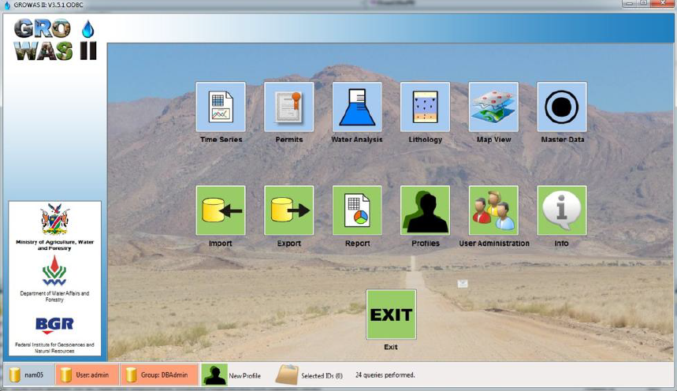

GROWAS II functionalities include:
- Geo-database for map visualizations and query functionalities (see Figure 3.5);
- Import and export templates of borehole completion reports, lithology logs, well installation logs, water sampling forms, water analysis forms, water level measurements and pump tests needed to be developed;
- Programming of modules for data storing, visualization, evaluation and licensing like: borehole information, lithology, water level monitoring, hydrochemistry, and a licensing module for drilling and water abstraction permits (see Figure 3.6);
- Report function for queries and annual reporting on groundwater information situation for Basin Management Units and Political Regions;
- Linkage to third party software like Google Earth.
The database is not internet based, but is available within intranet at the Department of Water Affairs and Forestry (DWAF).

Figure 3.5: Map-view for spatial queries. Map layers can be added and customized
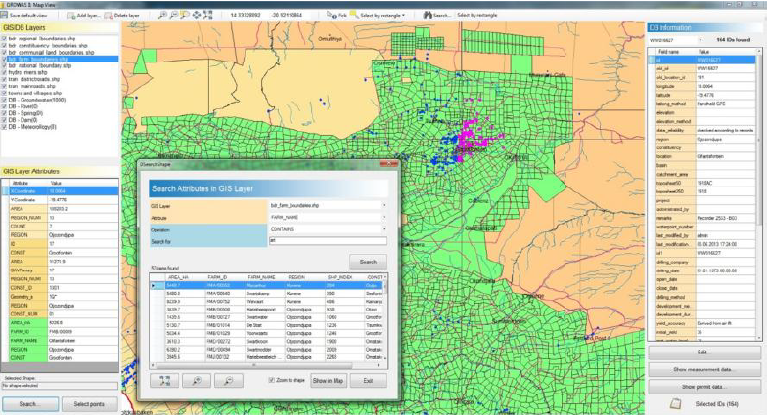

Figure 3.6: Temporary, confirmed or all monitoring data can be displayed to allow easy plausibility control
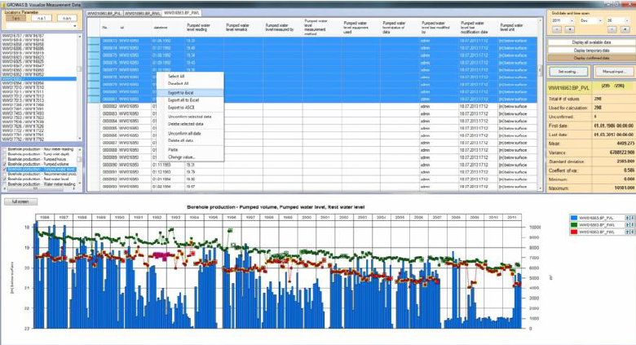

The introduction of the Integrated Water Resources Management Approach (IWRM) for the different water basins in Namibia goes hand in hand with the development of a nationwide integrated water resource management strategy and data warehouse, the so-called BWIS (Basin Water Information System). It is thus envisioned to connect GROWAS II with BWIS once operational.

3.2.3 South Africa
The South African National Water Act (No 36 of 1998), as well as the South African Water Services Act (No 108 of 1997) through Chapter 14 and Chapter 10 respectively, mandate the South African Department of Water and Sanitation (DWS) to establish various national water information systems to address the management, use, development, conservation, protection and control of South African waters in a sustainable and equitable manner. To this effect various water information systems have been developed over time, or are in the process of being developed, with the aim of providing meaningful information to water practitioners and managers. Due to a lack of standardization across domains this has led to a situation where systems have been developed in isolation and this has resulted in a dispersed data landscape with numerous ‘islands’ or ‘silos’ of data within DWS. This has hindered an effective holistic understanding of the water business within DWS and limits decision-making across multiple domains, which directly impacts effective service delivery.

The National Integrated Water Information System (NIWIS) (http://niwis.dws.gov.za) was then conceptualized to serve as an overarching single point of access to integrated DWS business-relevant information derived from data housed in multiple isolated databases in the DWS (see Figure 3.7). The scope of the NIWIS was to develop DWS business-relevant information system for which data exists, and to structure the information in a ready-to-use format for users which include: top-level management, public, managers, scientists, water management institutions, strategic water users and research institutions across South Africa.

Figure 3.7: Structure of NIWIS
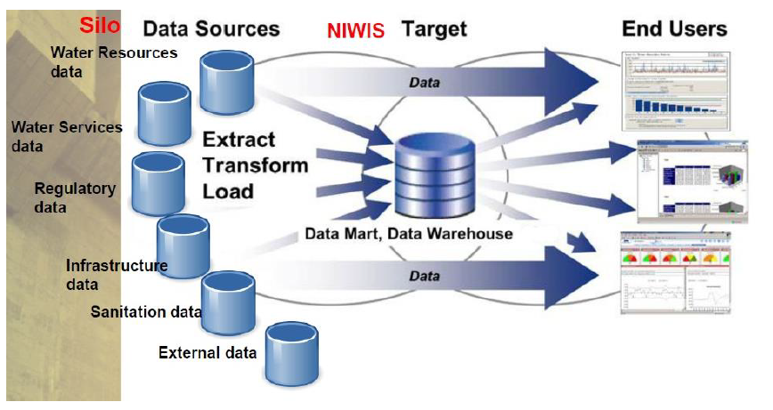

The high-level technical requirements included an integrated user-friendly and intuitive web-based solution, which incorporated GIS functionality, access control, low bandwidth usage, high levels of security and near real time extraction of information from multiple data sources in various formats. NIWIS has a 3-tier architecture comprised of a data layer, business layer and user interface layer which are based on standard Microsoft SQL Server, .NET Framework as well as an open-source GIS framework.

Figure 3.8 below shows the DWS functional areas that were covered by NIWIS.

Figure 3.8: Functional areas included in NIWIS

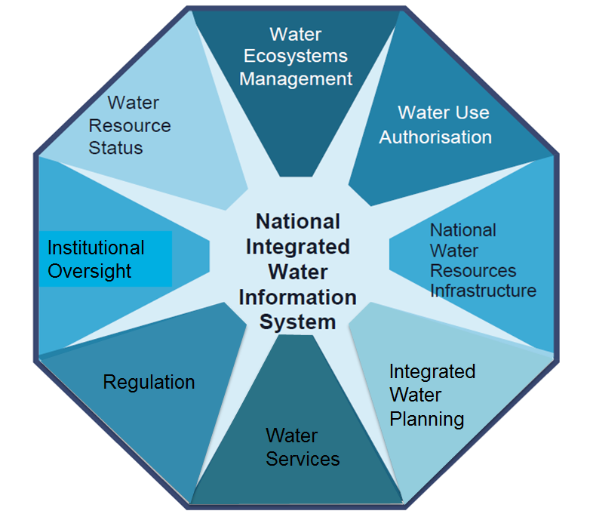

In summary, the following dashboards were developed for each of the functional areas cited:

- Surface Water Reserves and Groundwater Reserves for Water Ecosystems Management functional area,
- Water Use License Application Monitoring, Existing Lawful Water Use, General Authorisations and Water Licenses for Water Use Authorisation functional area,
- Dam Safety Regulation and Government Water Schemes for National Water Resources Infrastructure functional area,
- Water Reservoir Supply Risks for Integrated Water Planning functional area,
- Municipal Strategic Self Assessment, Access to municipal water scheme infrastructure, Access to Reliable Water Supply, Water Tariffs and Non-Revenue Water for Water Services functional area,
- Enforcement Case Management for Regulation functional area,
- Water Quality(Waste Water, Drinking Water and Resource Water), Surface Water Storage, River Flows, Groundwater Availability, Groundwater Development Potential, Floods and Monitoring Networks for Water (Surface, Groundwater and Water Quality) Monitoring Networks functional area.

An example of one of the pages providing information on groundwater (groundwater level monitoring network dashboard) is shown in Figure 3.9 below.

Figure 3.9: Information on groundwater in NIWIS
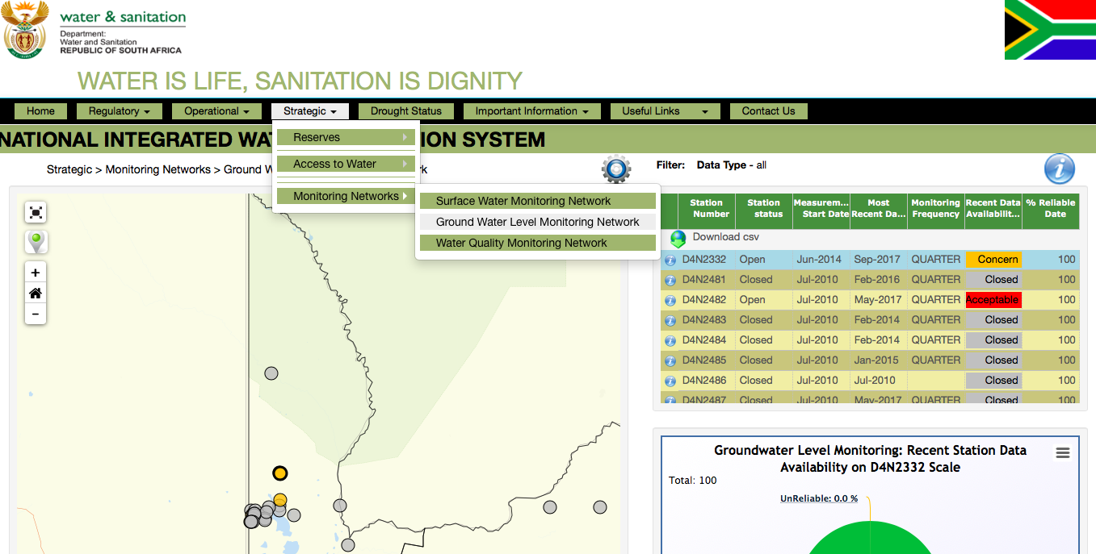

3.2.4 ORASECOM WIS
As part of the transboundary diagnostic analysis (TDA) study undertaken between 2009 and 2014, funded by the United Nations Development Programme (UNDP) and the Global Environment Facility (GEF), ORASECOM developed a public internet-based water information system, commonly known as WIS.

The WIS (http://wis.orasecom.org/) currently provides the following functions:
- Repository of data and information acquired and produced by ORASECOM and the projects associated with it (http://wis.orasecom.org/content/study/);
- Web-based search of ORASECOM data and information;
- Dedicated sections/categories of ORASECOM projects enabling the free download of data and information (mainly projects’ final reports);
- Links to riparian States websites;
- Password protected environment for submission of data by partners.
The current capabilities of WIS only allow the storage of data and do not allow the spatial visualization and preparation of selected data in thematic maps. The ORASECOM Secretariat lacks capacity in terms of groundwater data preparation and harmonization (e.g. preparation of maps using GIS softwares) as protocols for data collection and harmonization have not been implemented, and projects are currently delivered through consultancies and medium/short term specialists at the Secretariat. There is an on-going initiative (with funding from GIZ) to revamp and add functionalities to WIS.

3.2.5 Conclusions
The preliminary assessment of the current capabilities of national information systems in Botswana, Namibia and South Africa show that groundwater monitoring programmes for the acquisition and management of data and information, and platforms for stakeholder involvement do exist although there is a significant difference between countries (see Table 3.2). There is a general trend to:
- Integrate groundwater information into a nationwide IWRM strategy and data warehouse, e.g. NIWIS in South Africa and BWIS in Namibia (currently under development).
- Make the knowledge available to all by structuring the information in a ready-to-use format in user-friendly platforms not only for decisions makers but also for other stakeholders such as scientists, water management institutions, strategic water users and research institutions.

Nevertheless, there are still some challenges that need further attention. There is not a harmonized method to collect, store and share data among countries as protocols for data collection, data exchange and database maintenance have not been developed and implemented. There is still a need for improvement of data quality control methods and procedures. Due to operational challenges at the national level, there exist gaps in some of the data being monitored.
Most of the countries have more than one institution with overlapping mandates as far as groundwater development and management is concerned. As such, datasets are sometimes spread across the institutions. The regular updating of such datasets and databases is infrequent due to limited human resources capacity.
Most of the databases are main-frame-based and therefore not immediately accessible to all users, as that would be easier with web-based applications.
Existence of substantial backlogs in the conversion of data from hardcopy formats to digital/electronic formats is one of the main challenges. Another significant challenge is that some of the data were captured using proprietary computer software, which requires annual license fees renewals and use of dongles to access such data. More often than not, this proprietary software comes with externally funded national groundwater projects, and once such projects end, Member States are no longer able to maintain such databases or transfer data from such software to easily accessible tools such as Microsoft Excel.

Table 3.2: Preliminary assessment of the current capabilities of ORASECOM WIS and national information systems
 | Botswana | Namibia | South Africa
Borehole Archives | Yes | Yes | Yes
Information System for groundwater data (including spatial data visualization) | No | Yes (GROWAS II) | Yes  (NGIS - non spatial groundwater data archive)
Integrated Information System | No | No (BWIS not yet operational) | Yes (NIWIS)

Finally, considering that separate information systems already exist in the countries, it is recommended that the overall goal of ORASECOM WIS should be to provide a repository of selected data acquired at national level by the countries through protocols for data collection, data exchange and database maintenance that would be available to all users.

3.3 Preliminary assessment for the development of protocols for the data collection and database maintenance

To ensure that the STAS databases will be frequently updated and in a sustainable manner considering the existing financial and technical limitations, protocols for data collection, data exchange and database maintenance need to be developed and implemented. As not all of the country information systems are internet based, the situation in which the STAS databases will be updated remotely by ORASECOM is not likely. In this regard, it is proposed that for the time being, the STAS joint borehole database format should remain in the same format, i.e. CSV file. The update of the STAS databases should be done in each country by national officials. Their task would consist of populating all attributes by performing a reconciliation of new records, record updates and record deletions. To do that, each country should be responsible for separate STAS national databases with the same format (specified in protocols to be adopted by the countries) that would then be brought together under the overall coordination of ORASECOM.

The ORASECOM Secretariat should host the databases and act as their administrators by scheduling regular updates for the integration of the different national databases (e.g. during GWHC meetings). The protocols for data collection and database maintenance should be developed based on existing ones, e.g. the Observatory of the Sahara and Sahel (OSS) protocols on data collection and maintenance for the North Western Sahara Aquifer System (NWSAS) Consultation Mechanism (CM) and the Okavango River Commission (OKACOM) Protocol on Hydrological Data Sharing for the Okavango River Basin. It is also recommended that protocols clearly highlight harmonized units to be used.

3.4 Migration of the STAS databases and information to ORASECOM WIS

The STAS Dropbox (containing the STAS databases) should be transferred to the ORASECOM WIS repository of data (http://wis.orasecom.org/content/study/). The current capabilities of ORASECOM WIS do not allow the spatial visualization and preparation of selected data in thematic maps. In this regard, the UNESCO-IHP Water Information Network System (WINS) will temporarily host such data while the GIS functionality in ORASECOM WIS is being developed.
3.4.1 Presentation of WINS
Launched in January 2017, the Water Information Network System (WINS, available at http://ihp-wins.unesco.org/) is an open-access, knowledge-sharing platform on water-related issues at all levels, which is freely made available by the International Hydrological Programme of UNESCO. It provides Member States with a tool to foster capacity-building and sound, science-based water resources management.
WINS is built around three pillars:
- It provides a data and information base, which can be visualized in the form of maps at all scales. WINS users can combine those maps together, in order to create new information. The point of such a visualizing tool is to make complex information accessible and easily understandable by all users, including policy-makers within the water sector.
- WINS also offers an online library to share and access various types and formats of documents (PDF, word file, excel file, images, videos, etc.). This contributes to building an institutional memory, for the IHP as much as for the Member States who can share their experience of water resources management and governance
- Lastly, WINS hosts an online community, which aims at encouraging inter-disciplinary collaboration and knowledge sharing among water stakeholders. Users are gathered in working groups, in order to facilitate exchange and give feedbacks on their current work, as well as reinforced professional networking and mentoring.
All information shared on WINS benefit from a transparent and accurate identification through their metadata. Additionally, a UNESCO DOI (Digital Object Identifier) is attributed to layers, maps, and documents in order to reference and track electronic resources published on the platform. Unless otherwise specified by the users, all information is shared in an open-access manner, thus made available for free download.
As of May 2018, 36 Member States, 3 UNESCO Category 2 Centres and 2 Chairs have joined the platform and appointed WINS focal points, while 200 users have registered. More than 300 information (layers, maps or documents) have been shared of which more than 150 are made public on WINS. The platform has been presented at more than 30 events in 15 countries.

3.4.2 WINS for the STAS MCCM
A working group for the STAS MCCM was created on WINS to facilitate the exchange of data and the smooth transfer of knowledge from GGRETA project National Coordinators to ORASECOM Secretariat and GWHC Officials (http://ihp-wins.unesco.org/groups/group/GGRETA-Stampriet/?limit=20&offset=0).
The STAS working group is currently composed of the GGRETA project National Coordinators, GIS experts in the Departments of Water Affairs, and a Representative of UNESCO-IHP. User accounts will also be created for ORASECOM Secretariat and GWHC Officials. The Manager is responsible for overseeing the group. He/she can invite other users that might assist them in the upload of data (e.g. GIS experts in the Departments of Water Affairs) to join their group. The Manager will be responsible for checking the items (layer, map, document) uploaded by members of his/her group, and the completeness of the metadata. Once the item is in line with the platform’s requirements, the Manager is responsible for approving it. By doing so, WINS Administrators will be notified that the item is ready for publication, and will release it publicly.
A user guide for WINS is available on the platform (http://ihp-wins.unesco.org/get-started/1/).

3.4.3 Data migration from WINS to ORASECOM WIS
It is foreseen that once the GIS functionality in ORASECOM WIS is developed and operational, all spatial data will be migrated from WINS to ORASECOM WIS. Considering that the revamping of ORASECOM WIS is still pending funding, quotations could already be requested. It is recommended that the GIS functionality in ORASECOM WIS should be developed under GeoNode platform (http://geonode.org) which is the same as WINS’.
GeoNode is a web-based application and platform for developing GIS and deploying spatial data infrastructure (SDI). It has the added value of having been developed using open source coding which means that the purchase of software licenses is not required and that it can receive technical updates and/or new developments at a very limited low cost. GeoNode architecture is designed to be expandable and modifiable, easily integrating (and linking) with existing platforms. Over the past years, GeoNode platform has become a reference in the GIS community and is being used by several institutions such as the UN World Food Programme (https://geonode.wfp.org), the World Bank Global Facility for Disaster Reduction and Recovery (GFDRR) (https://www.geonode-gfdrrlab.org), the Ministry of Agriculture, Livestock and Food Supply in Brazil (http://geoinfo.cnpm.embrapa.br), the Department of Water Affairs in Benin (http://snieau.bj), and the Plan Trifinio (an environmental regional organization in Central America) (http://www.geoportaltrifinio.net/maps/), among others.

3.5 Workplan for the migration of the STAS databases and information to ORASECOM WIS

The migration of the STAS databases and information to ORASECOM WIS is expected to start in June 2018 and be completed by no later than 30 August 2018. In order to implement the decisions of the Council, a consultant will be contracted by UNESCO-IHP (in accordance to UNESCO rules and regulations) and will work in close collaboration with the ORASECOM Secretariat and the Department of Water Affairs (Botswana), Department of Water Affairs and Forestry (Namibia) and the Department of Water and Sanitation (South Africa). ORASECOM Secretariat and Member States will provide UNESCO-IHP with potential names of consultants to be hired. The main activities to be undertaken and their respective responsible, time frame and deliverables are presented in Table 3.3.

Table 3.3: Workplan for the migration of the STAS databases and information to ORASEOM WIS
Activities to be undertaken | Responsible | Time frame | Deliverable
Preparation of data transfer | UNESCO-IHP | May/June 2018 | Guidelines for the transfer & use of data
Transfer of data to ORASECOM WIS storage server | UNESCO-IHP and ORASECOM (with the assistance of a consultant) | June/July 2018 | Report on Transfer to ORASECOM WIS
Upload of GIS data to WINS and/or ORASECOM WIS (revamped version with GIS functionality under GeoNode platform) | Independent consultant and/or government officials | July 2018 | Report on Data layers uploaded to WINS
Assessment of the current capabilities of ORASECOM WIS and national information systems | Independent consultant (under the supervision of UNESCO-IHP and ORASECOM) | July 2018 | Report including quotations for revamping ORASECOM WIS
Development of protocols for the data collection and database maintenance | Independent consultant (under the supervision of UNESCO-IHP and ORASECOM) | August 2018 | Draft protocols for data collection and maintenance to be submitted and considered by countries
Training on operation and maintenance of WINS and ORASECOM WIS and data protocols | Independent consultant (under the supervision of UNESCO-IHP and ORASECOM) | September 2018 (potentially during a GWHC meeting) | Training Manual for GWHC officials on operation and maintenance of WINS and ORASECOM WIS and data protocols

Legally binding agreements over the Northern Western Sahara Aquifer System, Iullemeden Aquifer, Nubian Sandstone Aquifer, Guarani Aquifer, Genevese Aquifer, and Disi Aquifer
Efforts forged by subnational political entities crafted for the Hueco Bolson aquifer underlying the cities of Juárez and El Paso on the Mexico-US border in the form of Memoranda Of Understading
The GWHC reports directly to the TTT and not to the Council (see Figure 2.1).

