****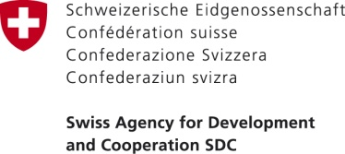





**Nesting a Multi-Country Cooperation Mechanism (MCCM) for the Stampriet Transboundary Aquifer System (STAS) in ORASECOM**

**17-18 August 2017**

**ORASECOM Ordinary Council Meeting**

**- CONCEPT NOTE –**

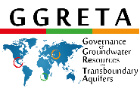

**1. BACKGROUND AND RATIONALE**

This Concept Note fleshes out a proposal made by Namibia for an ORASECOM-nested Multi-Country Cooperation Mechanism (MCCM) for the Stampriet Transboundary Aquifer System (STAS) [for the consideration of the ORASECOM Council]. It has been prepared at the request of the STAS countries as a follow up of the 3rd ORASECOM Ground Water Hydrology Committee (GWHC) Meeting and the Technical Task Team (TTT) held on 17th and 18th May 2017 in Isando, South Africa.

The Stampriet Transboundary Aquifer System (STAS) stretches from Central Namibia into Western Botswana and South Africa’s Northern Cape Province, and lies entirely within the Orange-Senqu River Basin. The STAS covers a total area of 86 647km², of which 73% is in Namibia, 19% in Botswana, and 8% in South Africa. With financial assistance from the Swiss Development Corporation (SDC), and with the technical assistance of UNESCO-IHP, the STAS countries have been actively cooperating in the in-depth assessment of the aquifer and its characteristics since 2013, through the Governance of Groundwater Resources in Transboundary Aquifers (GGRETA) project.

The first phase of the project (2013-2015) focused on an in-depth assessment of the STAS which allowed establishing a shared science based understanding of the resource. The activities of the second phase of the project (2016-2018) focus on consolidating the technical results achieved and the tools developed in the first phase, and on strengthening capacity on groundwater governance at the national and transboundary levels in order to support the process of establishment of a MCCM. The establishment of the STAS MCCM would be the first example of a mechanism for the management and governance of a transboundary aquifer in Southern Africa.

The cooperation on-going has yielded a map delineating the shared aquifer system, and an assessment of the aquifer characteristics, including current and projected uses of groundwater, and likely future stress conditions under relevant factors. As a result of the assessment, the hydrogeological typology of the STAS can be stated as a weakly recharging three layer aquifer system, characterised by low transmissvity, and low storage, primarily being utilised in Namibia for socio economic growth, where withdrawal from storage has caused local groundwater level declines; in the extension of the aquifers into South Africa, water quality constraints have restricted its utilisation, while in Botswana the potential for available resources is likely, but insufficient data is available for making firm conclusions.

In particular, the challenges which are emerging can be summed as follows:

* Lack of monitoring data (climate, groundwater abstraction, water levels, water quality) seriously hampers a systematic diagnostic analysis of groundwater quantity stress,
* pollution by humans and animals, and that caused by poor well construction and lack of protection, appears to be localized at present to the shallow Kalahari aquifers,
* there is no mining or industrial activity in the STAS area at present, however unregulated mining activities might lead to pollution of the aquifer system due to its fragility and vulnerability,
* acceleration of vertical leakage between superposed aquifers from uncemented borehole casings and metallic corrosion.

In view of the significance of the aquifer resources to the future of the three countries which share it, Botswana, Namibia and South Africa concur on the desirability of –

* achieving a shared STAS vision and perspective as each country pursues its national interests, mindful of those of neighbouring countries,
* ensuring consistency of direction and purpose of actions pursued domestically,
* achieving joint control of data and information,
* updating and developing a joint borehole database and numerical model as a prerequisite for the joint monitoring of the aquifer. This will allow to better evaluate the volume of aquifer storage in the STAS, define the degree of replenishment to the aquifer system, develop forecasts of the approach known as “business as usual” as well as alternative approaches that also include beneficial “interventions” by the STAS countries working jointly.

They also concur that the above desires can be achieved by upgrading and institutionalizing their informal cooperation on-going on the STAS, by nesting a MCCM for the STAS in ORASECOM.

The Implementation of STAS activities is part of the Action Area 1.1: Surface and groundwater assessments, Strategic Action 1.1.2: Detailed assessment of Stampriet Transboundary Aquifer ( Activity: Take forward recommendation from the study) of the IWRM Plan for the Orange-Senqu River Basin.

**2. OBJECTIVES & FUNCTIONS OF THE STAS MCCM**

The over-arching objective of a STAS MCCM is to transition from donor-driven cooperation to permanent, institutionalized cooperation among the countries which share the STAS.

In the short term, the STAS MCCM will report and discuss about on-going and upcoming activites related to the study and characterization of the STAS with the ultimate goal of collecting & exchanging data to ensure a regular update of the STAS model. The longer term vision is that the STAS MCCM could move from data collection & exchange to joint strategizing and advising STAS countries on the joint management of the aquifer and its resources.

Accordingly, the functions of the STAS MCCM will be the following in the foreseeable future:

* aquifer and aquifer-related data collection & exchange,
* developing and maintaining the STAS joint borehole database and numerical model,
* managing the data flow feeding the STAS model,
* set-up the framework and workplan for joint monitoring activities
* promoting and incorporating the STAS on the agenda of ORASECOM,
* attracting donor interest and eventually funding for STAS-related activities,
* liaising and coordinating joint activities with the SADC Groundwater Management Institute,
* any other matters that may arise or decided upon by the Country Representatives.

The STAS MCCM will also promote on the ORASECOM agenda the United Nations Resolution 63/124 (2008), concerning Draft Articles on the Law of Transboundary Aquifers[1]. It will also continues with implementation of groundwater related activities of the IWRM Plan through ORASECOM.

**3. STRUCTURE OF THE STAS MCCM**

It is proposed to integrate the national GGRETA project support structure in the Ground Water Hydrology Committee (GWHC), which operates under the Technical Task Team established by the ORASECOM Council. The National Focal Points (NFP) of the GGRETA project in the three countries, will double up as GWHC / Technical Task Team members. The Government representatives of GGRETA, will be the ORASECOM commissioners, however in case there is different in membership, countires can decide to change or keep the staus quo. The future reporting will be through ORASECOM and thus filter to governments (see Table 1). In the foreseeable future, therefore, the STAS MCCM will consist of the gathering of country NFP for Botswana, Namibia and South Africa during the ORASECOM GWHC meetings, for the purposes and with the functions indicated at 2 above.

Through the proposed merger, priority attention to the STAS relative to other aquifers underlying the Orange-Senqu basin will outlive the dissolution of the national GGRETA project support structure at the end of the project, late in 2018, and the STAS will be implemented in the agenda of IWRM Plan (Action Area 1.1) by GWHC in ORASECOM’s.

**4. LEGAL FOUNDATIONS OF THE STAS MCCM**

Under the ORASECOM Agreement (2000), Art.6.1 and its Revised Agreement, the Council has authority to establish *ad hoc* or permanent “working groups or committees” of representatives of the Parties. The four Task Teams mentioned under “Structure” above have been established accordingly. The Agreement does not state however the internal organization of the Task Teams. Presumably therefore, the matter is left to the discretion of each Task Team – including the Technical Task Team under which GWHC operates – to determine.

The Integrated Water Resources Management (IWRM) Plan of the Orange-Senqu Basin developed by ORASECOM, includes actions on surface and groundwater assessment and specifically mention the STAS. As such the future implementation and reporting falls under ORASECOM mandate and can be fully integrated therein.

Moreover, through the action of institutionalizing their cooperation as regards the STAS, Botswana, Namibia and South Africa will act in line with UN Resolution 63/124 (2008), carrying Draft Articles on the Law of Transboundary Aquifers and, in particular, Article 7.2 recommending that States sharing an aquifer establish “joint mechanisms of cooperation”.

**5. FUNDING ARRANGEMENTS**

It is established ORASECOM practice that each country bear the cost of its representative on the Task Teams in general, including the Technical Task Team and GWHC under it. There is no need to depart from such practice as regards the GWHC/STAS MCCM.

**6. ADVANTAGES**

There are distinct advantages to the proposal fleshed out in this Concept Note. They can be summed up as follows:

* expeditiousness of implementation, as the proposal to establish a MCCM for the STAS by merging the national GGRETA project support structure in GWHC only requires the ORASECOM Council’s [endorsement] [no objection]
* leanness of institutional architecture, as the GWHC will serve as the STAS MCCM
* economies of scale, as GWHC/STAS MCCM will rely on the support facilities and the resources available to ORASECOM
* zero additional costs to the STAS countries, as each STAS country-designated GGRETA project National Focal Point are already or will be that country’s GWHC member.

*Table 1 – Organogram of the ORASECOM-nested Multi-Country Cooperation Mechansim (MCCM) for the Stampriet Transboundary Aquifer System (STAS)*

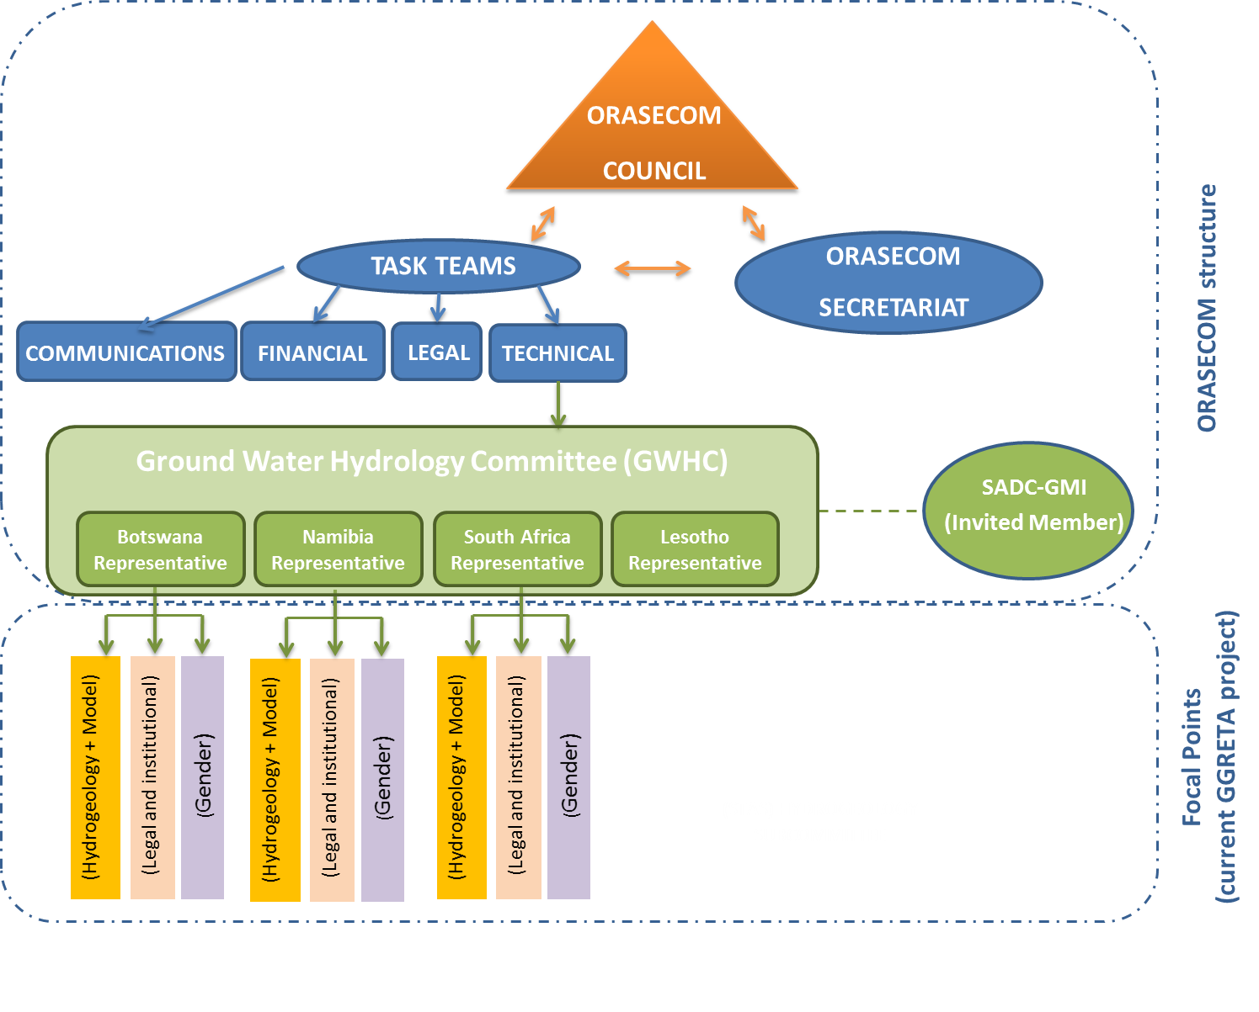

1. http://legal.un.org/ilc/texts/instruments/english/commentaries/8_5_2008.pdf